UNIT 9 · LESSON 1 STANDARD 6.NS.6

Graph on the Coordinate Plane (Flagship)
Student Notes Packet
Name: ______________________ Date: ____________ Period: ________

Today's Goals
Content: I can plot and identify points on the coordinate plane using ordered pairs.
Language: I can explain my work using the words coordinate plane, ordered pair, origin, and quadrant.

Key Vocabulary
Look at the picture, read the word, then read what it means.
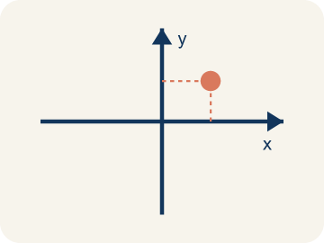 | Coordinate plane Plano cartesiano  A grid with a line going across and a line going up that cross.  Example: A grid with a horizontal line (x-axis) crossing a vertical line (y-axis), making four sections
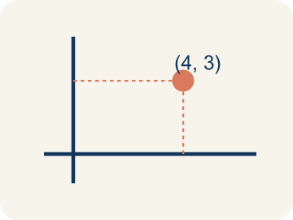 | Ordered pair Par ordenado  Two numbers (x, y) that tell where a point is on a grid.  Example: (3, 5) means move right 3 from the origin, then up 5
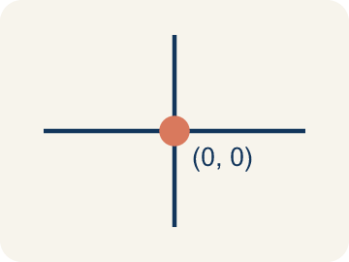 | Origin Origen  The point (0, 0) where the two grid lines cross.  Example: The starting point at the center where both axes cross — (0, 0)
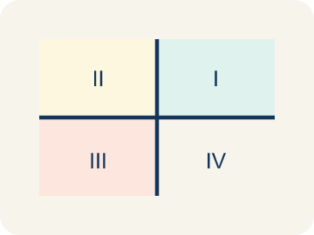 | Quadrant Cuadrante  One of the four parts of a coordinate grid.  Example: I (+,+) top-right, II (-,+) top-left, III (-,-) bottom-left, IV (+,-) bottom-right
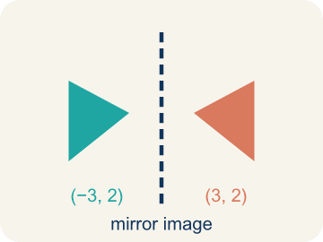 | Reflection Reflexión  A flipped, mirror image across a line.  Example: (3, 2) reflected over the x-axis becomes (3, -2) — same x, opposite y
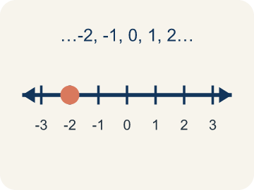 | Integer Número entero  Whole numbers and their opposites, like -2, -1, 0, 1, 2.  Example: ..., -3, -2, -1, 0, 1, 2, 3, ...

Worked Example

Watch & Read I Do — follow along with your teacher
Treasure Map Navigation
Captain Vega left a treasure map, but instead of an 'X marks the spot,' she hid the directions as ordered pairs! To find the treasure, you need to plot each point on the coordinate plane and connect them in order. The first clue says: Start at (2, 1), then go to (5, 4), then (8, 1).

Think about:
• What shape will the three points make when connected?
• Which number tells you how far right/left? Which tells you up/down?
• Why is the ORDER in an ordered pair important?
• What if one of the coordinates was negative?
• How would you describe a location without a coordinate plane?

Solved Example I Do — watch each step
Problem: Which ordered pair names a point 3 units right and 7 units up from the origin?
A) (3, 7)
B) (7, 3)
C) (3, 3)
D) (0, 7)
Step 1: The first coordinate is horizontal (right 3), the second is vertical (up 7).
Step 2: So (3, 7).
Answer: A. (3, 7)

Guided Practice

Solve Together We Do — work with your class
Problem: What are the coordinates of the origin?
A) (0, 0)
B) (1, 1)
C) (0, 1)
D) (1, 0)
Step 1:

Step 2:

Answer:

A drone delivery company programs flight paths using coordinate pairs. A drone starts at the warehouse (0, 0), flies to pickup at (3, 6), then delivers to (8, 2), then returns to base (0, 0).
How do ordered pairs help the drone navigate? What shape does the flight path make?

Sentence frame: The drone uses ordered pairs because the first number controls ___ movement and the second controls ___. The path makes a ___ shape.

Turn & Talk discuss with a partner
1. [Launch] On a treasure map laid over a coordinate plane, why do we always start at the origin (0, 0) and move sideways before moving up or down to reach the treasure?
Start with: The first number in (x, y) tells me to move ___.
El primer numero en (x, y) me dice que me mueva ___.
Word bank: coordinate plane, origin, ordered pair, x-axis, y-axis
2. [Explore] Your map says the treasure is at (4, 2). Walk your partner through every move you make from the origin, using the words x-axis and y-axis.
Start with: I move ___ units along the x-axis.
Me muevo ___ unidades por el eje x.
Word bank: origin, ordered pair, x-axis, y-axis, coordinate plane
3. [Connect] How is reading a coordinate pair on the treasure map like reading directions in a video game or on a real map?
Start with: The x-coordinate is like going ___.
La coordenada x es como ir ___.
Word bank: ordered pair, coordinate plane, x-axis, y-axis, origin
4. [Reflect] A teammate marked the treasure at (2, 6) by moving up 2 and over 6. What mistake did they make, and how would you coach them?
Start with: They mixed up the ___ and the ___.
Confundieron la ___ y la ___.
Word bank: ordered pair, x-axis, y-axis, origin, coordinate plane

Independent Practice

On Your Own You Do — show your work
Solve each problem. Show your thinking in the work box.
1. A point is at (6, 2). What does the 6 tell you?
A) Move 6 units to the right
B) Move 6 units up
C) Move 6 units to the left
D) The point is in Quadrant 6

Write About the Math

Build Strong Sentences The Writing Revolution
I can explain my work using the words coordinate plane, ordered pair, origin, and quadrant.

1. Kernel Sentence subject + verb
Model: Coordinate plane is a grid with a line going across and a line going up that cross.

Write a kernel sentence about coordinate plane. Use a subject and a verb.
Escribe una oración base sobre plano cartesiano. Usa un sujeto y un verbo.

2. Sentence Expansion because · but · so
Kernel: Coordinate plane matters in math
because Coordinate plane matters in math because ___.
Plano cartesiano importa en matemáticas porque ___.

but Coordinate plane matters in math, but ___.
Plano cartesiano importa en matemáticas, pero ___.

so Coordinate plane matters in math, so ___.
Plano cartesiano importa en matemáticas, entonces ___.

3. Explain Your Reasoning use a sentence starter
The first number in (x, y) tells me to move ___.
El primer numero en (x, y) me dice que me mueva ___.
The second number tells me to move ___.
El segundo numero me dice que me mueva ___.
I move ___ units along the x-axis.
Me muevo ___ unidades por el eje x.

Exit Ticket
Answer on your own. This shows what you learned today.
★ Point P is located 6 units right and 3 units up from the origin. What ordered pair names point P?
A) (6, 3)
B) (3, 6)
C) (6, 0)
D) (0, 3)

Answer Key & Teacher Guide
Teacher reference — remove or fold back before distributing to students.

Worked Notes (I Do / We Do)
I Do: A. (3, 7)
We Do: A. (0, 0)

Independent Practice
1. A) Move 6 units to the right — The first number (x-coordinate) tells you horizontal movement. 6 means go right 6 units from the origin.

Exit Ticket
A) (6, 3) — Right 6 = x-coordinate of 6, Up 3 = y-coordinate of 3. The ordered pair is (6, 3).

Writing (TWR) — what to look for
Kernel sentence: a complete sentence needs a subject and a verb. Example: Coordinate plane is a grid with a line going across and a line going up that cross.
Expansion: because = reason, but = contrast/exception, so = result. Answers vary; each must keep the kernel idea.

Turn & Talk — listen for
1. Student states the x-coordinate is the sideways move and the y-coordinate is the up/down move, both starting from the origin.
2. Student moves 4 right along the x-axis and 2 up along the y-axis, naming each axis and the origin as the start.
3. Student connects the x-value to horizontal travel and the y-value to vertical travel, like map directions from a start point.
4. Student identifies that the x- and y-coordinates were swapped and explains the correct order (x first, then y).

