Graph on the Coordinate Plane — Homework
Lesson 9-1-flagship • Standard 6.NS.6
Name: ______________________ Period: ______ Date: ____________

Today's Goals
Content: I can plot and identify points on the coordinate plane using ordered pairs.
Language: I can explain my work using the words coordinate plane, ordered pair, origin, and quadrant.

Key Words
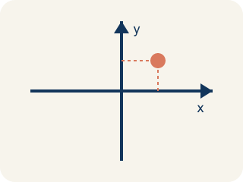
Coordinate plane (Plano cartesiano) — A grid with a line going across and a line going up that cross.
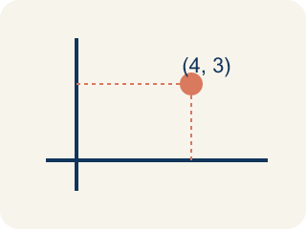
Ordered pair (Par ordenado) — Two numbers (x, y) that tell where a point is on a grid.
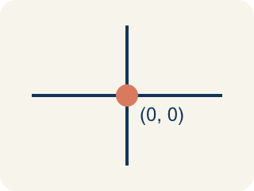
Origin (Origen) — The point (0, 0) where the two grid lines cross.
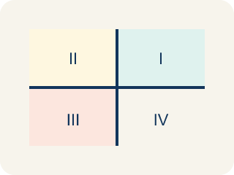
Quadrant (Cuadrante) — One of the four parts of a coordinate grid.
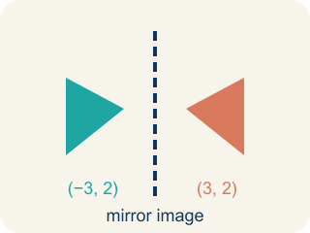
Reflection (Reflexión) — A flipped, mirror image across a line.
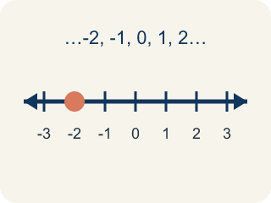
Integer (Número entero) — Whole numbers and their opposites, like -2, -1, 0, 1, 2.

Practice
Show your work. Use the blank space under each problem.
1. Which ordered pair names a point 3 units right and 7 units up from the origin?
A. (3, 7)
B. (7, 3)
C. (3, 3)
D. (0, 7)
______________________________________________________________________
2. What are the coordinates of the origin?
A. (0, 0)
B. (1, 1)
C. (0, 1)
D. (1, 0)
______________________________________________________________________
3. Match each point to its quadrant or axis.
Item | Answer choices
____ (3, 2) | F. x-axis
____ (-4, 5) | E. y-axis
____ (-2, -6) | D. Quadrant IV
____ (7, -1) | C. Quadrant III
____ (0, 3) | B. Quadrant II
____ (5, 0) | A. Quadrant I
______________________________________________________________________
4. Complete the table. Write the ordered pair for each description.
Description | Ordered Pair
Right 7, Up 2
Right 0, Up 5
Right 4, Up 0
Right 3, Up 3
______________________________________________________________________
5. Sort each item into the correct group.
• undefined → __________________
• undefined → __________________
• undefined → __________________
• undefined → __________________
• undefined → __________________
______________________________________________________________________

Answer Key (Teacher)
1. A. (3, 7)
The first coordinate is horizontal (right 3), the second is vertical (up 7). So (3, 7).
2. A. (0, 0)
The origin is where the x-axis and y-axis cross, at (0, 0).
3. Matches:
(3, 2) → Quadrant I
(-4, 5) → Quadrant II
(-2, -6) → Quadrant III
(7, -1) → Quadrant IV
(0, 3) → y-axis
(5, 0) → x-axis

4. Complete the table. Write the ordered pair for each description.
Right 7, Up 2 — Ordered Pair: (7, 2)
Right 0, Up 5 — Ordered Pair: (0, 5)
Right 4, Up 0 — Ordered Pair: (4, 0)
Right 3, Up 3 — Ordered Pair: (3, 3)

5. Correct groups:
undefined → undefined
undefined → undefined
undefined → undefined
undefined → undefined
undefined → undefined

