UNIT 9 · LESSON 5 STANDARD 6.NS.6B

Ordered Pairs in All Four Quadrants
Student Notes Packet
Name: ______________________ Date: ____________ Period: ________

Today's Goals
Content: I can plot ordered pairs in all four quadrants of the coordinate plane.
Language: I can explain my work using the words quadrant, negative coordinate, reflection, and axis.

Key Vocabulary
Look at the picture, read the word, then read what it means.
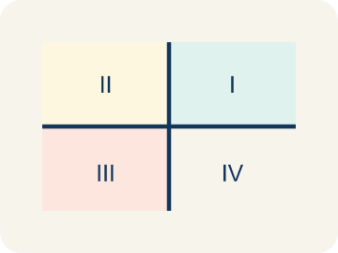 | Quadrant Cuadrante  One of the four parts of a coordinate grid, numbered I to IV.  Example: I (+, +) top-right, II (-, +) top-left, III (-, -) bottom-left, IV (+, -) bottom-right
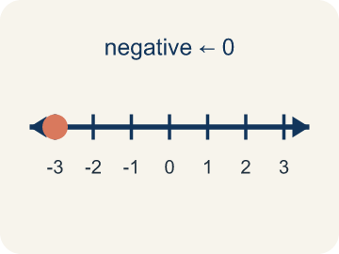 | Negative coordinate Coordenada negativa  A coordinate less than zero. It means left or below the center point.  Example: (-3, 2) means 3 left and 2 up from the origin
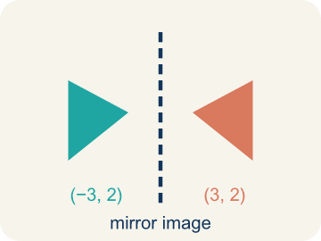 | Reflection Reflexión  A flipped, mirror image of a point across a line.  Example: (3, 2) reflected over the y-axis is (-3, 2) — same distance, opposite side
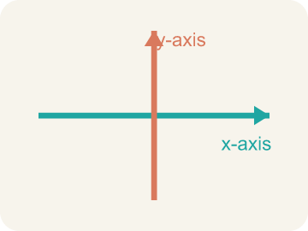 | Axis Eje  A line on the grid. The x-axis goes across; the y-axis goes up.  Example: The x-axis goes left-right; the y-axis goes up-down; they cross at (0, 0)
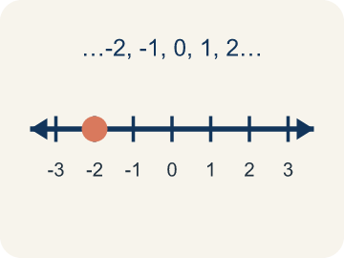 | Integer Número entero  Whole numbers and their opposites, like -2, -1, 0, 1, 2.  Example: ..., -3, -2, -1, 0, 1, 2, 3, ...

Worked Example

Watch & Read I Do — follow along with your teacher
Expanding the Treasure Map
Captain Vega realized her treasure map only covered one corner of the island! She needs to expand the map in all directions — north, south, east, and west of the base camp at the origin (0, 0). Now clues can have negative coordinates: (-4, 3) means 4 units west and 3 units north. A clue at (2, -5) means 2 units east and 5 units south. Which quadrant is each clue in?

Think about:
• How do you know which quadrant a point is in by looking at the signs of its coordinates?
• What do negative x-values and negative y-values mean on the map?
• Where is the point (0, 0) on the expanded map?
• Can a point be in more than one quadrant?
• What quadrant is a point on if one of its coordinates is zero?

Solved Example I Do — watch each step
Problem: In which quadrant is the point (-4, 5)?
A) Quadrant I
B) Quadrant II
C) Quadrant III
D) Quadrant IV
Step 1: The x-coordinate is negative (left) and the y-coordinate is positive (up).
Step 2: Left and up is Quadrant II.
Answer: B. Quadrant II

Guided Practice

Solve Together We Do — work with your class
Problem: A point has a positive x-coordinate and a negative y-coordinate. Which quadrant is it in?
A) Quadrant I
B) Quadrant II
C) Quadrant III
D) Quadrant IV
Step 1:

Step 2:

Answer:

A city uses a coordinate grid to map locations. City Hall is at the origin (0, 0). The library is at (-3, 4), the park is at (5, -2), the school is at (2, 3), and the hospital is at (-4, -1).
How do four-quadrant coordinates help a city map locations in every direction from the center?

Sentence frame: The library is in Quadrant ___ because its x is ___ and its y is ___. The park is in Quadrant ___ because ___. Four-quadrant coordinates help because ___.

Turn & Talk discuss with a partner
1. [Launch] What do the signs of the coordinates in an ordered pair tell you about which quadrant the point is in?
Start with: If both coordinates are positive, the point is in quadrant ___.
Si ambas coordenadas son positivas, el punto esta en el cuadrante ___.
Word bank: quadrant, ordered pair, negative coordinate, x-axis, y-axis
2. [Explore] Plot (-3, -4). Which quadrant is it in, and how do the negative coordinates change the directions you move from the origin?
Start with: A negative x means I move ___.
Una x negativa significa que me muevo ___.
Word bank: quadrant, negative coordinate, ordered pair, x-axis, y-axis
3. [Connect] How are the four quadrants like a tic-tac-toe of positive and negative directions on the coordinate plane?
Start with: Quadrant ___ has both coordinates positive.
El cuadrante ___ tiene ambas coordenadas positivas.
Word bank: quadrant, negative coordinate, ordered pair, x-axis, y-axis
4. [Reflect] A point has coordinates (5, -2). Without plotting, how can you describe exactly where it is and which quadrant it is in?
Start with: The point is ___ of the y-axis and ___ of the x-axis.
El punto esta a la ___ del eje y y ___ del eje x.
Word bank: quadrant, ordered pair, negative coordinate, x-axis, y-axis

Independent Practice

On Your Own You Do — show your work
Solve each problem. Show your thinking in the work box.
1. Which point is located on the x-axis?
A) (4, 0)
B) (0, 4)
C) (4, 4)
D) (-4, -4)

2. Point A is at (-5, 3). If you move 8 units to the right, what are the new coordinates?
A) (3, 3)
B) (-13, 3)
C) (-5, 11)
D) (-5, -5)

3. In which quadrant is the point (-4, -6)?
A) Quadrant III
B) Quadrant I
C) Quadrant II
D) Quadrant IV

4. Point A is (5, 3). Which point shares the same x-coordinate?
A) (5, -2)
B) (3, 5)
C) (-5, 3)
D) (2, 5)

Write About the Math

Build Strong Sentences The Writing Revolution
I can explain my work using the words quadrant, negative coordinate, reflection, and axis.

1. Kernel Sentence subject + verb
Model: Quadrant is one of the four parts of a coordinate grid, numbered I to IV.

Write a kernel sentence about quadrant. Use a subject and a verb.
Escribe una oración base sobre cuadrante. Usa un sujeto y un verbo.

2. Sentence Expansion because · but · so
Kernel: Quadrant matters in math
because Quadrant matters in math because ___.
Cuadrante importa en matemáticas porque ___.

but Quadrant matters in math, but ___.
Cuadrante importa en matemáticas, pero ___.

so Quadrant matters in math, so ___.
Cuadrante importa en matemáticas, entonces ___.

3. Explain Your Reasoning use a sentence starter
If both coordinates are positive, the point is in quadrant ___.
Si ambas coordenadas son positivas, el punto esta en el cuadrante ___.
If the x is negative and the y is positive, the point is in quadrant ___.
Si la x es negativa y la y es positiva, el punto esta en el cuadrante ___.
A negative x means I move ___.
Una x negativa significa que me muevo ___.

Exit Ticket
Answer on your own. This shows what you learned today.
★ A point has a negative x-coordinate and a negative y-coordinate. Which quadrant is it in?
A) Quadrant I
B) Quadrant II
C) Quadrant III
D) Quadrant IV

Answer Key & Teacher Guide
Teacher reference — remove or fold back before distributing to students.

Worked Notes (I Do / We Do)
I Do: B. Quadrant II
We Do: D. Quadrant IV

Independent Practice
1. A) (4, 0) — A point is on the x-axis when its y-coordinate is 0. (4, 0) is on the x-axis.
2. A) (3, 3) — Moving right means adding to the x-coordinate: -5 + 8 = 3. The y stays the same. New point: (3, 3).
3. A) Quadrant III — Negative x and negative y place a point in Quadrant III.
4. A) (5, -2) — (5, -2) has the same x-coordinate, 5.

Exit Ticket
C) Quadrant III — Quadrant III is where both x and y are negative. This means the point is left of the origin and below the origin.

Writing (TWR) — what to look for
Kernel sentence: a complete sentence needs a subject and a verb. Example: Quadrant is one of the four parts of a coordinate grid, numbered I to IV.
Expansion: because = reason, but = contrast/exception, so = result. Answers vary; each must keep the kernel idea.

Turn & Talk — listen for
1. Student matches sign combinations to quadrants (e.g., (+,+) is I, (-,+) is II).
2. Student moves left for negative x and down for negative y, landing in quadrant III.
3. Student connects each quadrant to a unique sign pattern for x and y.
4. Student says (5, -2) is right and down, in quadrant IV, from the signs alone.

