Ordered Pairs in All Four Quadrants — Homework
Lesson 9-5 • Standard 6.NS.6b
Name: ______________________ Period: ______ Date: ____________

Today's Goals
Content: I can plot ordered pairs in all four quadrants of the coordinate plane.
Language: I can explain my work using the words quadrant, negative coordinate, reflection, and axis.

Key Words
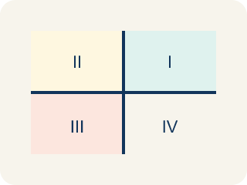
Quadrant (Cuadrante) — One of the four parts of a coordinate grid, numbered I to IV.
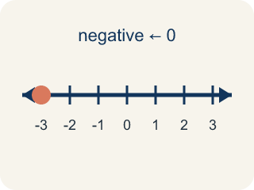
Negative coordinate (Coordenada negativa) — A coordinate less than zero. It means left or below the center point.
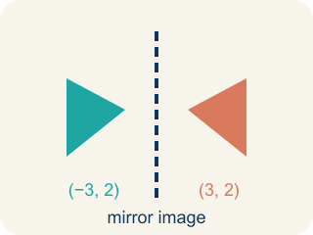
Reflection (Reflexión) — A flipped, mirror image of a point across a line.
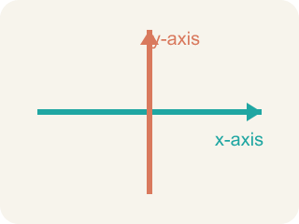
Axis (Eje) — A line on the grid. The x-axis goes across; the y-axis goes up.
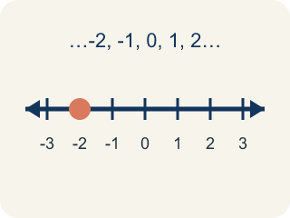
Integer (Número entero) — Whole numbers and their opposites, like -2, -1, 0, 1, 2.

Practice
Show your work. Use the blank space under each problem.
1. In which quadrant is the point (-4, 5)?
A. Quadrant I
B. Quadrant II
C. Quadrant III
D. Quadrant IV
______________________________________________________________________
2. A point has a positive x-coordinate and a negative y-coordinate. Which quadrant is it in?
A. Quadrant I
B. Quadrant II
C. Quadrant III
D. Quadrant IV
______________________________________________________________________
3. For each ordered pair, write the signs of x and y and name the quadrant (or axis).
Point | x sign | y sign | Quadrant or Axis
(6, -2)
(-3, -5)
(0, 7)
(-1, 8)
(4, 0)
______________________________________________________________________
4. Match each quadrant to its coordinate sign pattern.
Item | Answer choices
____ Quadrant I | F. x = 0
____ Quadrant II | E. y = 0
____ Quadrant III | D. (+, -)
____ Quadrant IV | C. (-, -)
____ x-axis | B. (-, +)
____ y-axis | A. (+, +)
______________________________________________________________________
5. Point A is at (-5, 3). If you move 8 units to the right, what are the new coordinates?
A. (3, 3)
B. (-13, 3)
C. (-5, 11)
D. (-5, -5)
______________________________________________________________________
6. In which quadrant is the point (-4, -6)?
A. Quadrant III
B. Quadrant I
C. Quadrant II
D. Quadrant IV
______________________________________________________________________
7. Point A is (5, 3). Which point shares the same x-coordinate?
A. (5, -2)
B. (3, 5)
C. (-5, 3)
D. (2, 5)
______________________________________________________________________
8. Which ordered pair is in Quadrant IV?
A. (8, -3)
B. (-8, 3)
C. (8, 3)
D. (-8, -3)
______________________________________________________________________
9. The point (0, -7) lies on which axis?
A. The y-axis
B. The x-axis
C. Quadrant III
D. Quadrant IV
______________________________________________________________________

Answer Key (Teacher)
1. B. Quadrant II
The x-coordinate is negative (left) and the y-coordinate is positive (up). Left and up is Quadrant II.
2. D. Quadrant IV
Positive x (right) and negative y (down) = Quadrant IV (bottom-right).
3. For each ordered pair, write the signs of x and y and name the quadrant (or axis).
(6, -2) — x sign: +
(6, -2) — y sign: -
(6, -2) — Quadrant or Axis: IV
(-3, -5) — x sign: -
(-3, -5) — y sign: -
(-3, -5) — Quadrant or Axis: III
(0, 7) — x sign: 0
(0, 7) — y sign: +
(0, 7) — Quadrant or Axis: y-axis
(-1, 8) — x sign: -
(-1, 8) — y sign: +
(-1, 8) — Quadrant or Axis: II
(4, 0) — x sign: +
(4, 0) — y sign: 0
(4, 0) — Quadrant or Axis: x-axis

4. Matches:
Quadrant I → (+, +)
Quadrant II → (-, +)
Quadrant III → (-, -)
Quadrant IV → (+, -)
x-axis → y = 0
y-axis → x = 0

5. A. (3, 3)
Moving right means adding to the x-coordinate: -5 + 8 = 3. The y stays the same. New point: (3, 3).
6. A. Quadrant III
Negative x and negative y place a point in Quadrant III.
7. A. (5, -2)
(5, -2) has the same x-coordinate, 5.
8. A. (8, -3)
Quadrant IV has positive x and negative y: (8, -3).
9. A. The y-axis
With x = 0, the point is on the y-axis.

