Distance on the Coordinate Plane — Homework
Lesson 9-6 • Standard 6.NS.8
Name: ______________________ Period: ______ Date: ____________

Today's Goals
Content: I can find the distance between two points on the coordinate plane using absolute value.
Language: I can explain my work using the words distance, absolute value, horizontal distance, and vertical distance.

Key Words
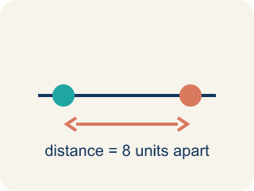
Distance (Distancia) — How far apart two points are. It is never negative.
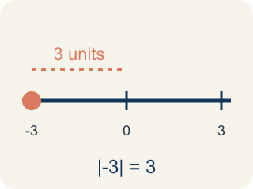
Absolute value (Valor absoluto) — How far a number is from zero.

Horizontal distance (Distancia horizontal) — How far apart two points are going left or right.

Vertical distance (Distancia vertical) — How far apart two points are going up or down.
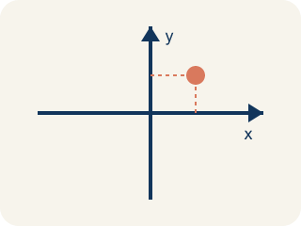
Coordinate plane (Plano cartesiano) — A grid with a line going across and a line going up that cross.
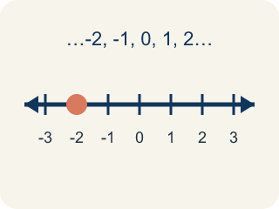
Integer (Número entero) — Whole numbers and their opposites, like -2, -1, 0, 1, 2.

Practice
Show your work. Use the blank space under each problem.
1. What is the distance between (-4, 3) and (2, 3)?
A. 2 units
B. 4 units
C. 6 units
D. 8 units
______________________________________________________________________
2. What is the distance between (5, -2) and (5, 4)?
A. 2 units
B. 4 units
C. 6 units
D. 10 units
______________________________________________________________________
3. Find the perimeter of each rectangle using its vertex coordinates.
Rectangle | Vertices | Width | Height | Perimeter
Rect 1 | (-3, 1), (4, 1), (4, 5), (-3, 5)
Rect 2 | (-2, -4), (6, -4), (6, 2), (-2, 2)
______________________________________________________________________
4. Two points are at (-3, -7) and (-3, 5). What is the distance between them?
A. 12 units
B. 2 units
C. 7 units
D. 8 units
______________________________________________________________________
5. What is the distance between (2, 3) and (2, 9)?
A. 6
B. 12
C. 3
D. 11
______________________________________________________________________
6. What is the distance between (-4, 1) and (5, 1)?
A. 9
B. 1
C. -9
D. 4
______________________________________________________________________
7. A point is at (-3, 2) and another at (-3, -5). How far apart are they?
A. 7
B. 3
C. 2
D. 8
______________________________________________________________________
8. Why can you find the distance between (1, 4) and (6, 4) by subtracting x-values?
A. They have the same y-coordinate, so the segment is horizontal
B. All points are the same
C. Distance is always the larger number
D. You must always add the coordinates
______________________________________________________________________

Answer Key (Teacher)
1. C. 6 units
Both points have y = 3, so this is a horizontal distance. |2 - (-4)| = |2 + 4| = 6 units.
2. C. 6 units
Both points have x = 5, so this is a vertical distance. |4 - (-2)| = |4 + 2| = 6 units.
3. Find the perimeter of each rectangle using its vertex coordinates.
Rect 1 — Width: 7
Rect 1 — Height: 4
Rect 1 — Perimeter: 22
Rect 2 — Width: 8
Rect 2 — Height: 6
Rect 2 — Perimeter: 28

4. A. 12 units
Same x = -3. Distance = |5 - (-7)| = |5 + 7| = 12 units.
5. A. 6
Same x, so subtract y-values: 9 − 3 = 6 units.
6. A. 9
Same y; distance = |5 − (-4)| = 9 units.
7. A. 7
Same x; distance = |2 − (-5)| = 7 units.
8. A. They have the same y-coordinate, so the segment is horizontal
Equal y-values mean a horizontal segment, so distance = |6 − 1| = 5.

