Reflect Points Across Axes — Homework
Lesson 9-7 • Standard 6.NS.6b
Name: ______________________ Period: ______ Date: ____________

Today's Goals
Content: I can reflect points across the x-axis and y-axis on the coordinate plane.
Language: I can explain my work using the words reflection, x-axis, y-axis, and symmetry.

Key Words
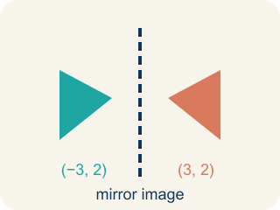
Reflection (Reflexión) — A flipped image of a point on the other side of a line, the same distance away.
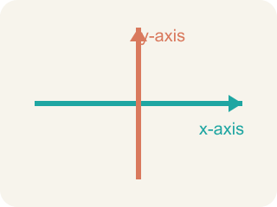
x-axis (Eje x) — The line that goes across the grid. Flipping over it changes the y sign.

y-axis (Eje y) — The line that goes up the grid. Flipping over it changes the x sign.

Symmetry (Simetría) — When a shape looks the same on both sides of a line.
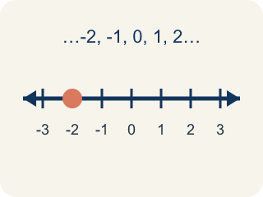
Integer (Número entero) — Whole numbers and their opposites, like -2, -1, 0, 1, 2.

Practice
Show your work. Use the blank space under each problem.
1. What is the reflection of (4, -3) over the x-axis?
A. (-4, -3)
B. (4, 3)
C. (-4, 3)
D. (3, -4)
______________________________________________________________________
2. What is the reflection of (-2, 6) over the y-axis?
A. (2, 6)
B. (-2, -6)
C. (2, -6)
D. (6, -2)
______________________________________________________________________
3. Find the reflection of each point over the given axis.
Original Point | Axis | Reflected Point
(3, -7) | x-axis
(-5, 2) | y-axis
(8, -1) | x-axis
(-4, -6) | y-axis
(0, 9) | x-axis
(-3, 0) | y-axis
______________________________________________________________________
4. Match each reflection rule to its description.
Item | Answer choices
____ Over x-axis | F. Reflects to itself over any axis
____ Over y-axis | E. Reflects to itself over y-axis
____ Over both axes | D. Reflects to itself over x-axis
____ Point on x-axis | C. Both coordinates change sign
____ Point on y-axis | B. x-coordinate changes sign
____ (0, 0) | A. y-coordinate changes sign
______________________________________________________________________
5. Point A is at (-3, 5). It is reflected over the x-axis to A', then A' is reflected over the y-axis to A''. What are the coordinates of A''?
A. (3, -5)
B. (-3, -5)
C. (3, 5)
D. (-3, 5)
______________________________________________________________________
6. Reflect (3, 5) across the x-axis. What is the image?
A. (3, -5)
B. (-3, 5)
C. (-3, -5)
D. (5, 3)
______________________________________________________________________
7. Reflect (-2, 4) across the y-axis. What is the image?
A. (2, 4)
B. (-2, -4)
C. (2, -4)
D. (4, -2)
______________________________________________________________________
8. A point (6, -1) is reflected across the x-axis. Which coordinate changes sign?
A. The y-coordinate
B. The x-coordinate
C. Both coordinates
D. Neither coordinate
______________________________________________________________________
9. Reflect (-4, -7) across the y-axis. What is the image?
A. (4, -7)
B. (-4, 7)
C. (4, 7)
D. (-7, -4)
______________________________________________________________________

Answer Key (Teacher)
1. B. (4, 3)
Reflecting over the x-axis changes the sign of the y-coordinate. The x stays the same (4), and the y changes from -3 to 3. The answer is (4, 3).
2. A. (2, 6)
Reflecting over the y-axis changes the sign of the x-coordinate. x goes from -2 to 2, and y stays 6. The answer is (2, 6).
3. Find the reflection of each point over the given axis.
(3, -7) — Reflected Point: (3, 7)
(-5, 2) — Reflected Point: (5, 2)
(8, -1) — Reflected Point: (8, 1)
(-4, -6) — Reflected Point: (4, -6)
(0, 9) — Reflected Point: (0, -9)
(-3, 0) — Reflected Point: (3, 0)

4. Matches:
Over x-axis → y-coordinate changes sign
Over y-axis → x-coordinate changes sign
Over both axes → Both coordinates change sign
Point on x-axis → Reflects to itself over x-axis
Point on y-axis → Reflects to itself over y-axis
(0, 0) → Reflects to itself over any axis

5. A. (3, -5)
Over x-axis: (-3, 5) → (-3, -5). Then over y-axis: (-3, -5) → (3, -5). Both coordinates changed sign.
6. A. (3, -5)
Reflecting across the x-axis changes the sign of the y-coordinate: (3, -5).
7. A. (2, 4)
Reflecting across the y-axis changes the sign of the x-coordinate: (2, 4).
8. A. The y-coordinate
Reflecting across the x-axis flips the sign of y only, giving (6, 1).
9. A. (4, -7)
Reflecting across the y-axis changes the sign of x: (4, -7).

