Histogram Hero Lab
Name: __________________ Date: __________________
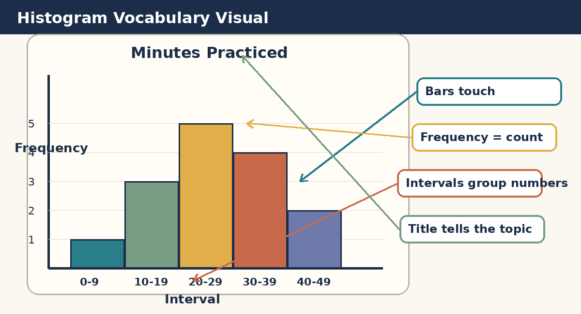
Remember: A histogram shows how many data values are in each interval. Each bar is one group of numbers.1. Vocabulary Notes
Word | Meaning
Histogram | A graph that shows how many data values are in each interval.
Data | The numbers or information we collect.
Interval | A group of numbers on the bottom of the histogram.
Frequency | How many data values are in an interval.
Axis | The lines on the side and bottom of the graph.
Bar | The shaded rectangle for each interval.

2. Sort the Data into Ready-Made Intervals
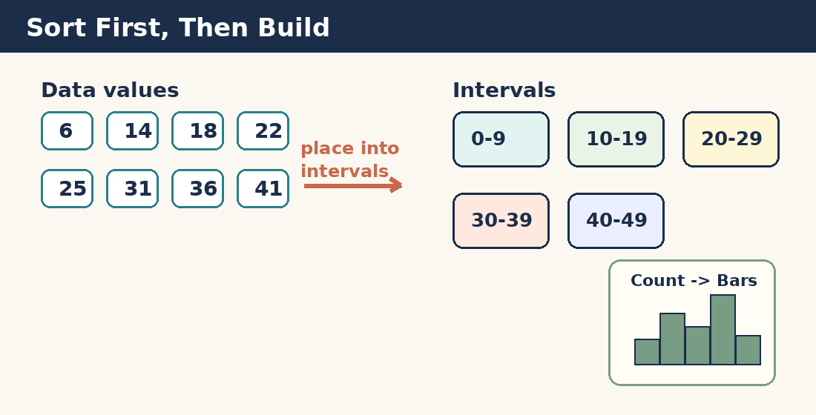
Topic: Minutes students practiced a skill yesterday
6, 14, 18, 22, 25, 31, 36, 41, 9, 12, 16, 27, 29, 33, 38, 44, 4, 20, 24, 35
Interval | Frequency
0-9
10-19
20-29
30-39
40-49

3. Build a Histogram: Guided Practice
Step-by-step:
1) Use your frequency table from page 3.
2) Find each interval on the bottom.
3) Shade each bar up to the frequency.
4) Add a clear title if your teacher asks.

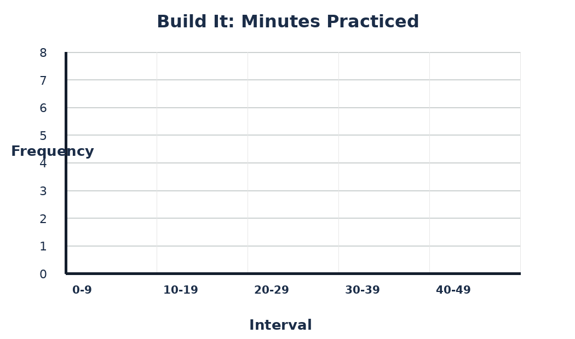
Sentence frame: The interval with the greatest frequency is __________ because it has __________ data values.

4. Interpret a Histogram
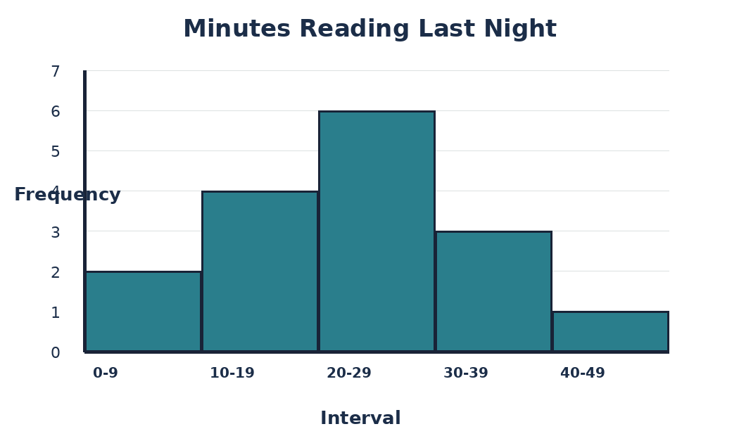
Directions: Use the histogram to answer each question. Write the interval or the frequency.

1. Which interval has the greatest frequency?
________________________________________________________________________________
2. How many students read for 20-29 minutes?
________________________________________________________________________________
3. How many students read for 0-9 minutes?
________________________________________________________________________________
4. How many students read for 30-39 minutes?
________________________________________________________________________________
5. Finish the sentence: Most students read for __________ minutes.
________________________________________________________________________________

5. Build Another Histogram
Topic: Basketball shots made in 2 minutes. The intervals are already chosen for you.

3, 8, 12, 15, 18, 21, 5, 9, 11, 14, 17, 20, 1, 6, 10, 13, 19, 23
Interval | Tally Marks | Frequency
0-4
5-9
10-14
15-19
20-24
Now shade the bars on the graph.
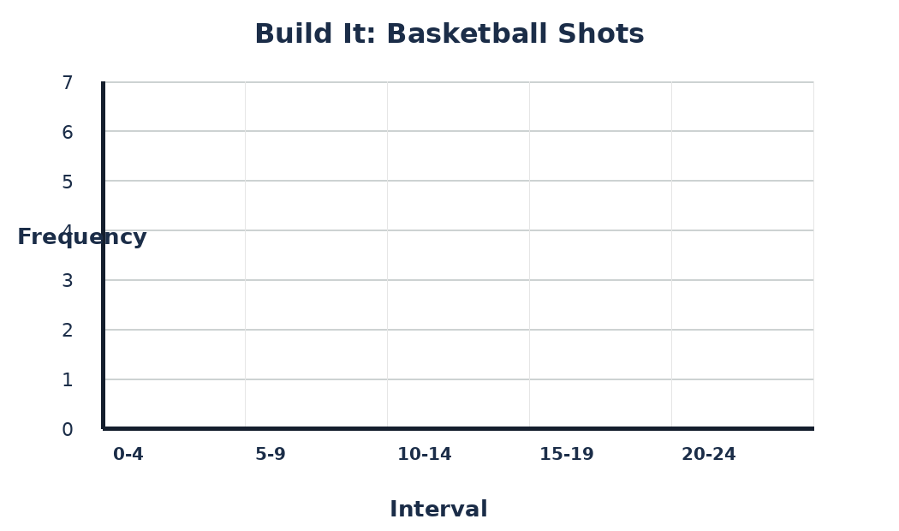

6. Create Your Own Histogram
Choose one: How many minutes did classmates play outside yesterday? OR How many minutes did classmates spend on homework?

Fill in numbers for each of the students (make it up)
#1 | #2 | #3 | #4 | #5 | #6 | #7 | #8 | #9 | #10
Sort your answers into the intervals below.
Interval | Tally Marks | Frequency
0-9
10-19
20-29
30-39
40-49
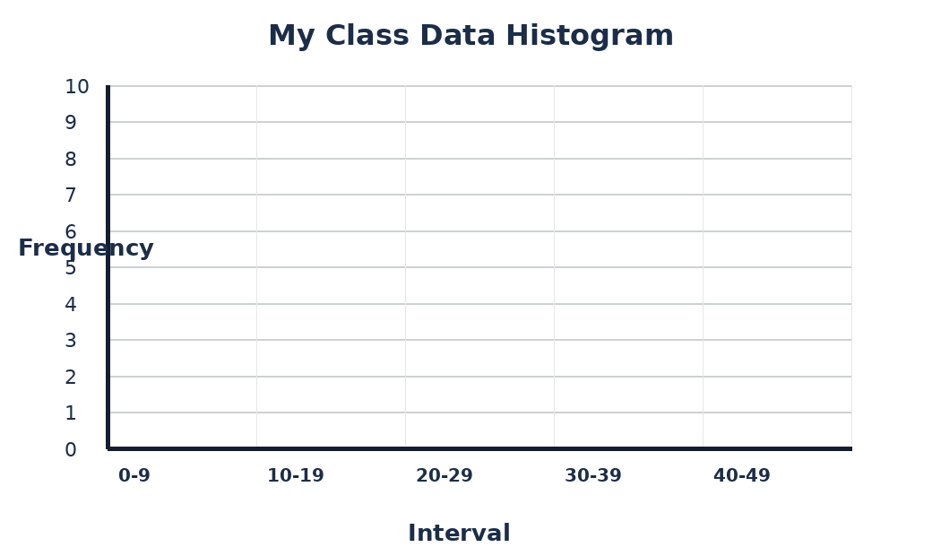

8. Exit Ticket
Use the words: histogram, interval, frequency, data

1. What does a histogram show?
________________________________________________________________________________
________________________________________________________________________________
2. Why do we sort the data into intervals before we build the graph?
________________________________________________________________________________
________________________________________________________________________________
3. Look at your histogram from page 8. Which interval had the greatest frequency?
________________________________________________________________________________
________________________________________________________________________________
4. Write one thing you understand better now.
________________________________________________________________________________
________________________________________________________________________________

Student Checklist
Check | I did this
□ | I sorted data into intervals.
□ | I used tally marks.
□ | I wrote the frequency for each interval.
□ | I shaded bars carefully.
□ | I answered questions using the histogram.

