1-1-flagship Prime Factorization Flagship
Number System Launch | Standard: 6.NS.4 | Color-by-Number Practice

Learning Goal: I can write a number as a product of its prime factors using a factor tree. | Directions: Solve each problem. Match each answer to the Color Code. On the next page, color every box with that problem number using the matching color.

Vocabulary: prime, factor, factor tree, product | Explain one: I solved problem ___ by ___. Because ___, my answer is ___.

Solve First
1. Write the prime factorization of 48.  Work: ________________________________________  Answer: ________________ | 2. Write the prime factorization of 54.  Work: ________________________________________  Answer: ________________
3. Write the prime factorization of 60.  Work: ________________________________________  Answer: ________________ | 4. Write the prime factorization of 75.  Work: ________________________________________  Answer: ________________
5. Write the prime factorization of 80.  Work: ________________________________________  Answer: ________________ | 6. Write the prime factorization of 90.  Work: ________________________________________  Answer: ________________
7. Write the prime factorization of 96.  Work: ________________________________________  Answer: ________________ | 8. Write the prime factorization of 108.  Work: ________________________________________  Answer: ________________
9. Write the prime factorization of 120.  Work: ________________________________________  Answer: ________________ | 10. Write the prime factorization of 126.  Work: ________________________________________  Answer: ________________
11. Write the prime factorization of 150.  Work: ________________________________________  Answer: ________________ | 12. Write the prime factorization of 180.  Work: ________________________________________  Answer: ________________

Quick check: Before coloring, make sure every answer appears in the Color Code on the next page.

1-1-flagship Mystery Picture: Mission Patch Mosaic
Solve a problem, match the answer to a color, then color every box with that problem number.
Color Code | Color Code | Color Code | Color Code
2 x 2 x 2 x 2 x 3 = red | 2 x 3 x 3 x 3 = orange | 2 x 2 x 3 x 5 = yellow | 3 x 5 x 5 = green
2 x 2 x 2 x 2 x 5 = blue | 2 x 3 x 3 x 5 = purple | 2 x 2 x 2 x 2 x 2 x 3 = pink | 2 x 2 x 3 x 3 x 3 = brown
2 x 2 x 2 x 3 x 5 = gray | 2 x 3 x 3 x 7 = teal | 2 x 3 x 5 x 5 = black | 2 x 2 x 3 x 3 x 5 = light blue

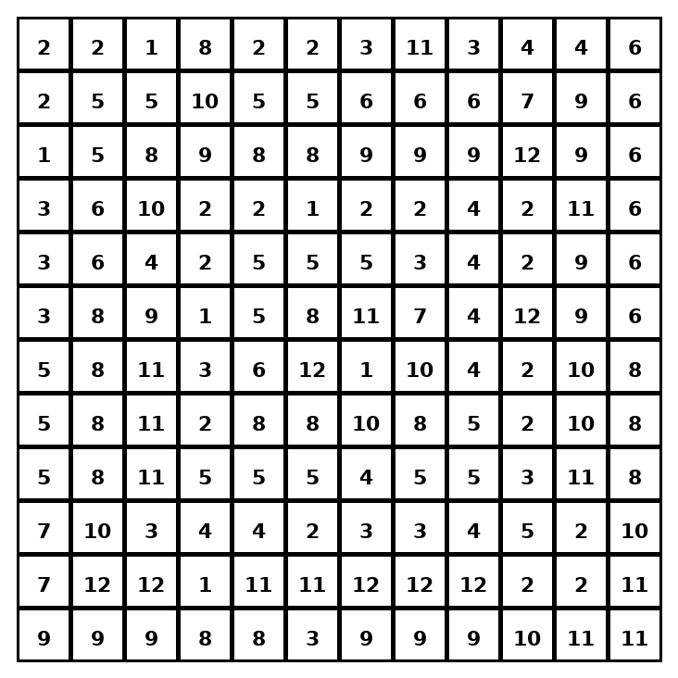

Early finisher writing: Choose one problem and explain your thinking in one complete sentence: Because ___, I ___.
____________________________________________________________________________________________

Teacher Answer Key
# | Answer | Color | Teacher Tip
1 | 2 x 2 x 2 x 2 x 3 | red | Use a factor tree until every branch ends in a prime number.
2 | 2 x 3 x 3 x 3 | orange | Use a factor tree until every branch ends in a prime number.
3 | 2 x 2 x 3 x 5 | yellow | Use a factor tree until every branch ends in a prime number.
4 | 3 x 5 x 5 | green | Use a factor tree until every branch ends in a prime number.
5 | 2 x 2 x 2 x 2 x 5 | blue | Use a factor tree until every branch ends in a prime number.
6 | 2 x 3 x 3 x 5 | purple | Use a factor tree until every branch ends in a prime number.
7 | 2 x 2 x 2 x 2 x 2 x 3 | pink | Use a factor tree until every branch ends in a prime number.
8 | 2 x 2 x 3 x 3 x 3 | brown | Use a factor tree until every branch ends in a prime number.
9 | 2 x 2 x 2 x 3 x 5 | gray | Use a factor tree until every branch ends in a prime number.
10 | 2 x 3 x 3 x 7 | teal | Use a factor tree until every branch ends in a prime number.
11 | 2 x 3 x 5 x 5 | black | Use a factor tree until every branch ends in a prime number.
12 | 2 x 2 x 3 x 3 x 5 | light blue | Use a factor tree until every branch ends in a prime number.

Use note: This file is original practice aligned to the lesson skill. It is designed for low-prep review, centers, sub plans, or early finishers.

