1-2 Greatest Common Factor
Number System Launch | Standard: 6.NS.4 | Color-by-Number Practice

Learning Goal: I can find the greatest common factor (GCF) of two numbers by listing or comparing their factors. | Directions: Solve each problem. Match each answer to the Color Code. On the next page, color every box with that problem number using the matching color.

Vocabulary: factor, common factor, greatest common factor | Explain one: I solved problem ___ by ___. Because ___, my answer is ___.

Solve First
1. Find the GCF of 18 and 24.  Work: ________________________________________  Answer: ________________ | 2. Find the GCF of 20 and 35.  Work: ________________________________________  Answer: ________________
3. Find the GCF of 28 and 42.  Work: ________________________________________  Answer: ________________ | 4. Find the GCF of 32 and 48.  Work: ________________________________________  Answer: ________________
5. Find the GCF of 45 and 60.  Work: ________________________________________  Answer: ________________ | 6. Find the GCF of 36 and 54.  Work: ________________________________________  Answer: ________________
7. Find the GCF of 27 and 45.  Work: ________________________________________  Answer: ________________ | 8. Find the GCF of 40 and 56.  Work: ________________________________________  Answer: ________________
9. Find the GCF of 50 and 75.  Work: ________________________________________  Answer: ________________ | 10. Find the GCF of 63 and 84.  Work: ________________________________________  Answer: ________________
11. Find the GCF of 72 and 96.  Work: ________________________________________  Answer: ________________ | 12. Find the GCF of 81 and 108.  Work: ________________________________________  Answer: ________________

Quick check: Before coloring, make sure every answer appears in the Color Code on the next page.

1-2 Mystery Picture: Mission Patch Mosaic
Solve a problem, match the answer to a color, then color every box with that problem number.
Color Code | Color Code | Color Code | Color Code
6 = red | 5 = orange | 14 = yellow | 16 = green
15 = blue | 18 = purple | 9 = pink | 8 = brown
25 = gray | 21 = teal | 24 = black | 27 = light blue

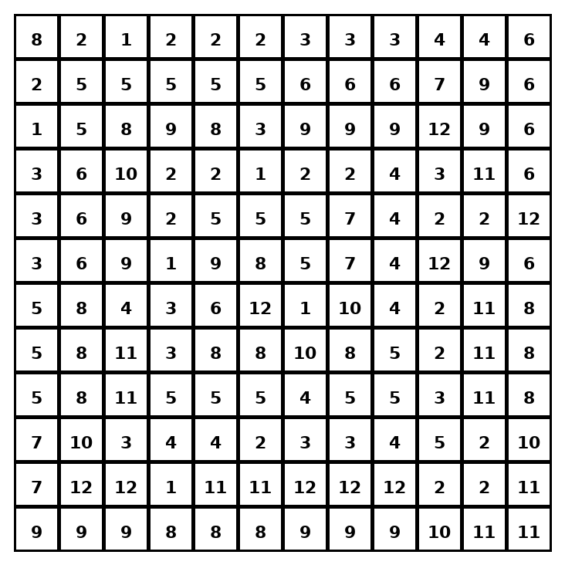

Early finisher writing: Choose one problem and explain your thinking in one complete sentence: Because ___, I ___.
____________________________________________________________________________________________

Teacher Answer Key
# | Answer | Color | Teacher Tip
1 | 6 | red | List factors or compare prime factors.
2 | 5 | orange | List factors or compare prime factors.
3 | 14 | yellow | List factors or compare prime factors.
4 | 16 | green | List factors or compare prime factors.
5 | 15 | blue | List factors or compare prime factors.
6 | 18 | purple | List factors or compare prime factors.
7 | 9 | pink | List factors or compare prime factors.
8 | 8 | brown | List factors or compare prime factors.
9 | 25 | gray | List factors or compare prime factors.
10 | 21 | teal | List factors or compare prime factors.
11 | 24 | black | List factors or compare prime factors.
12 | 27 | light blue | List factors or compare prime factors.

Use note: This file is original practice aligned to the lesson skill. It is designed for low-prep review, centers, sub plans, or early finishers.

