1-3 Least Common Multiple
Number System Launch | Standard: 6.NS.4 | Color-by-Number Practice

Learning Goal: I can find the least common multiple (LCM) of two numbers by listing or comparing their multiples. | Directions: Solve each problem. Match each answer to the Color Code. On the next page, color every box with that problem number using the matching color.

Vocabulary: multiple, common multiple, least common multiple | Explain one: I solved problem ___ by ___. Because ___, my answer is ___.

Solve First
1. Find the LCM of 3 and 4.  Work: ________________________________________  Answer: ________________ | 2. Find the LCM of 4 and 6.  Work: ________________________________________  Answer: ________________
3. Find the LCM of 5 and 8.  Work: ________________________________________  Answer: ________________ | 4. Find the LCM of 6 and 9.  Work: ________________________________________  Answer: ________________
5. Find the LCM of 8 and 10.  Work: ________________________________________  Answer: ________________ | 6. Find the LCM of 7 and 12.  Work: ________________________________________  Answer: ________________
7. Find the LCM of 9 and 12.  Work: ________________________________________  Answer: ________________ | 8. Find the LCM of 10 and 15.  Work: ________________________________________  Answer: ________________
9. Find the LCM of 12 and 15.  Work: ________________________________________  Answer: ________________ | 10. Find the LCM of 8 and 14.  Work: ________________________________________  Answer: ________________
11. Find the LCM of 6 and 16.  Work: ________________________________________  Answer: ________________ | 12. Find the LCM of 9 and 15.  Work: ________________________________________  Answer: ________________

Quick check: Before coloring, make sure every answer appears in the Color Code on the next page.

1-3 Mystery Picture: Mission Patch Mosaic
Solve a problem, match the answer to a color, then color every box with that problem number.
Color Code | Color Code | Color Code | Color Code
12 = red | 40 = orange | 18 = yellow | 84 = green
36 = blue | 30 = purple | 60 = pink | 56 = brown
48 = gray | 45 = teal

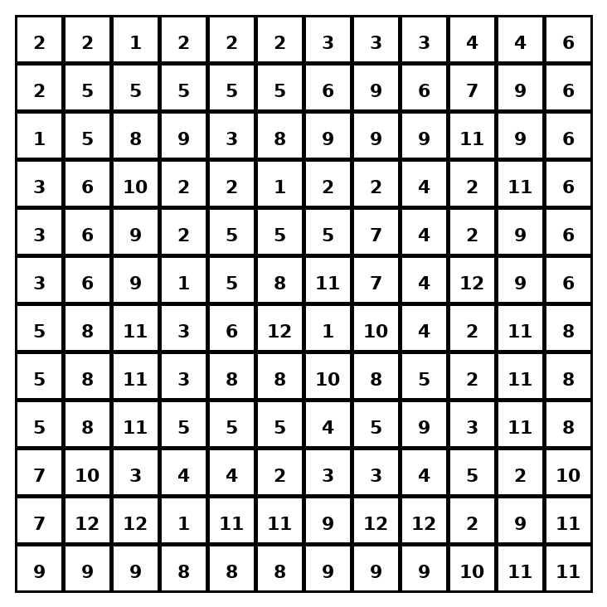

Early finisher writing: Choose one problem and explain your thinking in one complete sentence: Because ___, I ___.
____________________________________________________________________________________________

Teacher Answer Key
# | Answer | Color | Teacher Tip
1 | 12 | red | List multiples until both numbers share one.
2 | 12 | red | List multiples until both numbers share one.
3 | 40 | orange | List multiples until both numbers share one.
4 | 18 | yellow | List multiples until both numbers share one.
5 | 40 | orange | List multiples until both numbers share one.
6 | 84 | green | List multiples until both numbers share one.
7 | 36 | blue | List multiples until both numbers share one.
8 | 30 | purple | List multiples until both numbers share one.
9 | 60 | pink | List multiples until both numbers share one.
10 | 56 | brown | List multiples until both numbers share one.
11 | 48 | gray | List multiples until both numbers share one.
12 | 45 | teal | List multiples until both numbers share one.

Use note: This file is original practice aligned to the lesson skill. It is designed for low-prep review, centers, sub plans, or early finishers.

