1-4 Divide Multi-Digit Numbers
Number System Launch | Standard: 6.NS.2 | Color-by-Number Practice

Learning Goal: I can divide multi-digit whole numbers and explain the meaning of the quotient and remainder. | Directions: Solve each problem. Match each answer to the Color Code. On the next page, color every box with that problem number using the matching color.

Vocabulary: dividend, divisor, quotient, remainder | Explain one: I solved problem ___ by ___. Because ___, my answer is ___.

Solve First
1. 69 ÷ 3 =  Work: ________________________________________  Answer: ________________ | 2. 136 ÷ 4 =  Work: ________________________________________  Answer: ________________
3. 225 ÷ 5 =  Work: ________________________________________  Answer: ________________ | 4. 336 ÷ 6 =  Work: ________________________________________  Answer: ________________
5. 469 ÷ 7 =  Work: ________________________________________  Answer: ________________ | 6. 624 ÷ 8 =  Work: ________________________________________  Answer: ________________
7. 801 ÷ 9 =  Work: ________________________________________  Answer: ________________ | 8. 1152 ÷ 12 =  Work: ________________________________________  Answer: ________________
9. 648 ÷ 6 =  Work: ________________________________________  Answer: ________________ | 10. 625 ÷ 5 =  Work: ________________________________________  Answer: ________________
11. 1152 ÷ 8 =  Work: ________________________________________  Answer: ________________ | 12. 1872 ÷ 12 =  Work: ________________________________________  Answer: ________________

Quick check: Before coloring, make sure every answer appears in the Color Code on the next page.

1-4 Mystery Picture: Mission Patch Mosaic
Solve a problem, match the answer to a color, then color every box with that problem number.
Color Code | Color Code | Color Code | Color Code
23 = red | 34 = orange | 45 = yellow | 56 = green
67 = blue | 78 = purple | 89 = pink | 96 = brown
108 = gray | 125 = teal | 144 = black | 156 = light blue

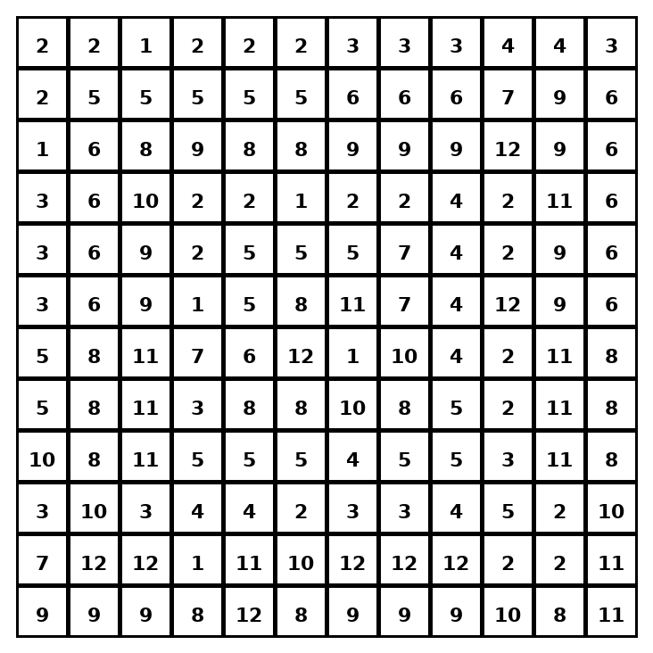

Early finisher writing: Choose one problem and explain your thinking in one complete sentence: Because ___, I ___.
____________________________________________________________________________________________

Teacher Answer Key
# | Answer | Color | Teacher Tip
1 | 23 | red | Use long division or fact families.
2 | 34 | orange | Use long division or fact families.
3 | 45 | yellow | Use long division or fact families.
4 | 56 | green | Use long division or fact families.
5 | 67 | blue | Use long division or fact families.
6 | 78 | purple | Use long division or fact families.
7 | 89 | pink | Use long division or fact families.
8 | 96 | brown | Use long division or fact families.
9 | 108 | gray | Use long division or fact families.
10 | 125 | teal | Use long division or fact families.
11 | 144 | black | Use long division or fact families.
12 | 156 | light blue | Use long division or fact families.

Use note: This file is original practice aligned to the lesson skill. It is designed for low-prep review, centers, sub plans, or early finishers.

