1-5 Add and Subtract Decimals
Number System Launch | Standard: 6.NS.3 | Color-by-Number Practice

Learning Goal: I can add and subtract decimals by lining up the place values and the decimal points. | Directions: Solve each problem. Match each answer to the Color Code. On the next page, color every box with that problem number using the matching color.

Vocabulary: decimal point, place value, sum, difference | Explain one: I solved problem ___ by ___. Because ___, my answer is ___.

Solve First
1. 3.4 + 2.15 =  Work: ________________________________________  Answer: ________________ | 2. 8.75 + 1.6 =  Work: ________________________________________  Answer: ________________
3. 12.5 + 3.48 =  Work: ________________________________________  Answer: ________________ | 4. 9.2 - 4.37 =  Work: ________________________________________  Answer: ________________
5. 15.75 - 6.5 =  Work: ________________________________________  Answer: ________________ | 6. 2.06 + 1.35 =  Work: ________________________________________  Answer: ________________
7. 10 - 4.28 =  Work: ________________________________________  Answer: ________________ | 8. 6.8 + 2.75 =  Work: ________________________________________  Answer: ________________
9. 11.11 + 2.22 =  Work: ________________________________________  Answer: ________________ | 10. 7.5 - 3.06 =  Work: ________________________________________  Answer: ________________
11. 0.84 + 0.39 =  Work: ________________________________________  Answer: ________________ | 12. 20.25 - 8.7 =  Work: ________________________________________  Answer: ________________

Quick check: Before coloring, make sure every answer appears in the Color Code on the next page.

1-5 Mystery Picture: Mission Patch Mosaic
Solve a problem, match the answer to a color, then color every box with that problem number.
Color Code | Color Code | Color Code | Color Code
5.55 = red | 10.35 = orange | 15.98 = yellow | 4.83 = green
9.25 = blue | 3.41 = purple | 5.72 = pink | 9.55 = brown
13.33 = gray | 4.44 = teal | 1.23 = black | 11.55 = light blue

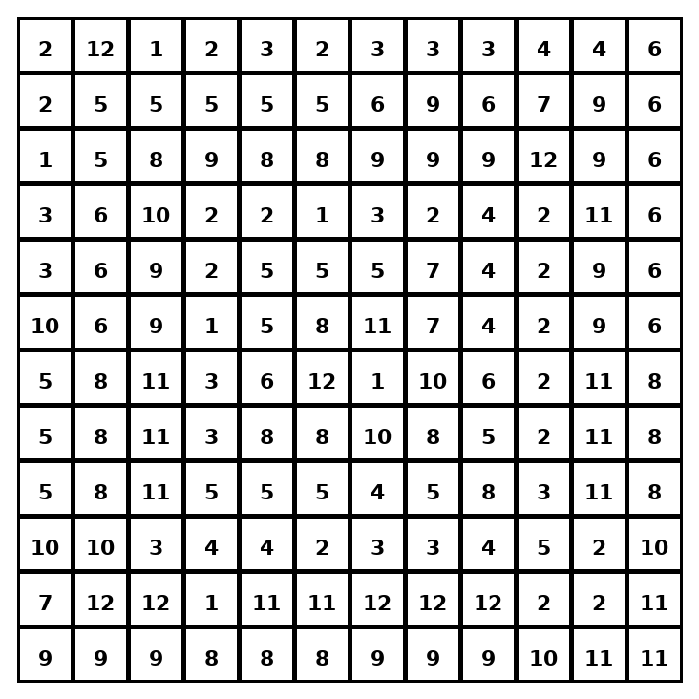

Early finisher writing: Choose one problem and explain your thinking in one complete sentence: Because ___, I ___.
____________________________________________________________________________________________

Teacher Answer Key
# | Answer | Color | Teacher Tip
1 | 5.55 | red | Line up decimal points before adding or subtracting.
2 | 10.35 | orange | Line up decimal points before adding or subtracting.
3 | 15.98 | yellow | Line up decimal points before adding or subtracting.
4 | 4.83 | green | Line up decimal points before adding or subtracting.
5 | 9.25 | blue | Line up decimal points before adding or subtracting.
6 | 3.41 | purple | Line up decimal points before adding or subtracting.
7 | 5.72 | pink | Line up decimal points before adding or subtracting.
8 | 9.55 | brown | Line up decimal points before adding or subtracting.
9 | 13.33 | gray | Line up decimal points before adding or subtracting.
10 | 4.44 | teal | Line up decimal points before adding or subtracting.
11 | 1.23 | black | Line up decimal points before adding or subtracting.
12 | 11.55 | light blue | Line up decimal points before adding or subtracting.

Use note: This file is original practice aligned to the lesson skill. It is designed for low-prep review, centers, sub plans, or early finishers.

