1-6 Multiply Decimals
Number System Launch | Standard: 6.NS.3 | Color-by-Number Practice

Learning Goal: I can multiply decimals and place the decimal point correctly in the product. | Directions: Solve each problem. Match each answer to the Color Code. On the next page, color every box with that problem number using the matching color.

Vocabulary: factor, product, decimal point | Explain one: I solved problem ___ by ___. Because ___, my answer is ___.

Solve First
1. 1.2 x 3 =  Work: ________________________________________  Answer: ________________ | 2. 2.5 x 4 =  Work: ________________________________________  Answer: ________________
3. 0.6 x 7 =  Work: ________________________________________  Answer: ________________ | 4. 1.5 x 6 =  Work: ________________________________________  Answer: ________________
5. 2.4 x 3 =  Work: ________________________________________  Answer: ________________ | 6. 0.8 x 9 =  Work: ________________________________________  Answer: ________________
7. 3.2 x 5 =  Work: ________________________________________  Answer: ________________ | 8. 1.25 x 4 =  Work: ________________________________________  Answer: ________________
9. 0.45 x 6 =  Work: ________________________________________  Answer: ________________ | 10. 2.75 x 2 =  Work: ________________________________________  Answer: ________________
11. 3.5 x 1.2 =  Work: ________________________________________  Answer: ________________ | 12. 0.9 x 0.7 =  Work: ________________________________________  Answer: ________________

Quick check: Before coloring, make sure every answer appears in the Color Code on the next page.

1-6 Mystery Picture: Mission Patch Mosaic
Solve a problem, match the answer to a color, then color every box with that problem number.
Color Code | Color Code | Color Code | Color Code
3.6 = red | 10 = orange | 4.2 = yellow | 9 = green
7.2 = blue | 16 = purple | 5 = pink | 2.7 = brown
5.5 = gray | 0.63 = teal

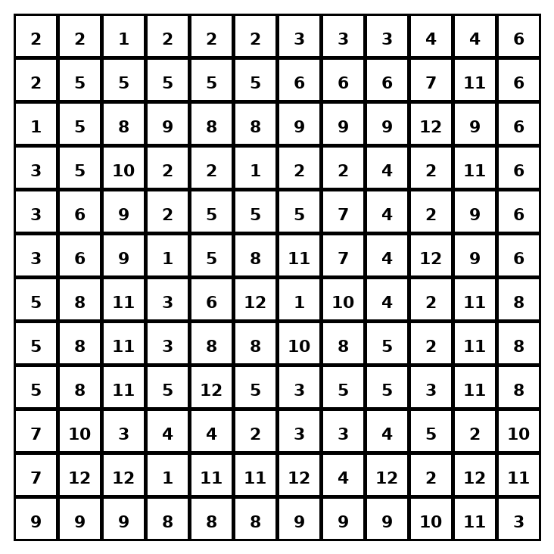

Early finisher writing: Choose one problem and explain your thinking in one complete sentence: Because ___, I ___.
____________________________________________________________________________________________

Teacher Answer Key
# | Answer | Color | Teacher Tip
1 | 3.6 | red | Multiply first, then place the decimal point.
2 | 10 | orange | Multiply first, then place the decimal point.
3 | 4.2 | yellow | Multiply first, then place the decimal point.
4 | 9 | green | Multiply first, then place the decimal point.
5 | 7.2 | blue | Multiply first, then place the decimal point.
6 | 7.2 | blue | Multiply first, then place the decimal point.
7 | 16 | purple | Multiply first, then place the decimal point.
8 | 5 | pink | Multiply first, then place the decimal point.
9 | 2.7 | brown | Multiply first, then place the decimal point.
10 | 5.5 | gray | Multiply first, then place the decimal point.
11 | 4.2 | yellow | Multiply first, then place the decimal point.
12 | 0.63 | teal | Multiply first, then place the decimal point.

Use note: This file is original practice aligned to the lesson skill. It is designed for low-prep review, centers, sub plans, or early finishers.

