1-7 Divide Decimals
Number System Launch | Standard: 6.NS.3 | Color-by-Number Practice

Learning Goal: I can divide with decimals by making the divisor a whole number first. | Directions: Solve each problem. Match each answer to the Color Code. On the next page, color every box with that problem number using the matching color.

Vocabulary: dividend, divisor, quotient, decimal point | Explain one: I solved problem ___ by ___. Because ___, my answer is ___.

Solve First
1. 6.4 ÷ 2 =  Work: ________________________________________  Answer: ________________ | 2. 9.6 ÷ 3 =  Work: ________________________________________  Answer: ________________
3. 12.5 ÷ 5 =  Work: ________________________________________  Answer: ________________ | 4. 7.2 ÷ 0.9 =  Work: ________________________________________  Answer: ________________
5. 4.8 ÷ 0.6 =  Work: ________________________________________  Answer: ________________ | 6. 15 ÷ 1.5 =  Work: ________________________________________  Answer: ________________
7. 8.4 ÷ 0.7 =  Work: ________________________________________  Answer: ________________ | 8. 3.6 ÷ 0.4 =  Work: ________________________________________  Answer: ________________
9. 18.9 ÷ 3 =  Work: ________________________________________  Answer: ________________ | 10. 5.6 ÷ 0.8 =  Work: ________________________________________  Answer: ________________
11. 14.4 ÷ 1.2 =  Work: ________________________________________  Answer: ________________ | 12. 2.7 ÷ 0.3 =  Work: ________________________________________  Answer: ________________

Quick check: Before coloring, make sure every answer appears in the Color Code on the next page.

1-7 Mystery Picture: Mission Patch Mosaic
Solve a problem, match the answer to a color, then color every box with that problem number.
Color Code | Color Code | Color Code | Color Code
3.2 = red | 2.5 = orange | 8 = yellow | 10 = green
12 = blue | 9 = purple | 6.3 = pink | 7 = brown

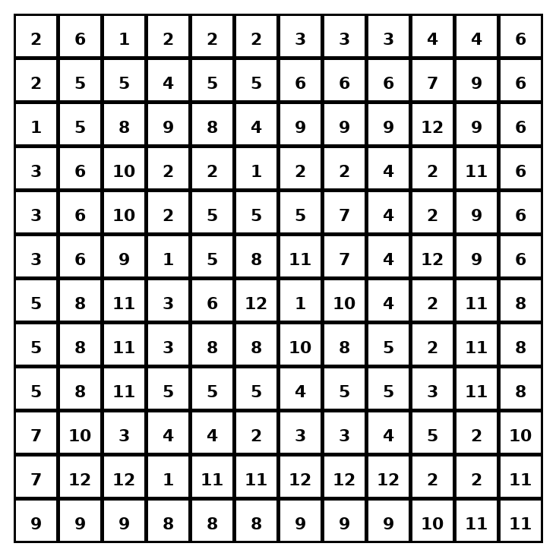

Early finisher writing: Choose one problem and explain your thinking in one complete sentence: Because ___, I ___.
____________________________________________________________________________________________

Teacher Answer Key
# | Answer | Color | Teacher Tip
1 | 3.2 | red | Make the divisor a whole number if needed.
2 | 3.2 | red | Make the divisor a whole number if needed.
3 | 2.5 | orange | Make the divisor a whole number if needed.
4 | 8 | yellow | Make the divisor a whole number if needed.
5 | 8 | yellow | Make the divisor a whole number if needed.
6 | 10 | green | Make the divisor a whole number if needed.
7 | 12 | blue | Make the divisor a whole number if needed.
8 | 9 | purple | Make the divisor a whole number if needed.
9 | 6.3 | pink | Make the divisor a whole number if needed.
10 | 7 | brown | Make the divisor a whole number if needed.
11 | 12 | blue | Make the divisor a whole number if needed.
12 | 9 | purple | Make the divisor a whole number if needed.

Use note: This file is original practice aligned to the lesson skill. It is designed for low-prep review, centers, sub plans, or early finishers.

