10-1-flagship Volume with Whole Number Edges Flagship
Time Capsule Engineers | Standard: 6.G.2 | Color-by-Number Practice

Learning Goal: I can find the volume of a rectangular prism with whole-number edges using length x width x height. | Directions: Solve each problem. Match each answer to the Color Code. On the next page, color every box with that problem number using the matching color.

Vocabulary: volume, length, width, height | Explain one: I solved problem ___ by ___. Because ___, my answer is ___.

Solve First
1. Find the volume of a rectangular prism with l=6, w=8, h=10.  Work: ________________________________________  Answer: ________________ | 2. Find the volume of a rectangular prism with l=5, w=9, h=12.  Work: ________________________________________  Answer: ________________
3. Find the volume of a rectangular prism with l=7, w=7, h=11.  Work: ________________________________________  Answer: ________________ | 4. Find the volume of a rectangular prism with l=8, w=9, h=4.  Work: ________________________________________  Answer: ________________
5. Find the volume of a rectangular prism with l=10, w=10, h=6.  Work: ________________________________________  Answer: ________________ | 6. Find the volume of a rectangular prism with l=12, w=5, h=7.  Work: ________________________________________  Answer: ________________
7. Find the volume of a rectangular prism with l=15, w=4, h=6.  Work: ________________________________________  Answer: ________________ | 8. Find the volume of a rectangular prism with l=9, w=11, h=3.  Work: ________________________________________  Answer: ________________
9. Find the volume of a rectangular prism with l=14, w=6, h=5.  Work: ________________________________________  Answer: ________________ | 10. Find the volume of a rectangular prism with l=16, w=3, h=8.  Work: ________________________________________  Answer: ________________
11. Find the volume of a rectangular prism with l=18, w=5, h=4.  Work: ________________________________________  Answer: ________________ | 12. Find the volume of a rectangular prism with l=20, w=6, h=3.  Work: ________________________________________  Answer: ________________

Quick check: Before coloring, make sure every answer appears in the Color Code on the next page.

10-1-flagship Mystery Picture: Engineering Tile Mosaic
Solve a problem, match the answer to a color, then color every box with that problem number.
Color Code | Color Code | Color Code | Color Code
480 = red | 540 = orange | 539 = yellow | 288 = green
600 = blue | 420 = purple | 360 = pink | 297 = brown
384 = gray

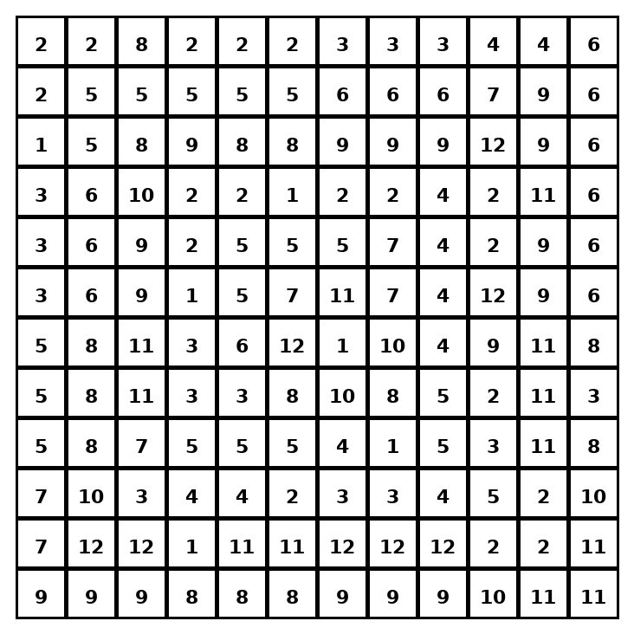

Early finisher writing: Choose one problem and explain your thinking in one complete sentence: Because ___, I ___.
____________________________________________________________________________________________

Teacher Answer Key
# | Answer | Color | Teacher Tip
1 | 480 | red | V = length x width x height.
2 | 540 | orange | V = length x width x height.
3 | 539 | yellow | V = length x width x height.
4 | 288 | green | V = length x width x height.
5 | 600 | blue | V = length x width x height.
6 | 420 | purple | V = length x width x height.
7 | 360 | pink | V = length x width x height.
8 | 297 | brown | V = length x width x height.
9 | 420 | purple | V = length x width x height.
10 | 384 | gray | V = length x width x height.
11 | 360 | pink | V = length x width x height.
12 | 360 | pink | V = length x width x height.

Use note: This file is original practice aligned to the lesson skill. It is designed for low-prep review, centers, sub plans, or early finishers.

