10-1 Volume with Whole Number Edges
Time Capsule Engineers | Standard: 6.G.2 | Color-by-Number Practice

Learning Goal: I can find the volume of a rectangular prism with whole-number edges using length x width x height. | Directions: Solve each problem. Match each answer to the Color Code. On the next page, color every box with that problem number using the matching color.

Vocabulary: volume, length, width, height | Explain one: I solved problem ___ by ___. Because ___, my answer is ___.

Solve First
1. Find the volume of a rectangular prism with l=3, w=4, h=5.  Work: ________________________________________  Answer: ________________ | 2. Find the volume of a rectangular prism with l=2, w=6, h=7.  Work: ________________________________________  Answer: ________________
3. Find the volume of a rectangular prism with l=4, w=5, h=6.  Work: ________________________________________  Answer: ________________ | 4. Find the volume of a rectangular prism with l=5, w=5, h=5.  Work: ________________________________________  Answer: ________________
5. Find the volume of a rectangular prism with l=3, w=8, h=4.  Work: ________________________________________  Answer: ________________ | 6. Find the volume of a rectangular prism with l=6, w=7, h=2.  Work: ________________________________________  Answer: ________________
7. Find the volume of a rectangular prism with l=9, w=3, h=4.  Work: ________________________________________  Answer: ________________ | 8. Find the volume of a rectangular prism with l=10, w=2, h=5.  Work: ________________________________________  Answer: ________________
9. Find the volume of a rectangular prism with l=8, w=4, h=6.  Work: ________________________________________  Answer: ________________ | 10. Find the volume of a rectangular prism with l=7, w=5, h=3.  Work: ________________________________________  Answer: ________________
11. Find the volume of a rectangular prism with l=12, w=3, h=2.  Work: ________________________________________  Answer: ________________ | 12. Find the volume of a rectangular prism with l=11, w=4, h=5.  Work: ________________________________________  Answer: ________________

Quick check: Before coloring, make sure every answer appears in the Color Code on the next page.

10-1 Mystery Picture: Engineering Tile Mosaic
Solve a problem, match the answer to a color, then color every box with that problem number.
Color Code | Color Code | Color Code | Color Code
60 = red | 84 = orange | 120 = yellow | 125 = green
96 = blue | 108 = purple | 100 = pink | 192 = brown
105 = gray | 72 = teal | 220 = black

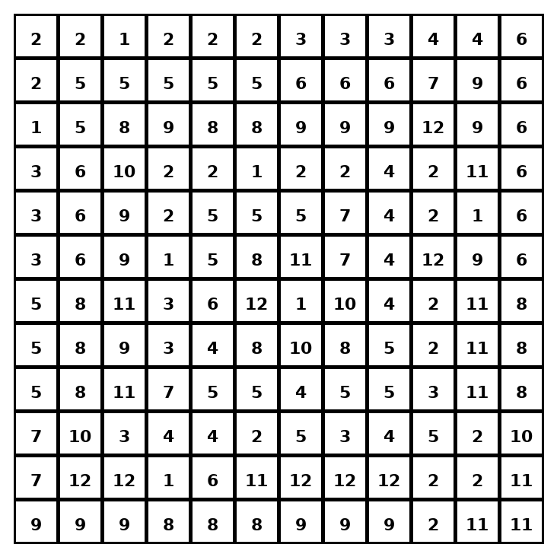

Early finisher writing: Choose one problem and explain your thinking in one complete sentence: Because ___, I ___.
____________________________________________________________________________________________

Teacher Answer Key
# | Answer | Color | Teacher Tip
1 | 60 | red | V = length x width x height.
2 | 84 | orange | V = length x width x height.
3 | 120 | yellow | V = length x width x height.
4 | 125 | green | V = length x width x height.
5 | 96 | blue | V = length x width x height.
6 | 84 | orange | V = length x width x height.
7 | 108 | purple | V = length x width x height.
8 | 100 | pink | V = length x width x height.
9 | 192 | brown | V = length x width x height.
10 | 105 | gray | V = length x width x height.
11 | 72 | teal | V = length x width x height.
12 | 220 | black | V = length x width x height.

Use note: This file is original practice aligned to the lesson skill. It is designed for low-prep review, centers, sub plans, or early finishers.

