10-2 Volume of Rectangular Prisms
Time Capsule Engineers | Standard: 6.G.2 | Color-by-Number Practice

Learning Goal: I can find the volume of a rectangular prism, including ones with fractional edge lengths, using base area x height. | Directions: Solve each problem. Match each answer to the Color Code. On the next page, color every box with that problem number using the matching color.

Vocabulary: volume, base area, height | Explain one: I solved problem ___ by ___. Because ___, my answer is ___.

Solve First
1. Find volume: l=1 1/2, w=4, h=5.  Work: ________________________________________  Answer: ________________ | 2. Find volume: l=2 1/2, w=2, h=6.  Work: ________________________________________  Answer: ________________
3. Find volume: l=3 1/2, w=3, h=4.  Work: ________________________________________  Answer: ________________ | 4. Find volume: l=4 1/2, w=2, h=5.  Work: ________________________________________  Answer: ________________
5. Find volume: l=3/4, w=8, h=6.  Work: ________________________________________  Answer: ________________ | 6. Find volume: l=1 1/4, w=4, h=8.  Work: ________________________________________  Answer: ________________
7. Find volume: l=1 3/4, w=8, h=2.  Work: ________________________________________  Answer: ________________ | 8. Find volume: l=2 1/4, w=4, h=4.  Work: ________________________________________  Answer: ________________
9. Find volume: l=2/3, w=6, h=9.  Work: ________________________________________  Answer: ________________ | 10. Find volume: l=1 1/3, w=3, h=6.  Work: ________________________________________  Answer: ________________
11. Find volume: l=1 2/3, w=6, h=3.  Work: ________________________________________  Answer: ________________ | 12. Find volume: l=2 1/3, w=3, h=9.  Work: ________________________________________  Answer: ________________

Quick check: Before coloring, make sure every answer appears in the Color Code on the next page.

10-2 Mystery Picture: Engineering Tile Mosaic
Solve a problem, match the answer to a color, then color every box with that problem number.
Color Code | Color Code | Color Code | Color Code
30 = red | 42 = orange | 45 = yellow | 36 = green
40 = blue | 28 = purple | 24 = pink | 63 = brown

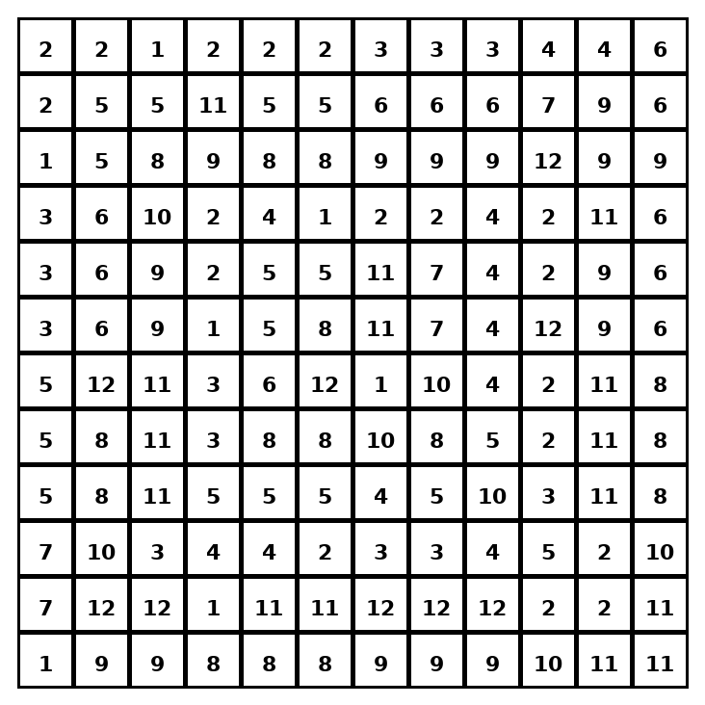

Early finisher writing: Choose one problem and explain your thinking in one complete sentence: Because ___, I ___.
____________________________________________________________________________________________

Teacher Answer Key
# | Answer | Color | Teacher Tip
1 | 30 | red | Multiply length x width x height.
2 | 30 | red | Multiply length x width x height.
3 | 42 | orange | Multiply length x width x height.
4 | 45 | yellow | Multiply length x width x height.
5 | 36 | green | Multiply length x width x height.
6 | 40 | blue | Multiply length x width x height.
7 | 28 | purple | Multiply length x width x height.
8 | 36 | green | Multiply length x width x height.
9 | 36 | green | Multiply length x width x height.
10 | 24 | pink | Multiply length x width x height.
11 | 30 | red | Multiply length x width x height.
12 | 63 | brown | Multiply length x width x height.

Use note: This file is original practice aligned to the lesson skill. It is designed for low-prep review, centers, sub plans, or early finishers.

