10-3 Surface Area Using Nets
Time Capsule Engineers | Standard: 6.G.4 | Color-by-Number Practice

Learning Goal: I can find the surface area of a solid by using its net. | Directions: Solve each problem. Match each answer to the Color Code. On the next page, color every box with that problem number using the matching color.

Vocabulary: net, face, surface area | Explain one: I solved problem ___ by ___. Because ___, my answer is ___.

Solve First
1. A net makes a rectangular prism with l=2, w=3, h=4. Find surface area.  Work: ________________________________________  Answer: ________________ | 2. A net makes a rectangular prism with l=3, w=4, h=5. Find surface area.  Work: ________________________________________  Answer: ________________
3. A net makes a rectangular prism with l=2, w=5, h=6. Find surface area.  Work: ________________________________________  Answer: ________________ | 4. A net makes a rectangular prism with l=4, w=4, h=7. Find surface area.  Work: ________________________________________  Answer: ________________
5. A net makes a rectangular prism with l=3, w=6, h=2. Find surface area.  Work: ________________________________________  Answer: ________________ | 6. A net makes a rectangular prism with l=5, w=5, h=3. Find surface area.  Work: ________________________________________  Answer: ________________
7. A net makes a rectangular prism with l=6, w=2, h=8. Find surface area.  Work: ________________________________________  Answer: ________________ | 8. A net makes a rectangular prism with l=7, w=3, h=4. Find surface area.  Work: ________________________________________  Answer: ________________
9. A net makes a rectangular prism with l=8, w=2, h=5. Find surface area.  Work: ________________________________________  Answer: ________________ | 10. A net makes a rectangular prism with l=9, w=3, h=2. Find surface area.  Work: ________________________________________  Answer: ________________
11. A net makes a rectangular prism with l=10, w=4, h=3. Find surface area.  Work: ________________________________________  Answer: ________________ | 12. A net makes a rectangular prism with l=6, w=5, h=4. Find surface area.  Work: ________________________________________  Answer: ________________

Quick check: Before coloring, make sure every answer appears in the Color Code on the next page.

10-3 Mystery Picture: Engineering Tile Mosaic
Solve a problem, match the answer to a color, then color every box with that problem number.
Color Code | Color Code | Color Code | Color Code
52 = red | 94 = orange | 104 = yellow | 144 = green
72 = blue | 110 = purple | 152 = pink | 122 = brown
132 = gray | 102 = teal | 164 = black | 148 = light blue

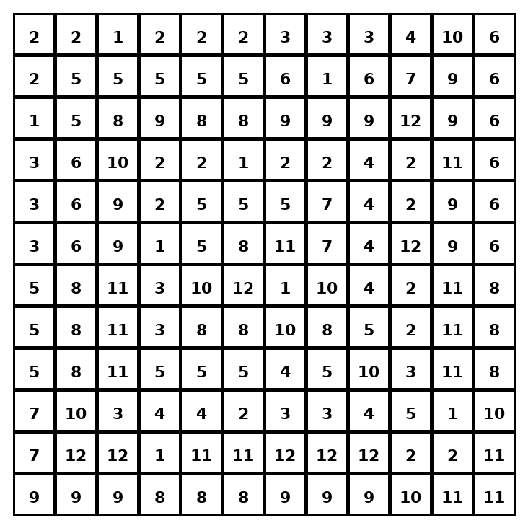

Early finisher writing: Choose one problem and explain your thinking in one complete sentence: Because ___, I ___.
____________________________________________________________________________________________

Teacher Answer Key
# | Answer | Color | Teacher Tip
1 | 52 | red | Add the areas of all 6 faces.
2 | 94 | orange | Add the areas of all 6 faces.
3 | 104 | yellow | Add the areas of all 6 faces.
4 | 144 | green | Add the areas of all 6 faces.
5 | 72 | blue | Add the areas of all 6 faces.
6 | 110 | purple | Add the areas of all 6 faces.
7 | 152 | pink | Add the areas of all 6 faces.
8 | 122 | brown | Add the areas of all 6 faces.
9 | 132 | gray | Add the areas of all 6 faces.
10 | 102 | teal | Add the areas of all 6 faces.
11 | 164 | black | Add the areas of all 6 faces.
12 | 148 | light blue | Add the areas of all 6 faces.

Use note: This file is original practice aligned to the lesson skill. It is designed for low-prep review, centers, sub plans, or early finishers.

