10-4 Surface Area of Prisms
Time Capsule Engineers | Standard: 6.G.4 | Color-by-Number Practice

Learning Goal: I can find the surface area of rectangular and triangular prisms. | Directions: Solve each problem. Match each answer to the Color Code. On the next page, color every box with that problem number using the matching color.

Vocabulary: surface area, prism, face | Explain one: I solved problem ___ by ___. Because ___, my answer is ___.

Solve First
1. Find surface area of a rectangular prism with l=2, w=3, h=4.  Work: ________________________________________  Answer: ________________ | 2. Find surface area of a rectangular prism with l=3, w=5, h=6.  Work: ________________________________________  Answer: ________________
3. Find surface area of a rectangular prism with l=4, w=6, h=2.  Work: ________________________________________  Answer: ________________ | 4. Find surface area of a rectangular prism with l=5, w=5, h=5.  Work: ________________________________________  Answer: ________________
5. Find surface area of a rectangular prism with l=6, w=3, h=7.  Work: ________________________________________  Answer: ________________ | 6. Find surface area of a rectangular prism with l=7, w=2, h=8.  Work: ________________________________________  Answer: ________________
7. Find surface area of a rectangular prism with l=8, w=4, h=3.  Work: ________________________________________  Answer: ________________ | 8. Find surface area of a rectangular prism with l=9, w=3, h=4.  Work: ________________________________________  Answer: ________________
9. Find surface area of a rectangular prism with l=10, w=2, h=5.  Work: ________________________________________  Answer: ________________ | 10. Find surface area of a rectangular prism with l=6, w=6, h=2.  Work: ________________________________________  Answer: ________________
11. Find surface area of a rectangular prism with l=4, w=7, h=5.  Work: ________________________________________  Answer: ________________ | 12. Find surface area of a rectangular prism with l=5, w=8, h=3.  Work: ________________________________________  Answer: ________________

Quick check: Before coloring, make sure every answer appears in the Color Code on the next page.

10-4 Mystery Picture: Engineering Tile Mosaic
Solve a problem, match the answer to a color, then color every box with that problem number.
Color Code | Color Code | Color Code | Color Code
52 = red | 126 = orange | 88 = yellow | 150 = green
162 = blue | 172 = purple | 136 = pink | 160 = brown
120 = gray | 166 = teal | 158 = black

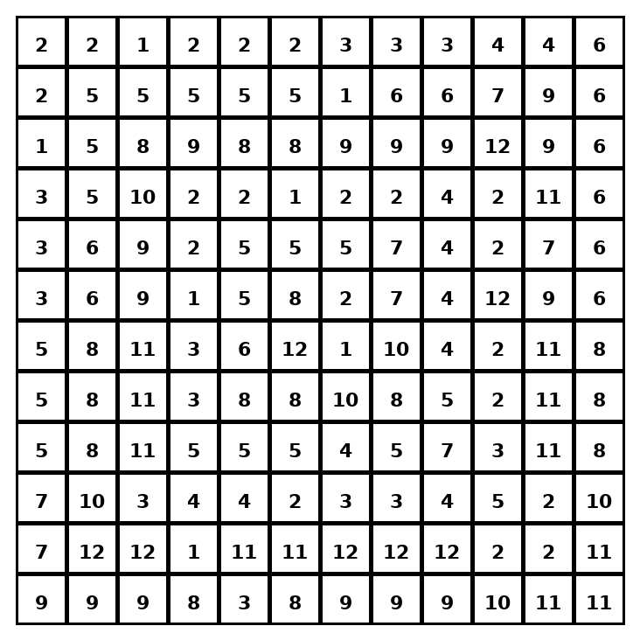

Early finisher writing: Choose one problem and explain your thinking in one complete sentence: Because ___, I ___.
____________________________________________________________________________________________

Teacher Answer Key
# | Answer | Color | Teacher Tip
1 | 52 | red | SA = 2lw + 2lh + 2wh.
2 | 126 | orange | SA = 2lw + 2lh + 2wh.
3 | 88 | yellow | SA = 2lw + 2lh + 2wh.
4 | 150 | green | SA = 2lw + 2lh + 2wh.
5 | 162 | blue | SA = 2lw + 2lh + 2wh.
6 | 172 | purple | SA = 2lw + 2lh + 2wh.
7 | 136 | pink | SA = 2lw + 2lh + 2wh.
8 | 150 | green | SA = 2lw + 2lh + 2wh.
9 | 160 | brown | SA = 2lw + 2lh + 2wh.
10 | 120 | gray | SA = 2lw + 2lh + 2wh.
11 | 166 | teal | SA = 2lw + 2lh + 2wh.
12 | 158 | black | SA = 2lw + 2lh + 2wh.

Use note: This file is original practice aligned to the lesson skill. It is designed for low-prep review, centers, sub plans, or early finishers.

