10-5 Surface Area of Pyramids
Time Capsule Engineers | Standard: 6.G.4 | Color-by-Number Practice

Learning Goal: I can find the surface area of a pyramid by adding the base area and the lateral faces. | Directions: Solve each problem. Match each answer to the Color Code. On the next page, color every box with that problem number using the matching color.

Vocabulary: pyramid, base, lateral face, slant height | Explain one: I solved problem ___ by ___. Because ___, my answer is ___.

Solve First
1. A square pyramid has base side 4 and slant height 3. Find surface area.  Work: ________________________________________  Answer: ________________ | 2. A square pyramid has base side 6 and slant height 4. Find surface area.  Work: ________________________________________  Answer: ________________
3. A square pyramid has base side 8 and slant height 5. Find surface area.  Work: ________________________________________  Answer: ________________ | 4. A square pyramid has base side 10 and slant height 6. Find surface area.  Work: ________________________________________  Answer: ________________
5. A square pyramid has base side 5 and slant height 4. Find surface area.  Work: ________________________________________  Answer: ________________ | 6. A square pyramid has base side 7 and slant height 6. Find surface area.  Work: ________________________________________  Answer: ________________
7. A square pyramid has base side 9 and slant height 8. Find surface area.  Work: ________________________________________  Answer: ________________ | 8. A square pyramid has base side 12 and slant height 5. Find surface area.  Work: ________________________________________  Answer: ________________
9. A square pyramid has base side 14 and slant height 7. Find surface area.  Work: ________________________________________  Answer: ________________ | 10. A square pyramid has base side 16 and slant height 6. Find surface area.  Work: ________________________________________  Answer: ________________
11. A square pyramid has base side 18 and slant height 8. Find surface area.  Work: ________________________________________  Answer: ________________ | 12. A square pyramid has base side 20 and slant height 9. Find surface area.  Work: ________________________________________  Answer: ________________

Quick check: Before coloring, make sure every answer appears in the Color Code on the next page.

10-5 Mystery Picture: Engineering Tile Mosaic
Solve a problem, match the answer to a color, then color every box with that problem number.
Color Code | Color Code | Color Code | Color Code
40 = red | 84 = orange | 144 = yellow | 220 = green
65 = blue | 133 = purple | 225 = pink | 264 = brown
392 = gray | 448 = teal | 612 = black | 760 = light blue

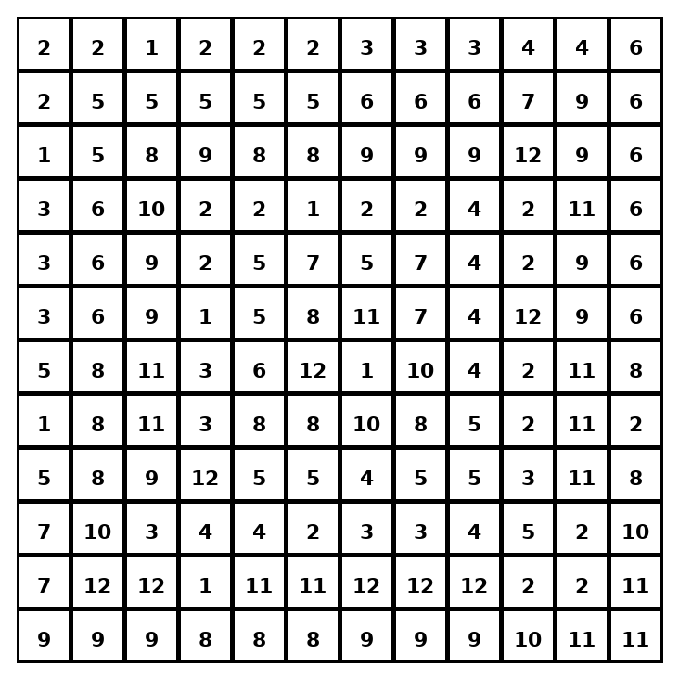

Early finisher writing: Choose one problem and explain your thinking in one complete sentence: Because ___, I ___.
____________________________________________________________________________________________

Teacher Answer Key
# | Answer | Color | Teacher Tip
1 | 40 | red | Add base area plus four triangular faces.
2 | 84 | orange | Add base area plus four triangular faces.
3 | 144 | yellow | Add base area plus four triangular faces.
4 | 220 | green | Add base area plus four triangular faces.
5 | 65 | blue | Add base area plus four triangular faces.
6 | 133 | purple | Add base area plus four triangular faces.
7 | 225 | pink | Add base area plus four triangular faces.
8 | 264 | brown | Add base area plus four triangular faces.
9 | 392 | gray | Add base area plus four triangular faces.
10 | 448 | teal | Add base area plus four triangular faces.
11 | 612 | black | Add base area plus four triangular faces.
12 | 760 | light blue | Add base area plus four triangular faces.

Use note: This file is original practice aligned to the lesson skill. It is designed for low-prep review, centers, sub plans, or early finishers.

