2-1-flagship Interpret Division of Fractions Flagship
Fraction Detective Agency | Standard: 6.NS.1 | Color-by-Number Practice

Learning Goal: I can use models to interpret what it means to divide by a fraction. | Directions: Solve each problem. Match each answer to the Color Code. On the next page, color every box with that problem number using the matching color.

Vocabulary: fraction, group size, quotient | Explain one: I solved problem ___ by ___. Because ___, my answer is ___.

Solve First
1. How many groups of 2/3 are in 4? Write 4 ÷ 2/3.  Work: ________________________________________  Answer: ________________ | 2. How many groups of 3/4 are in 6? Write 6 ÷ 3/4.  Work: ________________________________________  Answer: ________________
3. How many groups of 5/8 are in 5? Write 5 ÷ 5/8.  Work: ________________________________________  Answer: ________________ | 4. How many groups of 3/5 are in 9? Write 9 ÷ 3/5.  Work: ________________________________________  Answer: ________________
5. How many groups of 7/10 are in 7? Write 7 ÷ 7/10.  Work: ________________________________________  Answer: ________________ | 6. How many groups of 4/5 are in 8? Write 8 ÷ 4/5.  Work: ________________________________________  Answer: ________________
7. How many groups of 3/8 are in 3? Write 3 ÷ 3/8.  Work: ________________________________________  Answer: ________________ | 8. How many groups of 5/6 are in 10? Write 10 ÷ 5/6.  Work: ________________________________________  Answer: ________________
9. How many groups of 3/4 are in 12? Write 12 ÷ 3/4.  Work: ________________________________________  Answer: ________________ | 10. How many groups of 2/5 are in 6? Write 6 ÷ 2/5.  Work: ________________________________________  Answer: ________________
11. How many groups of 11/12 are in 11? Write 11 ÷ 11/12.  Work: ________________________________________  Answer: ________________ | 12. How many groups of 5/8 are in 15? Write 15 ÷ 5/8.  Work: ________________________________________  Answer: ________________

Quick check: Before coloring, make sure every answer appears in the Color Code on the next page.

2-1-flagship Mystery Picture: Case File Mosaic
Solve a problem, match the answer to a color, then color every box with that problem number.
Color Code | Color Code | Color Code | Color Code
6 = red | 8 = orange | 15 = yellow | 10 = green
12 = blue | 16 = purple | 24 = pink

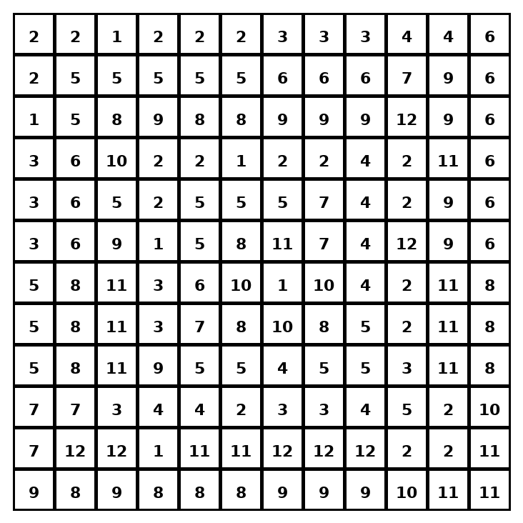

Early finisher writing: Choose one problem and explain your thinking in one complete sentence: Because ___, I ___.
____________________________________________________________________________________________

Teacher Answer Key
# | Answer | Color | Teacher Tip
1 | 6 | red | Think: how many fraction-size groups fit inside the whole amount?
2 | 8 | orange | Think: how many fraction-size groups fit inside the whole amount?
3 | 8 | orange | Think: how many fraction-size groups fit inside the whole amount?
4 | 15 | yellow | Think: how many fraction-size groups fit inside the whole amount?
5 | 10 | green | Think: how many fraction-size groups fit inside the whole amount?
6 | 10 | green | Think: how many fraction-size groups fit inside the whole amount?
7 | 8 | orange | Think: how many fraction-size groups fit inside the whole amount?
8 | 12 | blue | Think: how many fraction-size groups fit inside the whole amount?
9 | 16 | purple | Think: how many fraction-size groups fit inside the whole amount?
10 | 15 | yellow | Think: how many fraction-size groups fit inside the whole amount?
11 | 12 | blue | Think: how many fraction-size groups fit inside the whole amount?
12 | 24 | pink | Think: how many fraction-size groups fit inside the whole amount?

Use note: This file is original practice aligned to the lesson skill. It is designed for low-prep review, centers, sub plans, or early finishers.

