2-2 Divide Whole Numbers by Fractions
Fraction Detective Agency | Standard: 6.NS.1 | Color-by-Number Practice

Learning Goal: I can divide a whole number by a fraction by multiplying by the reciprocal. | Directions: Solve each problem. Match each answer to the Color Code. On the next page, color every box with that problem number using the matching color.

Vocabulary: reciprocal, quotient, fraction division | Explain one: I solved problem ___ by ___. Because ___, my answer is ___.

Solve First
1. 2 ÷ 1/2 =  Work: ________________________________________  Answer: ________________ | 2. 3 ÷ 1/3 =  Work: ________________________________________  Answer: ________________
3. 4 ÷ 1/2 =  Work: ________________________________________  Answer: ________________ | 4. 5 ÷ 1/5 =  Work: ________________________________________  Answer: ________________
5. 6 ÷ 1/4 =  Work: ________________________________________  Answer: ________________ | 6. 3 ÷ 2/3 =  Work: ________________________________________  Answer: ________________
7. 4 ÷ 2/5 =  Work: ________________________________________  Answer: ________________ | 8. 7 ÷ 7/8 =  Work: ________________________________________  Answer: ________________
9. 8 ÷ 4/5 =  Work: ________________________________________  Answer: ________________ | 10. 5 ÷ 5/6 =  Work: ________________________________________  Answer: ________________
11. 9 ÷ 3/4 =  Work: ________________________________________  Answer: ________________ | 12. 6 ÷ 2/3 =  Work: ________________________________________  Answer: ________________

Quick check: Before coloring, make sure every answer appears in the Color Code on the next page.

2-2 Mystery Picture: Case File Mosaic
Solve a problem, match the answer to a color, then color every box with that problem number.
Color Code | Color Code | Color Code | Color Code
4 = red | 9 = orange | 8 = yellow | 25 = green
24 = blue | 4 1/2 = purple | 10 = pink | 6 = brown
12 = gray

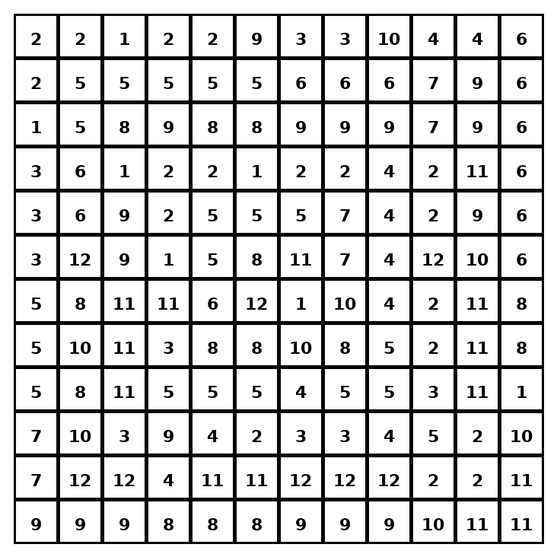

Early finisher writing: Choose one problem and explain your thinking in one complete sentence: Because ___, I ___.
____________________________________________________________________________________________

Teacher Answer Key
# | Answer | Color | Teacher Tip
1 | 4 | red | Multiply by the reciprocal.
2 | 9 | orange | Multiply by the reciprocal.
3 | 8 | yellow | Multiply by the reciprocal.
4 | 25 | green | Multiply by the reciprocal.
5 | 24 | blue | Multiply by the reciprocal.
6 | 4 1/2 | purple | Multiply by the reciprocal.
7 | 10 | pink | Multiply by the reciprocal.
8 | 8 | yellow | Multiply by the reciprocal.
9 | 10 | pink | Multiply by the reciprocal.
10 | 6 | brown | Multiply by the reciprocal.
11 | 12 | gray | Multiply by the reciprocal.
12 | 9 | orange | Multiply by the reciprocal.

Use note: This file is original practice aligned to the lesson skill. It is designed for low-prep review, centers, sub plans, or early finishers.

