2-3 Divide Fractions
Fraction Detective Agency | Standard: 6.NS.1 | Color-by-Number Practice

Learning Goal: I can divide a fraction by a fraction by multiplying by the reciprocal and simplifying. | Directions: Solve each problem. Match each answer to the Color Code. On the next page, color every box with that problem number using the matching color.

Vocabulary: reciprocal, quotient, simplify | Explain one: I solved problem ___ by ___. Because ___, my answer is ___.

Solve First
1. 1/2 ÷ 1/4 =  Work: ________________________________________  Answer: ________________ | 2. 2/3 ÷ 1/3 =  Work: ________________________________________  Answer: ________________
3. 3/4 ÷ 1/2 =  Work: ________________________________________  Answer: ________________ | 4. 4/5 ÷ 2/5 =  Work: ________________________________________  Answer: ________________
5. 5/6 ÷ 1/3 =  Work: ________________________________________  Answer: ________________ | 6. 3/8 ÷ 1/4 =  Work: ________________________________________  Answer: ________________
7. 2/5 ÷ 1/10 =  Work: ________________________________________  Answer: ________________ | 8. 7/8 ÷ 1/4 =  Work: ________________________________________  Answer: ________________
9. 3/5 ÷ 2/5 =  Work: ________________________________________  Answer: ________________ | 10. 5/9 ÷ 1/3 =  Work: ________________________________________  Answer: ________________
11. 4/7 ÷ 2/7 =  Work: ________________________________________  Answer: ________________ | 12. 9/10 ÷ 3/5 =  Work: ________________________________________  Answer: ________________

Quick check: Before coloring, make sure every answer appears in the Color Code on the next page.

2-3 Mystery Picture: Case File Mosaic
Solve a problem, match the answer to a color, then color every box with that problem number.
Color Code | Color Code | Color Code | Color Code
2 = red | 1 1/2 = orange | 2 1/2 = yellow | 4 = green
3 1/2 = blue | 1 2/3 = purple

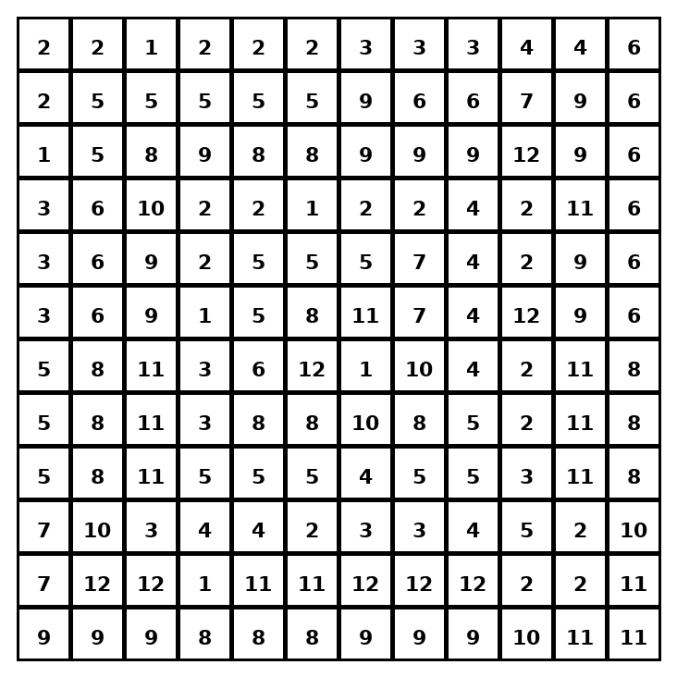

Early finisher writing: Choose one problem and explain your thinking in one complete sentence: Because ___, I ___.
____________________________________________________________________________________________

Teacher Answer Key
# | Answer | Color | Teacher Tip
1 | 2 | red | Keep, change, flip.
2 | 2 | red | Keep, change, flip.
3 | 1 1/2 | orange | Keep, change, flip.
4 | 2 | red | Keep, change, flip.
5 | 2 1/2 | yellow | Keep, change, flip.
6 | 1 1/2 | orange | Keep, change, flip.
7 | 4 | green | Keep, change, flip.
8 | 3 1/2 | blue | Keep, change, flip.
9 | 1 1/2 | orange | Keep, change, flip.
10 | 1 2/3 | purple | Keep, change, flip.
11 | 2 | red | Keep, change, flip.
12 | 1 1/2 | orange | Keep, change, flip.

Use note: This file is original practice aligned to the lesson skill. It is designed for low-prep review, centers, sub plans, or early finishers.

