2-4 Divide Mixed Numbers
Fraction Detective Agency | Standard: 6.NS.1 | Color-by-Number Practice

Learning Goal: I can divide mixed numbers by first changing them to improper fractions. | Directions: Solve each problem. Match each answer to the Color Code. On the next page, color every box with that problem number using the matching color.

Vocabulary: mixed number, improper fraction, reciprocal | Explain one: I solved problem ___ by ___. Because ___, my answer is ___.

Solve First
1. 1 1/2 ÷ 1/2 =  Work: ________________________________________  Answer: ________________ | 2. 2 1/2 ÷ 1/4 =  Work: ________________________________________  Answer: ________________
3. 2 1/3 ÷ 2/3 =  Work: ________________________________________  Answer: ________________ | 4. 2 1/4 ÷ 3/4 =  Work: ________________________________________  Answer: ________________
5. 2 1/5 ÷ 1/5 =  Work: ________________________________________  Answer: ________________ | 6. 2 1/6 ÷ 1/3 =  Work: ________________________________________  Answer: ________________
7. 3 1/2 ÷ 1/2 =  Work: ________________________________________  Answer: ________________ | 8. 3 3/4 ÷ 3/4 =  Work: ________________________________________  Answer: ________________
9. 2 2/3 ÷ 2/3 =  Work: ________________________________________  Answer: ________________ | 10. 3 1/3 ÷ 5/6 =  Work: ________________________________________  Answer: ________________
11. 4 1/2 ÷ 1 1/2 =  Work: ________________________________________  Answer: ________________ | 12. 2 3/4 ÷ 1/2 =  Work: ________________________________________  Answer: ________________

Quick check: Before coloring, make sure every answer appears in the Color Code on the next page.

2-4 Mystery Picture: Case File Mosaic
Solve a problem, match the answer to a color, then color every box with that problem number.
Color Code | Color Code | Color Code | Color Code
3 = red | 10 = orange | 3 1/2 = yellow | 11 = green
6 1/2 = blue | 7 = purple | 5 = pink | 4 = brown
5 1/2 = gray

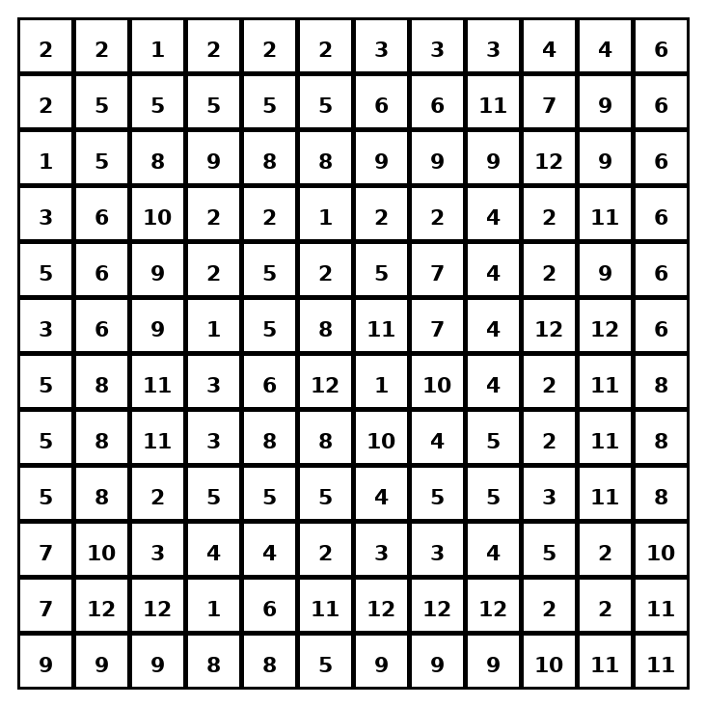

Early finisher writing: Choose one problem and explain your thinking in one complete sentence: Because ___, I ___.
____________________________________________________________________________________________

Teacher Answer Key
# | Answer | Color | Teacher Tip
1 | 3 | red | Change mixed numbers to improper fractions first.
2 | 10 | orange | Change mixed numbers to improper fractions first.
3 | 3 1/2 | yellow | Change mixed numbers to improper fractions first.
4 | 3 | red | Change mixed numbers to improper fractions first.
5 | 11 | green | Change mixed numbers to improper fractions first.
6 | 6 1/2 | blue | Change mixed numbers to improper fractions first.
7 | 7 | purple | Change mixed numbers to improper fractions first.
8 | 5 | pink | Change mixed numbers to improper fractions first.
9 | 4 | brown | Change mixed numbers to improper fractions first.
10 | 4 | brown | Change mixed numbers to improper fractions first.
11 | 3 | red | Change mixed numbers to improper fractions first.
12 | 5 1/2 | gray | Change mixed numbers to improper fractions first.

Use note: This file is original practice aligned to the lesson skill. It is designed for low-prep review, centers, sub plans, or early finishers.

