2-5 Fraction Division Problem Solving
Fraction Detective Agency | Standard: 6.NS.1 | Color-by-Number Practice

Learning Goal: I can solve real-world problems by writing and solving fraction division equations. | Directions: Solve each problem. Match each answer to the Color Code. On the next page, color every box with that problem number using the matching color.

Vocabulary: total, group size, quotient | Explain one: I solved problem ___ by ___. Because ___, my answer is ___.

Solve First
1. A student has 3 cups of trail mix. Each bag uses 1/2. How many bags can be made?  Work: ________________________________________  Answer: ________________ | 2. A student has 4 yards of ribbon. Each bow uses 1/4. How many bows can be made?  Work: ________________________________________  Answer: ________________
3. A student has 5 liters of juice. Each bottle uses 2/3. How many bottles can be made?  Work: ________________________________________  Answer: ________________ | 4. A student has 6 pounds of clay. Each model uses 3/4. How many models can be made?  Work: ________________________________________  Answer: ________________
5. A student has 2 sheets of paper. Each bookmark uses 1/5. How many bookmarks can be made?  Work: ________________________________________  Answer: ________________ | 6. A student has 8 meters of string. Each bracelet uses 2/5. How many bracelets can be made?  Work: ________________________________________  Answer: ________________
7. A student has 7 cups of paint. Each poster uses 7/8. How many posters can be made?  Work: ________________________________________  Answer: ________________ | 8. A student has 9 cups of flour. Each batch uses 3/4. How many batchs can be made?  Work: ________________________________________  Answer: ________________
9. A student has 10 miles of trail. Each section uses 5/6. How many sections can be made?  Work: ________________________________________  Answer: ________________ | 10. A student has 12 ounces of beads. Each necklace uses 2/3. How many necklaces can be made?  Work: ________________________________________  Answer: ________________
11. A student has 15 feet of tape. Each label uses 5/8. How many labels can be made?  Work: ________________________________________  Answer: ________________ | 12. A student has 6 pans of brownies. Each piece uses 1/6. How many pieces can be made?  Work: ________________________________________  Answer: ________________

Quick check: Before coloring, make sure every answer appears in the Color Code on the next page.

2-5 Mystery Picture: Case File Mosaic
Solve a problem, match the answer to a color, then color every box with that problem number.
Color Code | Color Code | Color Code | Color Code
6 = red | 16 = orange | 7 1/2 = yellow | 8 = green
10 = blue | 20 = purple | 12 = pink | 18 = brown
24 = gray | 36 = teal

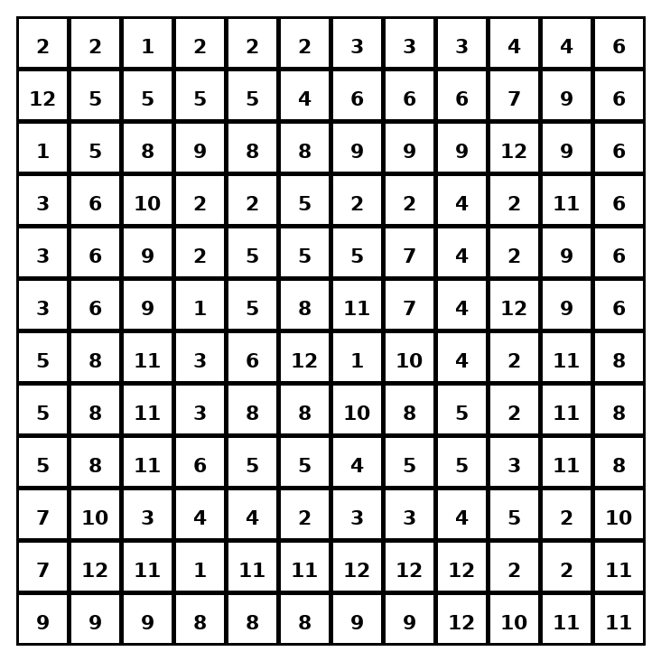

Early finisher writing: Choose one problem and explain your thinking in one complete sentence: Because ___, I ___.
____________________________________________________________________________________________

Teacher Answer Key
# | Answer | Color | Teacher Tip
1 | 6 | red | Write total ÷ group size.
2 | 16 | orange | Write total ÷ group size.
3 | 7 1/2 | yellow | Write total ÷ group size.
4 | 8 | green | Write total ÷ group size.
5 | 10 | blue | Write total ÷ group size.
6 | 20 | purple | Write total ÷ group size.
7 | 8 | green | Write total ÷ group size.
8 | 12 | pink | Write total ÷ group size.
9 | 12 | pink | Write total ÷ group size.
10 | 18 | brown | Write total ÷ group size.
11 | 24 | gray | Write total ÷ group size.
12 | 36 | teal | Write total ÷ group size.

Use note: This file is original practice aligned to the lesson skill. It is designed for low-prep review, centers, sub plans, or early finishers.

