3-1 Understand Ratios
Culinary Academy | Standard: 6.RP.1 | Color-by-Number Practice

Learning Goal: I can write and describe a ratio that compares two quantities. | Directions: Solve each problem. Match each answer to the Color Code. On the next page, color every box with that problem number using the matching color.

Vocabulary: ratio, part-to-part, simplify | Explain one: I solved problem ___ by ___. Because ___, my answer is ___.

Solve First
1. Simplify the ratio 6:9.  Work: ________________________________________  Answer: ________________ | 2. Simplify the ratio 8:12.  Work: ________________________________________  Answer: ________________
3. Simplify the ratio 10:15.  Work: ________________________________________  Answer: ________________ | 4. Simplify the ratio 12:18.  Work: ________________________________________  Answer: ________________
5. Simplify the ratio 14:21.  Work: ________________________________________  Answer: ________________ | 6. Simplify the ratio 16:20.  Work: ________________________________________  Answer: ________________
7. Simplify the ratio 18:24.  Work: ________________________________________  Answer: ________________ | 8. Simplify the ratio 20:25.  Work: ________________________________________  Answer: ________________
9. Simplify the ratio 24:30.  Work: ________________________________________  Answer: ________________ | 10. Simplify the ratio 27:36.  Work: ________________________________________  Answer: ________________
11. Simplify the ratio 28:42.  Work: ________________________________________  Answer: ________________ | 12. Simplify the ratio 30:45.  Work: ________________________________________  Answer: ________________

Quick check: Before coloring, make sure every answer appears in the Color Code on the next page.

3-1 Mystery Picture: Chef Badge Mosaic
Solve a problem, match the answer to a color, then color every box with that problem number.
Color Code | Color Code | Color Code | Color Code
2:3 = red | 4:5 = orange | 3:4 = yellow

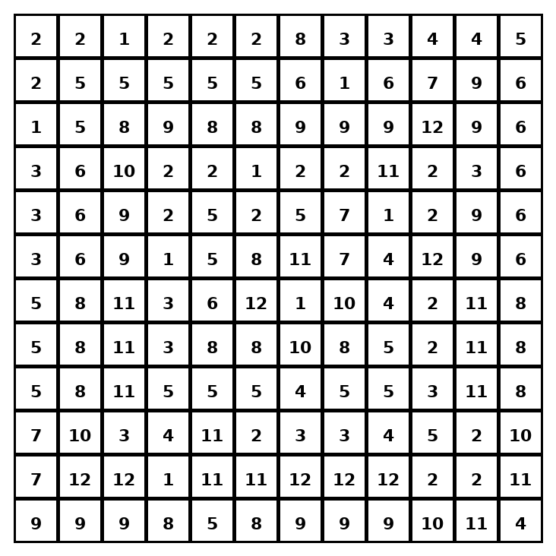

Early finisher writing: Choose one problem and explain your thinking in one complete sentence: Because ___, I ___.
____________________________________________________________________________________________

Teacher Answer Key
# | Answer | Color | Teacher Tip
1 | 2:3 | red | Divide both parts by the same factor.
2 | 2:3 | red | Divide both parts by the same factor.
3 | 2:3 | red | Divide both parts by the same factor.
4 | 2:3 | red | Divide both parts by the same factor.
5 | 2:3 | red | Divide both parts by the same factor.
6 | 4:5 | orange | Divide both parts by the same factor.
7 | 3:4 | yellow | Divide both parts by the same factor.
8 | 4:5 | orange | Divide both parts by the same factor.
9 | 4:5 | orange | Divide both parts by the same factor.
10 | 3:4 | yellow | Divide both parts by the same factor.
11 | 2:3 | red | Divide both parts by the same factor.
12 | 2:3 | red | Divide both parts by the same factor.

Use note: This file is original practice aligned to the lesson skill. It is designed for low-prep review, centers, sub plans, or early finishers.

