3-2 Ratio Tables
Culinary Academy | Standard: 6.RP.3a | Color-by-Number Practice

Learning Goal: I can use a ratio table to find equivalent ratios. | Directions: Solve each problem. Match each answer to the Color Code. On the next page, color every box with that problem number using the matching color.

Vocabulary: ratio table, equivalent ratio, scale factor | Explain one: I solved problem ___ by ___. Because ___, my answer is ___.

Solve First
1. A ratio table starts 2:5. What is the second number when the first number is 8?  Work: ________________________________________  Answer: ________________ | 2. A ratio table starts 3:7. What is the second number when the first number is 15?  Work: ________________________________________  Answer: ________________
3. A ratio table starts 4:9. What is the second number when the first number is 12?  Work: ________________________________________  Answer: ________________ | 4. A ratio table starts 5:6. What is the second number when the first number is 20?  Work: ________________________________________  Answer: ________________
5. A ratio table starts 6:11. What is the second number when the first number is 12?  Work: ________________________________________  Answer: ________________ | 6. A ratio table starts 7:3. What is the second number when the first number is 35?  Work: ________________________________________  Answer: ________________
7. A ratio table starts 8:12. What is the second number when the first number is 24?  Work: ________________________________________  Answer: ________________ | 8. A ratio table starts 9:4. What is the second number when the first number is 54?  Work: ________________________________________  Answer: ________________
9. A ratio table starts 10:15. What is the second number when the first number is 20?  Work: ________________________________________  Answer: ________________ | 10. A ratio table starts 12:5. What is the second number when the first number is 48?  Work: ________________________________________  Answer: ________________
11. A ratio table starts 3:8. What is the second number when the first number is 21?  Work: ________________________________________  Answer: ________________ | 12. A ratio table starts 4:11. What is the second number when the first number is 20?  Work: ________________________________________  Answer: ________________

Quick check: Before coloring, make sure every answer appears in the Color Code on the next page.

3-2 Mystery Picture: Chef Badge Mosaic
Solve a problem, match the answer to a color, then color every box with that problem number.
Color Code | Color Code | Color Code | Color Code
20 = red | 35 = orange | 27 = yellow | 24 = green
22 = blue | 15 = purple | 36 = pink | 30 = brown
56 = gray | 55 = teal

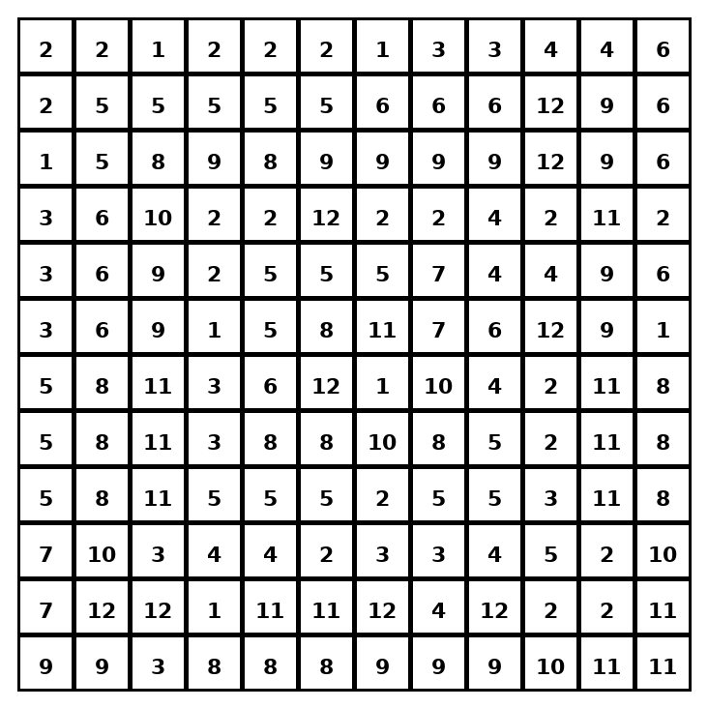

Early finisher writing: Choose one problem and explain your thinking in one complete sentence: Because ___, I ___.
____________________________________________________________________________________________

Teacher Answer Key
# | Answer | Color | Teacher Tip
1 | 20 | red | Multiply both parts by the same number.
2 | 35 | orange | Multiply both parts by the same number.
3 | 27 | yellow | Multiply both parts by the same number.
4 | 24 | green | Multiply both parts by the same number.
5 | 22 | blue | Multiply both parts by the same number.
6 | 15 | purple | Multiply both parts by the same number.
7 | 36 | pink | Multiply both parts by the same number.
8 | 24 | green | Multiply both parts by the same number.
9 | 30 | brown | Multiply both parts by the same number.
10 | 20 | red | Multiply both parts by the same number.
11 | 56 | gray | Multiply both parts by the same number.
12 | 55 | teal | Multiply both parts by the same number.

Use note: This file is original practice aligned to the lesson skill. It is designed for low-prep review, centers, sub plans, or early finishers.

