3-3 Graph Ratio Tables
Culinary Academy | Standard: 6.RP.3a | Color-by-Number Practice

Learning Goal: I can graph the values from a ratio table as points on the coordinate plane. | Directions: Solve each problem. Match each answer to the Color Code. On the next page, color every box with that problem number using the matching color.

Vocabulary: ordered pair, x-value, y-value, ratio table | Explain one: I solved problem ___ by ___. Because ___, my answer is ___.

Solve First
1. The ratio table has point (8, ?). If y = 3 for every x = 2, what is the y-value?  Work: ________________________________________  Answer: ________________ | 2. The ratio table has point (5, ?). If y = 4 for every x = 1, what is the y-value?  Work: ________________________________________  Answer: ________________
3. The ratio table has point (18, ?). If y = 2 for every x = 3, what is the y-value?  Work: ________________________________________  Answer: ________________ | 4. The ratio table has point (15, ?). If y = 1 for every x = 5, what is the y-value?  Work: ________________________________________  Answer: ________________
5. The ratio table has point (8, ?). If y = 3 for every x = 4, what is the y-value?  Work: ________________________________________  Answer: ________________ | 6. The ratio table has point (8, ?). If y = 5 for every x = 2, what is the y-value?  Work: ________________________________________  Answer: ________________
7. The ratio table has point (30, ?). If y = 1 for every x = 6, what is the y-value?  Work: ________________________________________  Answer: ________________ | 8. The ratio table has point (9, ?). If y = 4 for every x = 3, what is the y-value?  Work: ________________________________________  Answer: ________________
9. The ratio table has point (14, ?). If y = 2 for every x = 7, what is the y-value?  Work: ________________________________________  Answer: ________________ | 10. The ratio table has point (10, ?). If y = 6 for every x = 5, what is the y-value?  Work: ________________________________________  Answer: ________________
11. The ratio table has point (24, ?). If y = 3 for every x = 8, what is the y-value?  Work: ________________________________________  Answer: ________________ | 12. The ratio table has point (8, ?). If y = 7 for every x = 4, what is the y-value?  Work: ________________________________________  Answer: ________________

Quick check: Before coloring, make sure every answer appears in the Color Code on the next page.

3-3 Mystery Picture: Chef Badge Mosaic
Solve a problem, match the answer to a color, then color every box with that problem number.
Color Code | Color Code | Color Code | Color Code
12 = red | 20 = orange | 3 = yellow | 6 = green
5 = blue | 4 = purple | 9 = pink | 14 = brown

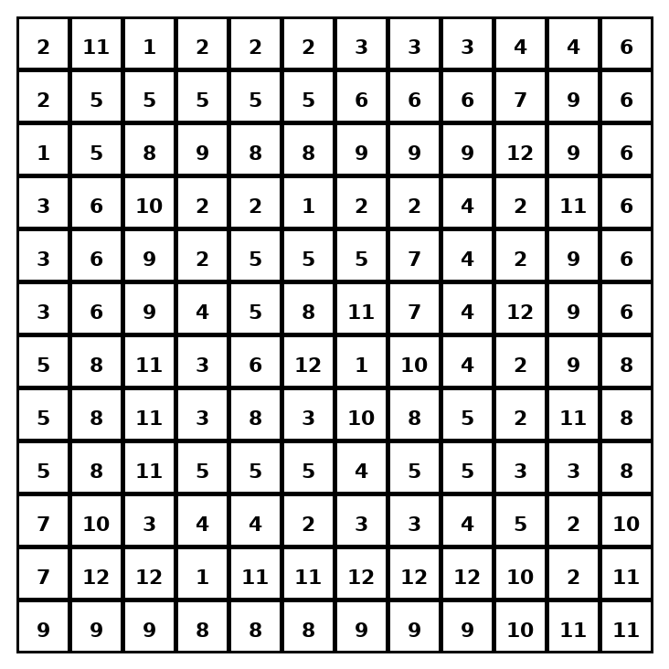

Early finisher writing: Choose one problem and explain your thinking in one complete sentence: Because ___, I ___.
____________________________________________________________________________________________

Teacher Answer Key
# | Answer | Color | Teacher Tip
1 | 12 | red | Scale x and y by the same factor.
2 | 20 | orange | Scale x and y by the same factor.
3 | 12 | red | Scale x and y by the same factor.
4 | 3 | yellow | Scale x and y by the same factor.
5 | 6 | green | Scale x and y by the same factor.
6 | 20 | orange | Scale x and y by the same factor.
7 | 5 | blue | Scale x and y by the same factor.
8 | 12 | red | Scale x and y by the same factor.
9 | 4 | purple | Scale x and y by the same factor.
10 | 12 | red | Scale x and y by the same factor.
11 | 9 | pink | Scale x and y by the same factor.
12 | 14 | brown | Scale x and y by the same factor.

Use note: This file is original practice aligned to the lesson skill. It is designed for low-prep review, centers, sub plans, or early finishers.

