3-4 Equivalent Ratios
Culinary Academy | Standard: 6.RP.3 | Color-by-Number Practice

Learning Goal: I can find and check equivalent ratios using multiplication and division. | Directions: Solve each problem. Match each answer to the Color Code. On the next page, color every box with that problem number using the matching color.

Vocabulary: equivalent, ratio, scale factor | Explain one: I solved problem ___ by ___. Because ___, my answer is ___.

Solve First
1. 3:4 = 15:n. Find n.  Work: ________________________________________  Answer: ________________ | 2. 2:5 = 18:n. Find n.  Work: ________________________________________  Answer: ________________
3. 4:7 = 36:n. Find n.  Work: ________________________________________  Answer: ________________ | 4. 5:8 = 45:n. Find n.  Work: ________________________________________  Answer: ________________
5. 6:11 = 42:n. Find n.  Work: ________________________________________  Answer: ________________ | 6. 7:9 = 56:n. Find n.  Work: ________________________________________  Answer: ________________
7. 8:3 = 64:n. Find n.  Work: ________________________________________  Answer: ________________ | 8. 9:5 = 72:n. Find n.  Work: ________________________________________  Answer: ________________
9. 10:6 = 90:n. Find n.  Work: ________________________________________  Answer: ________________ | 10. 12:7 = 84:n. Find n.  Work: ________________________________________  Answer: ________________
11. 11:4 = 99:n. Find n.  Work: ________________________________________  Answer: ________________ | 12. 13:5 = 104:n. Find n.  Work: ________________________________________  Answer: ________________

Quick check: Before coloring, make sure every answer appears in the Color Code on the next page.

3-4 Mystery Picture: Chef Badge Mosaic
Solve a problem, match the answer to a color, then color every box with that problem number.
Color Code | Color Code | Color Code | Color Code
20 = red | 45 = orange | 63 = yellow | 72 = green
77 = blue | 24 = purple | 40 = pink | 54 = brown
49 = gray | 36 = teal

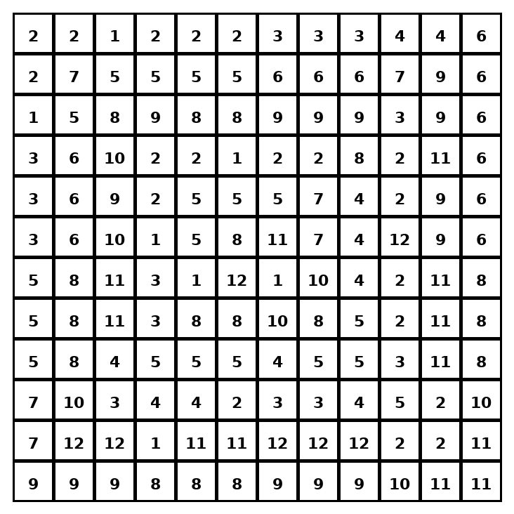

Early finisher writing: Choose one problem and explain your thinking in one complete sentence: Because ___, I ___.
____________________________________________________________________________________________

Teacher Answer Key
# | Answer | Color | Teacher Tip
1 | 20 | red | Find the scale factor from the first ratio to the second.
2 | 45 | orange | Find the scale factor from the first ratio to the second.
3 | 63 | yellow | Find the scale factor from the first ratio to the second.
4 | 72 | green | Find the scale factor from the first ratio to the second.
5 | 77 | blue | Find the scale factor from the first ratio to the second.
6 | 72 | green | Find the scale factor from the first ratio to the second.
7 | 24 | purple | Find the scale factor from the first ratio to the second.
8 | 40 | pink | Find the scale factor from the first ratio to the second.
9 | 54 | brown | Find the scale factor from the first ratio to the second.
10 | 49 | gray | Find the scale factor from the first ratio to the second.
11 | 36 | teal | Find the scale factor from the first ratio to the second.
12 | 40 | pink | Find the scale factor from the first ratio to the second.

Use note: This file is original practice aligned to the lesson skill. It is designed for low-prep review, centers, sub plans, or early finishers.

