3-5 Compare Ratios
Culinary Academy | Standard: 6.RP.3 | Color-by-Number Practice

Learning Goal: I can compare ratios by finding unit rates or using equivalent ratios. | Directions: Solve each problem. Match each answer to the Color Code. On the next page, color every box with that problem number using the matching color.

Vocabulary: unit rate, compare, per | Explain one: I solved problem ___ by ___. Because ___, my answer is ___.

Solve First
1. Find the unit rate: 12 points in 3 games.  Work: ________________________________________  Answer: ________________ | 2. Find the unit rate: 18 points in 6 games.  Work: ________________________________________  Answer: ________________
3. Find the unit rate: 20 points in 5 games.  Work: ________________________________________  Answer: ________________ | 4. Find the unit rate: 24 points in 8 games.  Work: ________________________________________  Answer: ________________
5. Find the unit rate: 30 points in 5 games.  Work: ________________________________________  Answer: ________________ | 6. Find the unit rate: 36 points in 9 games.  Work: ________________________________________  Answer: ________________
7. Find the unit rate: 40 points in 10 games.  Work: ________________________________________  Answer: ________________ | 8. Find the unit rate: 45 points in 5 games.  Work: ________________________________________  Answer: ________________
9. Find the unit rate: 48 points in 12 games.  Work: ________________________________________  Answer: ________________ | 10. Find the unit rate: 50 points in 10 games.  Work: ________________________________________  Answer: ________________
11. Find the unit rate: 56 points in 7 games.  Work: ________________________________________  Answer: ________________ | 12. Find the unit rate: 63 points in 9 games.  Work: ________________________________________  Answer: ________________

Quick check: Before coloring, make sure every answer appears in the Color Code on the next page.

3-5 Mystery Picture: Chef Badge Mosaic
Solve a problem, match the answer to a color, then color every box with that problem number.
Color Code | Color Code | Color Code | Color Code
4 = red | 3 = orange | 6 = yellow | 9 = green
5 = blue | 8 = purple | 7 = pink

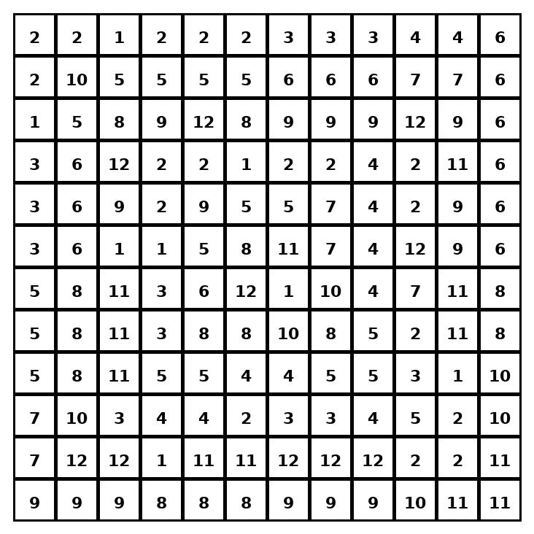

Early finisher writing: Choose one problem and explain your thinking in one complete sentence: Because ___, I ___.
____________________________________________________________________________________________

Teacher Answer Key
# | Answer | Color | Teacher Tip
1 | 4 | red | Divide total by number of groups.
2 | 3 | orange | Divide total by number of groups.
3 | 4 | red | Divide total by number of groups.
4 | 3 | orange | Divide total by number of groups.
5 | 6 | yellow | Divide total by number of groups.
6 | 4 | red | Divide total by number of groups.
7 | 4 | red | Divide total by number of groups.
8 | 9 | green | Divide total by number of groups.
9 | 4 | red | Divide total by number of groups.
10 | 5 | blue | Divide total by number of groups.
11 | 8 | purple | Divide total by number of groups.
12 | 7 | pink | Divide total by number of groups.

Use note: This file is original practice aligned to the lesson skill. It is designed for low-prep review, centers, sub plans, or early finishers.

