3-6 Use Ratio Reasoning
Culinary Academy | Standard: 6.RP.3 | Color-by-Number Practice

Learning Goal: I can use ratio reasoning to solve problems with proportions and scaling. | Directions: Solve each problem. Match each answer to the Color Code. On the next page, color every box with that problem number using the matching color.

Vocabulary: scale factor, equivalent, ratio reasoning | Explain one: I solved problem ___ by ___. Because ___, my answer is ___.

Solve First
1. The ratio is 2 cups of rice to 5 servings. If there are 12 cups of rice, how many servings?  Work: ________________________________________  Answer: ________________ | 2. The ratio is 3 red tiles to 4 blue tiles. If there are 27 red tiles, how many blue tiles?  Work: ________________________________________  Answer: ________________
3. The ratio is 4 minutes to 7 laps. If there are 20 minutes, how many laps?  Work: ________________________________________  Answer: ________________ | 4. The ratio is 5 tablespoons to 8 cups. If there are 30 tablespoons, how many cups?  Work: ________________________________________  Answer: ________________
5. The ratio is 6 stickers to 10 cards. If there are 42 stickers, how many cards?  Work: ________________________________________  Answer: ________________ | 6. The ratio is 7 tickets to 11 students. If there are 28 tickets, how many students?  Work: ________________________________________  Answer: ________________
7. The ratio is 8 pages to 12 minutes. If there are 40 pages, how many minutes?  Work: ________________________________________  Answer: ________________ | 8. The ratio is 9 ounces to 15 bottles. If there are 36 ounces, how many bottles?  Work: ________________________________________  Answer: ________________
9. The ratio is 10 feet to 14 boards. If there are 30 feet, how many boards?  Work: ________________________________________  Answer: ________________ | 10. The ratio is 12 meters to 18 flags. If there are 60 meters, how many flags?  Work: ________________________________________  Answer: ________________
11. The ratio is 3 coins to 8 bags. If there are 33 coins, how many bags?  Work: ________________________________________  Answer: ________________ | 12. The ratio is 4 points to 9 rounds. If there are 40 points, how many rounds?  Work: ________________________________________  Answer: ________________

Quick check: Before coloring, make sure every answer appears in the Color Code on the next page.

3-6 Mystery Picture: Chef Badge Mosaic
Solve a problem, match the answer to a color, then color every box with that problem number.
Color Code | Color Code | Color Code | Color Code
30 = red | 36 = orange | 35 = yellow | 48 = green
70 = blue | 44 = purple | 60 = pink | 42 = brown
90 = gray | 88 = teal

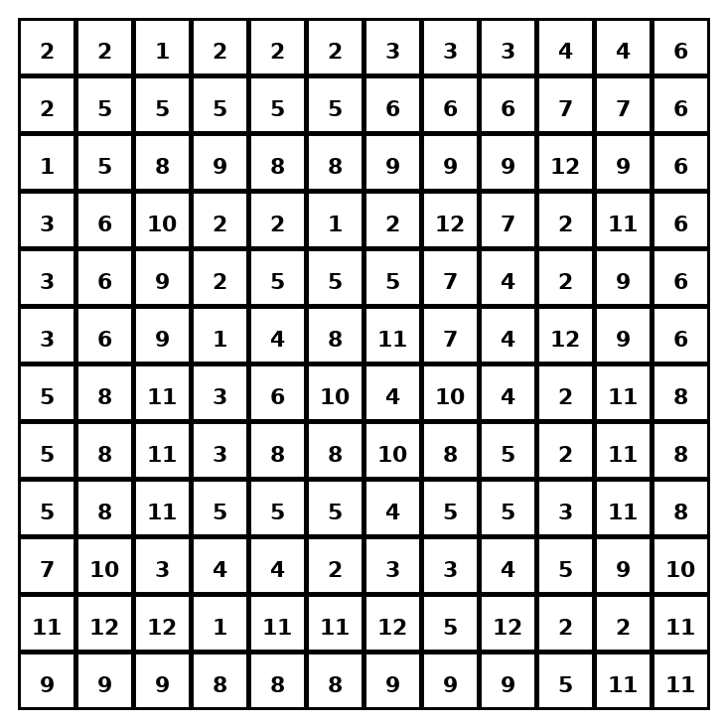

Early finisher writing: Choose one problem and explain your thinking in one complete sentence: Because ___, I ___.
____________________________________________________________________________________________

Teacher Answer Key
# | Answer | Color | Teacher Tip
1 | 30 | red | Use the same scale factor on both parts.
2 | 36 | orange | Use the same scale factor on both parts.
3 | 35 | yellow | Use the same scale factor on both parts.
4 | 48 | green | Use the same scale factor on both parts.
5 | 70 | blue | Use the same scale factor on both parts.
6 | 44 | purple | Use the same scale factor on both parts.
7 | 60 | pink | Use the same scale factor on both parts.
8 | 60 | pink | Use the same scale factor on both parts.
9 | 42 | brown | Use the same scale factor on both parts.
10 | 90 | gray | Use the same scale factor on both parts.
11 | 88 | teal | Use the same scale factor on both parts.
12 | 90 | gray | Use the same scale factor on both parts.

Use note: This file is original practice aligned to the lesson skill. It is designed for low-prep review, centers, sub plans, or early finishers.

