3-7 Ratio and Rate Problem Solving
Culinary Academy | Standard: 6.RP.3 | Color-by-Number Practice

Learning Goal: I can solve real-world rate problems by finding and using unit rates. | Directions: Solve each problem. Match each answer to the Color Code. On the next page, color every box with that problem number using the matching color.

Vocabulary: unit rate, per, compare | Explain one: I solved problem ___ by ___. Because ___, my answer is ___.

Solve First
1. Find the unit rate: 18 miles in 3 hours.  Work: ________________________________________  Answer: ________________ | 2. Find the unit rate: 24 pages in 4 minutes.  Work: ________________________________________  Answer: ________________
3. Find the unit rate: 35 dollars in 5 tickets.  Work: ________________________________________  Answer: ________________ | 4. Find the unit rate: 42 points in 6 games.  Work: ________________________________________  Answer: ________________
5. Find the unit rate: 56 ounces in 7 bottles.  Work: ________________________________________  Answer: ________________ | 6. Find the unit rate: 64 meters in 8 seconds.  Work: ________________________________________  Answer: ________________
7. Find the unit rate: 72 words in 9 lines.  Work: ________________________________________  Answer: ________________ | 8. Find the unit rate: 81 coins in 3 bags.  Work: ________________________________________  Answer: ________________
9. Find the unit rate: 96 students in 12 teams.  Work: ________________________________________  Answer: ________________ | 10. Find the unit rate: 105 photos in 7 albums.  Work: ________________________________________  Answer: ________________
11. Find the unit rate: 120 calories in 10 minutes.  Work: ________________________________________  Answer: ________________ | 12. Find the unit rate: 144 tiles in 12 rows.  Work: ________________________________________  Answer: ________________

Quick check: Before coloring, make sure every answer appears in the Color Code on the next page.

3-7 Mystery Picture: Chef Badge Mosaic
Solve a problem, match the answer to a color, then color every box with that problem number.
Color Code | Color Code | Color Code | Color Code
6 = red | 7 = orange | 8 = yellow | 27 = green
15 = blue | 12 = purple

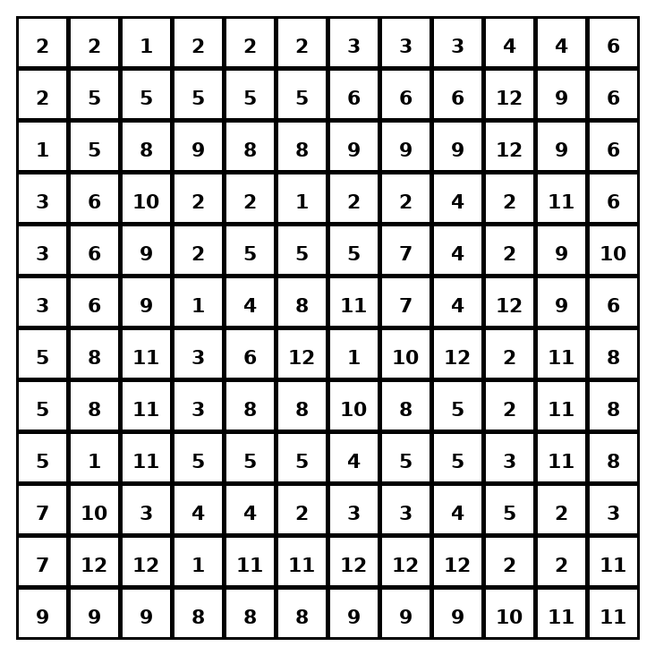

Early finisher writing: Choose one problem and explain your thinking in one complete sentence: Because ___, I ___.
____________________________________________________________________________________________

Teacher Answer Key
# | Answer | Color | Teacher Tip
1 | 6 | red | Divide by the number of groups.
2 | 6 | red | Divide by the number of groups.
3 | 7 | orange | Divide by the number of groups.
4 | 7 | orange | Divide by the number of groups.
5 | 8 | yellow | Divide by the number of groups.
6 | 8 | yellow | Divide by the number of groups.
7 | 8 | yellow | Divide by the number of groups.
8 | 27 | green | Divide by the number of groups.
9 | 8 | yellow | Divide by the number of groups.
10 | 15 | blue | Divide by the number of groups.
11 | 12 | purple | Divide by the number of groups.
12 | 12 | purple | Divide by the number of groups.

Use note: This file is original practice aligned to the lesson skill. It is designed for low-prep review, centers, sub plans, or early finishers.

