4-1-flagship Rates and Unit Rates Flagship
Arcade Builder | Standard: 6.RP.2 | Color-by-Number Practice

Learning Goal: I can find a unit rate to compare prices and decide the better buy. | Directions: Solve each problem. Match each answer to the Color Code. On the next page, color every box with that problem number using the matching color.

Vocabulary: unit rate, per, compare | Explain one: I solved problem ___ by ___. Because ___, my answer is ___.

Solve First
1. Find the unit rate: 48 dollars in 3 pounds.  Work: ________________________________________  Answer: ________________ | 2. Find the unit rate: 75 miles in 5 hours.  Work: ________________________________________  Answer: ________________
3. Find the unit rate: 96 points in 8 rounds.  Work: ________________________________________  Answer: ________________ | 4. Find the unit rate: 126 pages in 9 days.  Work: ________________________________________  Answer: ________________
5. Find the unit rate: 160 ounces in 20 cups.  Work: ________________________________________  Answer: ________________ | 6. Find the unit rate: 189 coins in 7 jars.  Work: ________________________________________  Answer: ________________
7. Find the unit rate: 225 tickets in 15 classes.  Work: ________________________________________  Answer: ________________ | 8. Find the unit rate: 252 meters in 12 minutes.  Work: ________________________________________  Answer: ________________
9. Find the unit rate: 288 stickers in 16 sheets.  Work: ________________________________________  Answer: ________________ | 10. Find the unit rate: 315 feet in 9 boards.  Work: ________________________________________  Answer: ________________
11. Find the unit rate: 360 students in 24 buses.  Work: ________________________________________  Answer: ________________ | 12. Find the unit rate: 432 gems in 18 levels.  Work: ________________________________________  Answer: ________________

Quick check: Before coloring, make sure every answer appears in the Color Code on the next page.

4-1-flagship Mystery Picture: Arcade Token Mosaic
Solve a problem, match the answer to a color, then color every box with that problem number.
Color Code | Color Code | Color Code | Color Code
16 = red | 15 = orange | 12 = yellow | 14 = green
8 = blue | 27 = purple | 21 = pink | 18 = brown
35 = gray | 24 = teal

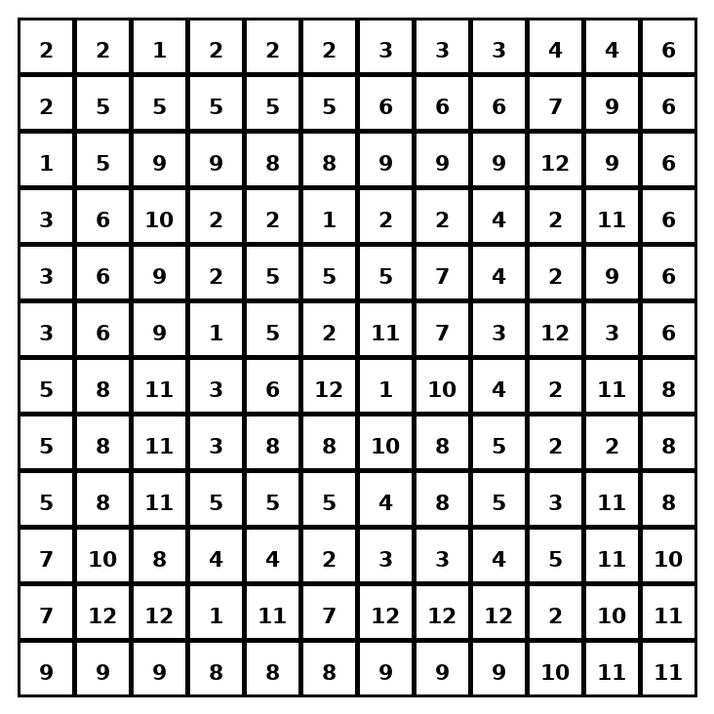

Early finisher writing: Choose one problem and explain your thinking in one complete sentence: Because ___, I ___.
____________________________________________________________________________________________

Teacher Answer Key
# | Answer | Color | Teacher Tip
1 | 16 | red | Divide by the number of groups.
2 | 15 | orange | Divide by the number of groups.
3 | 12 | yellow | Divide by the number of groups.
4 | 14 | green | Divide by the number of groups.
5 | 8 | blue | Divide by the number of groups.
6 | 27 | purple | Divide by the number of groups.
7 | 15 | orange | Divide by the number of groups.
8 | 21 | pink | Divide by the number of groups.
9 | 18 | brown | Divide by the number of groups.
10 | 35 | gray | Divide by the number of groups.
11 | 15 | orange | Divide by the number of groups.
12 | 24 | teal | Divide by the number of groups.

Use note: This file is original practice aligned to the lesson skill. It is designed for low-prep review, centers, sub plans, or early finishers.

