4-2 Relate Fractions, Decimals, and Percents
Arcade Builder | Standard: 6.RP.3c | Color-by-Number Practice

Learning Goal: I can write equivalent fractions, decimals, and percents for the same value. | Directions: Solve each problem. Match each answer to the Color Code. On the next page, color every box with that problem number using the matching color.

Vocabulary: fraction, decimal, percent, equivalent | Explain one: I solved problem ___ by ___. Because ___, my answer is ___.

Solve First
1. Write 1/2 as a percent.  Work: ________________________________________  Answer: ________________ | 2. Write 1/4 as a percent.  Work: ________________________________________  Answer: ________________
3. Write 3/4 as a percent.  Work: ________________________________________  Answer: ________________ | 4. Write 1/5 as a percent.  Work: ________________________________________  Answer: ________________
5. Write 2/5 as a percent.  Work: ________________________________________  Answer: ________________ | 6. Write 3/5 as a percent.  Work: ________________________________________  Answer: ________________
7. Write 4/5 as a percent.  Work: ________________________________________  Answer: ________________ | 8. Write 1/10 as a percent.  Work: ________________________________________  Answer: ________________
9. Write 7/10 as a percent.  Work: ________________________________________  Answer: ________________ | 10. Write 1/8 as a percent.  Work: ________________________________________  Answer: ________________
11. Write 3/8 as a percent.  Work: ________________________________________  Answer: ________________ | 12. Write 5/8 as a percent.  Work: ________________________________________  Answer: ________________

Quick check: Before coloring, make sure every answer appears in the Color Code on the next page.

4-2 Mystery Picture: Arcade Token Mosaic
Solve a problem, match the answer to a color, then color every box with that problem number.
Color Code | Color Code | Color Code | Color Code
50% = red | 25% = orange | 75% = yellow | 20% = green
40% = blue | 60% = purple | 80% = pink | 10% = brown
70% = gray | 12.5% = teal | 37.5% = black | 62.5% = light blue

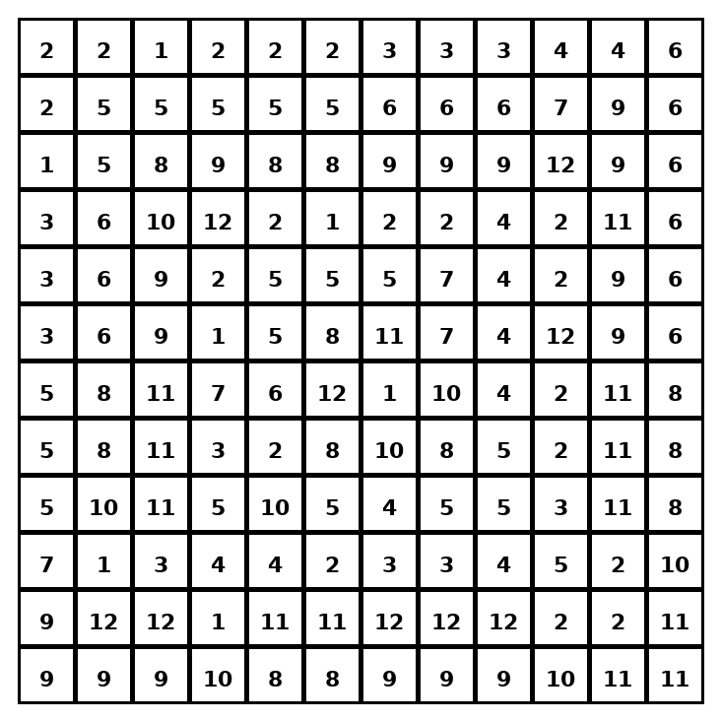

Early finisher writing: Choose one problem and explain your thinking in one complete sentence: Because ___, I ___.
____________________________________________________________________________________________

Teacher Answer Key
# | Answer | Color | Teacher Tip
1 | 50% | red | Change the fraction to a decimal or use an equivalent fraction out of 100.
2 | 25% | orange | Change the fraction to a decimal or use an equivalent fraction out of 100.
3 | 75% | yellow | Change the fraction to a decimal or use an equivalent fraction out of 100.
4 | 20% | green | Change the fraction to a decimal or use an equivalent fraction out of 100.
5 | 40% | blue | Change the fraction to a decimal or use an equivalent fraction out of 100.
6 | 60% | purple | Change the fraction to a decimal or use an equivalent fraction out of 100.
7 | 80% | pink | Change the fraction to a decimal or use an equivalent fraction out of 100.
8 | 10% | brown | Change the fraction to a decimal or use an equivalent fraction out of 100.
9 | 70% | gray | Change the fraction to a decimal or use an equivalent fraction out of 100.
10 | 12.5% | teal | Change the fraction to a decimal or use an equivalent fraction out of 100.
11 | 37.5% | black | Change the fraction to a decimal or use an equivalent fraction out of 100.
12 | 62.5% | light blue | Change the fraction to a decimal or use an equivalent fraction out of 100.

Use note: This file is original practice aligned to the lesson skill. It is designed for low-prep review, centers, sub plans, or early finishers.

