4-3 Percents Greater Than 100% and Less Than 1%
Arcade Builder | Standard: 6.RP.3c | Color-by-Number Practice

Learning Goal: I can write and interpret percents greater than 100% and less than 1%. | Directions: Solve each problem. Match each answer to the Color Code. On the next page, color every box with that problem number using the matching color.

Vocabulary: percent, decimal, greater than 100%, less than 1% | Explain one: I solved problem ___ by ___. Because ___, my answer is ___.

Solve First
1. Write 1.25 as a percent.  Work: ________________________________________  Answer: ________________ | 2. Write 1.5 as a percent.  Work: ________________________________________  Answer: ________________
3. Write 2 as a percent.  Work: ________________________________________  Answer: ________________ | 4. Write 0.01 as a percent.  Work: ________________________________________  Answer: ________________
5. Write 0.01 as a percent.  Work: ________________________________________  Answer: ________________ | 6. Write 0.01 as a percent.  Work: ________________________________________  Answer: ________________
7. Write 1.75 as a percent.  Work: ________________________________________  Answer: ________________ | 8. Write 2.4 as a percent.  Work: ________________________________________  Answer: ________________
9. Write 0 as a percent.  Work: ________________________________________  Answer: ________________ | 10. Write 0.01 as a percent.  Work: ________________________________________  Answer: ________________
11. Write 1.1 as a percent.  Work: ________________________________________  Answer: ________________ | 12. Write 3.25 as a percent.  Work: ________________________________________  Answer: ________________

Quick check: Before coloring, make sure every answer appears in the Color Code on the next page.

4-3 Mystery Picture: Arcade Token Mosaic
Solve a problem, match the answer to a color, then color every box with that problem number.
Color Code | Color Code | Color Code | Color Code
125% = red | 150% = orange | 200% = yellow | 0.5% = green
1% = blue | 0.8% = purple | 175% = pink | 240% = brown
0.2% = gray | 0.6% = teal | 110% = black | 325% = light blue

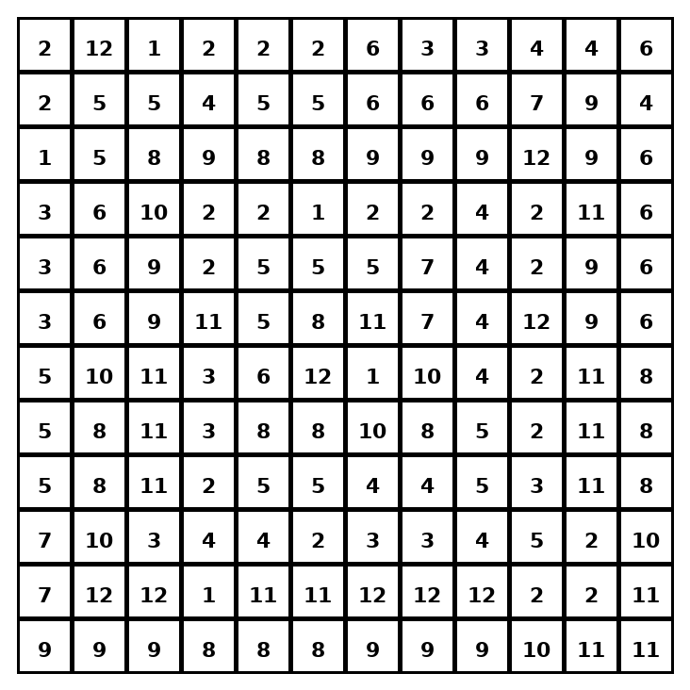

Early finisher writing: Choose one problem and explain your thinking in one complete sentence: Because ___, I ___.
____________________________________________________________________________________________

Teacher Answer Key
# | Answer | Color | Teacher Tip
1 | 125% | red | Multiply the decimal by 100.
2 | 150% | orange | Multiply the decimal by 100.
3 | 200% | yellow | Multiply the decimal by 100.
4 | 0.5% | green | Multiply the decimal by 100.
5 | 1% | blue | Multiply the decimal by 100.
6 | 0.8% | purple | Multiply the decimal by 100.
7 | 175% | pink | Multiply the decimal by 100.
8 | 240% | brown | Multiply the decimal by 100.
9 | 0.2% | gray | Multiply the decimal by 100.
10 | 0.6% | teal | Multiply the decimal by 100.
11 | 110% | black | Multiply the decimal by 100.
12 | 325% | light blue | Multiply the decimal by 100.

Use note: This file is original practice aligned to the lesson skill. It is designed for low-prep review, centers, sub plans, or early finishers.

