4-4 Find the Percent of a Number
Arcade Builder | Standard: 6.RP.3c | Color-by-Number Practice

Learning Goal: I can find the percent of a number using an equation or a model. | Directions: Solve each problem. Match each answer to the Color Code. On the next page, color every box with that problem number using the matching color.

Vocabulary: percent, of, multiply | Explain one: I solved problem ___ by ___. Because ___, my answer is ___.

Solve First
1. Find 10% of 80.  Work: ________________________________________  Answer: ________________ | 2. Find 25% of 40.  Work: ________________________________________  Answer: ________________
3. Find 50% of 18.  Work: ________________________________________  Answer: ________________ | 4. Find 75% of 24.  Work: ________________________________________  Answer: ________________
5. Find 20% of 35.  Work: ________________________________________  Answer: ________________ | 6. Find 30% of 60.  Work: ________________________________________  Answer: ________________
7. Find 40% of 45.  Work: ________________________________________  Answer: ________________ | 8. Find 15% of 200.  Work: ________________________________________  Answer: ________________
9. Find 5% of 160.  Work: ________________________________________  Answer: ________________ | 10. Find 60% of 50.  Work: ________________________________________  Answer: ________________
11. Find 12% of 100.  Work: ________________________________________  Answer: ________________ | 12. Find 35% of 80.  Work: ________________________________________  Answer: ________________

Quick check: Before coloring, make sure every answer appears in the Color Code on the next page.

4-4 Mystery Picture: Arcade Token Mosaic
Solve a problem, match the answer to a color, then color every box with that problem number.
Color Code | Color Code | Color Code | Color Code
8 = red | 10 = orange | 9 = yellow | 18 = green
7 = blue | 30 = purple | 12 = pink | 28 = brown

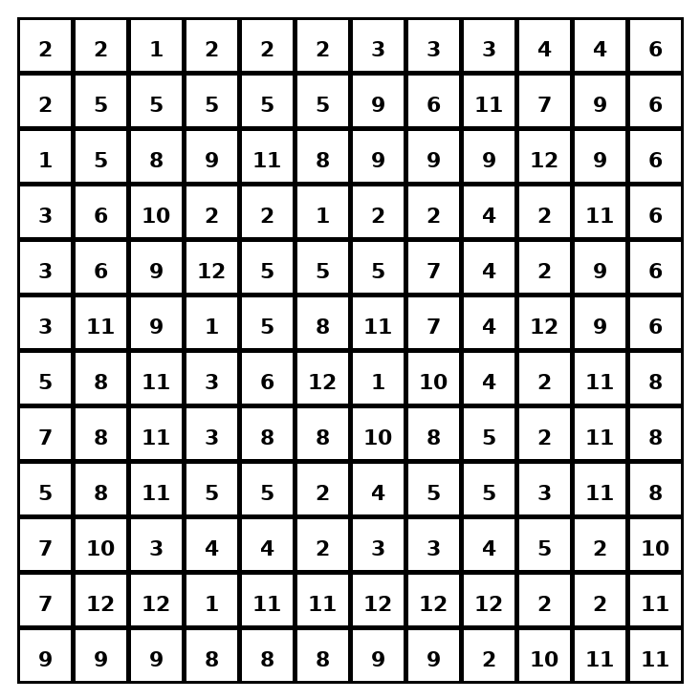

Early finisher writing: Choose one problem and explain your thinking in one complete sentence: Because ___, I ___.
____________________________________________________________________________________________

Teacher Answer Key
# | Answer | Color | Teacher Tip
1 | 8 | red | Change the percent to a fraction or decimal, then multiply.
2 | 10 | orange | Change the percent to a fraction or decimal, then multiply.
3 | 9 | yellow | Change the percent to a fraction or decimal, then multiply.
4 | 18 | green | Change the percent to a fraction or decimal, then multiply.
5 | 7 | blue | Change the percent to a fraction or decimal, then multiply.
6 | 18 | green | Change the percent to a fraction or decimal, then multiply.
7 | 18 | green | Change the percent to a fraction or decimal, then multiply.
8 | 30 | purple | Change the percent to a fraction or decimal, then multiply.
9 | 8 | red | Change the percent to a fraction or decimal, then multiply.
10 | 30 | purple | Change the percent to a fraction or decimal, then multiply.
11 | 12 | pink | Change the percent to a fraction or decimal, then multiply.
12 | 28 | brown | Change the percent to a fraction or decimal, then multiply.

Use note: This file is original practice aligned to the lesson skill. It is designed for low-prep review, centers, sub plans, or early finishers.

