4-5 Use Percent to Solve Problems
Arcade Builder | Standard: 6.RP.3c | Color-by-Number Practice

Learning Goal: I can solve problems involving discounts, markups, tax, and tips using percents. | Directions: Solve each problem. Match each answer to the Color Code. On the next page, color every box with that problem number using the matching color.

Vocabulary: discount, tax, tip, percent amount | Explain one: I solved problem ___ by ___. Because ___, my answer is ___.

Solve First
1. A $50 item has a 20% discount. What is 20% of $50?  Work: ________________________________________  Answer: ________________ | 2. A $80 item has a 10% tip. What is 10% of $80?  Work: ________________________________________  Answer: ________________
3. A $40 item has a 25% discount. What is 25% of $40?  Work: ________________________________________  Answer: ________________ | 4. A $60 item has a 15% tax/tip. What is 15% of $60?  Work: ________________________________________  Answer: ________________
5. A $90 item has a 30% discount. What is 30% of $90?  Work: ________________________________________  Answer: ________________ | 6. A $200 item has a 5% tax. What is 5% of $200?  Work: ________________________________________  Answer: ________________
7. A $75 item has a 40% discount. What is 40% of $75?  Work: ________________________________________  Answer: ________________ | 8. A $100 item has a 12% tip. What is 12% of $100?  Work: ________________________________________  Answer: ________________
9. A $36 item has a 50% discount. What is 50% of $36?  Work: ________________________________________  Answer: ________________ | 10. A $150 item has a 8% tax. What is 8% of $150?  Work: ________________________________________  Answer: ________________
11. A $120 item has a 35% discount. What is 35% of $120?  Work: ________________________________________  Answer: ________________ | 12. A $50 item has a 18% tip. What is 18% of $50?  Work: ________________________________________  Answer: ________________

Quick check: Before coloring, make sure every answer appears in the Color Code on the next page.

4-5 Mystery Picture: Arcade Token Mosaic
Solve a problem, match the answer to a color, then color every box with that problem number.
Color Code | Color Code | Color Code | Color Code
10 = red | 8 = orange | 9 = yellow | 27 = green
30 = blue | 12 = purple | 18 = pink | 42 = brown

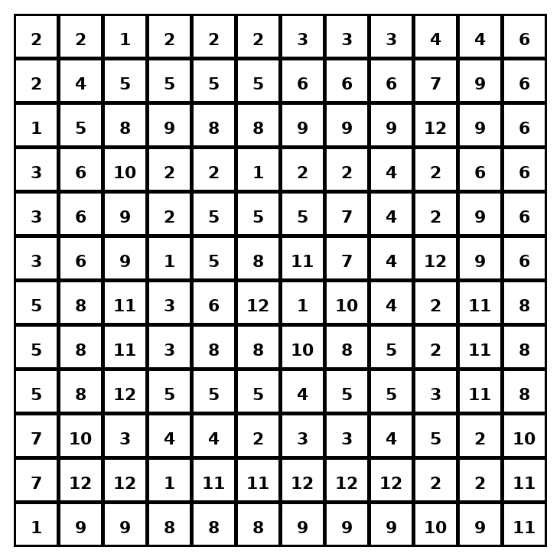

Early finisher writing: Choose one problem and explain your thinking in one complete sentence: Because ___, I ___.
____________________________________________________________________________________________

Teacher Answer Key
# | Answer | Color | Teacher Tip
1 | 10 | red | Find the percent amount first.
2 | 8 | orange | Find the percent amount first.
3 | 10 | red | Find the percent amount first.
4 | 9 | yellow | Find the percent amount first.
5 | 27 | green | Find the percent amount first.
6 | 10 | red | Find the percent amount first.
7 | 30 | blue | Find the percent amount first.
8 | 12 | purple | Find the percent amount first.
9 | 18 | pink | Find the percent amount first.
10 | 12 | purple | Find the percent amount first.
11 | 42 | brown | Find the percent amount first.
12 | 9 | yellow | Find the percent amount first.

Use note: This file is original practice aligned to the lesson skill. It is designed for low-prep review, centers, sub plans, or early finishers.

