4-6 Convert Measurement Units
Arcade Builder | Standard: 6.RP.3d | Color-by-Number Practice

Learning Goal: I can convert measurement units using ratios and conversion factors. | Directions: Solve each problem. Match each answer to the Color Code. On the next page, color every box with that problem number using the matching color.

Vocabulary: conversion factor, units, multiply | Explain one: I solved problem ___ by ___. Because ___, my answer is ___.

Solve First
1. Convert 3 feet to inches.  Work: ________________________________________  Answer: ________________ | 2. Convert 5 yards to feet.  Work: ________________________________________  Answer: ________________
3. Convert 2 hours to minutes.  Work: ________________________________________  Answer: ________________ | 4. Convert 4 minutes to seconds.  Work: ________________________________________  Answer: ________________
5. Convert 6 pounds to ounces.  Work: ________________________________________  Answer: ________________ | 6. Convert 3 quarts to cups.  Work: ________________________________________  Answer: ________________
7. Convert 2 gallons to quarts.  Work: ________________________________________  Answer: ________________ | 8. Convert 5 kilometers to meters.  Work: ________________________________________  Answer: ________________
9. Convert 7 meters to centimeters.  Work: ________________________________________  Answer: ________________ | 10. Convert 4 liters to milliliters.  Work: ________________________________________  Answer: ________________
11. Convert 3 weeks to days.  Work: ________________________________________  Answer: ________________ | 12. Convert 8 dozens to items.  Work: ________________________________________  Answer: ________________

Quick check: Before coloring, make sure every answer appears in the Color Code on the next page.

4-6 Mystery Picture: Arcade Token Mosaic
Solve a problem, match the answer to a color, then color every box with that problem number.
Color Code | Color Code | Color Code | Color Code
36 inches = red | 15 feet = orange | 120 minutes = yellow | 240 seconds = green
96 ounces = blue | 12 cups = purple | 8 quarts = pink | 5000 meters = brown
700 centimeters = gray | 4000 milliliters = teal | 21 days = black | 96 items = light blue

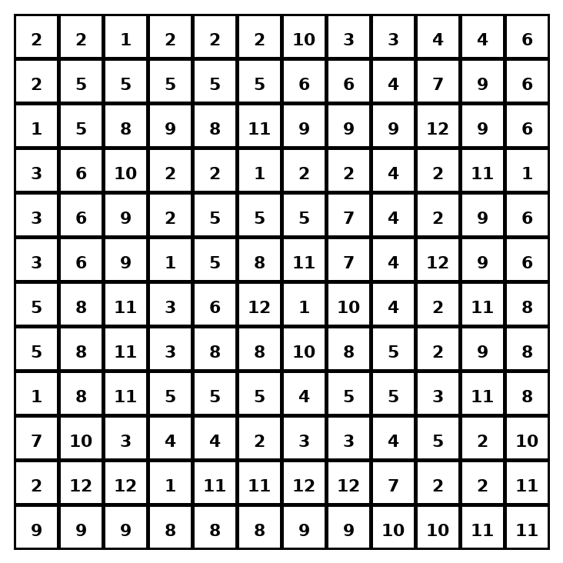

Early finisher writing: Choose one problem and explain your thinking in one complete sentence: Because ___, I ___.
____________________________________________________________________________________________

Teacher Answer Key
# | Answer | Color | Teacher Tip
1 | 36 inches | red | Multiply by the conversion factor.
2 | 15 feet | orange | Multiply by the conversion factor.
3 | 120 minutes | yellow | Multiply by the conversion factor.
4 | 240 seconds | green | Multiply by the conversion factor.
5 | 96 ounces | blue | Multiply by the conversion factor.
6 | 12 cups | purple | Multiply by the conversion factor.
7 | 8 quarts | pink | Multiply by the conversion factor.
8 | 5000 meters | brown | Multiply by the conversion factor.
9 | 700 centimeters | gray | Multiply by the conversion factor.
10 | 4000 milliliters | teal | Multiply by the conversion factor.
11 | 21 days | black | Multiply by the conversion factor.
12 | 96 items | light blue | Multiply by the conversion factor.

Use note: This file is original practice aligned to the lesson skill. It is designed for low-prep review, centers, sub plans, or early finishers.

