5-2 Area of Trapezoids
Architecture Firm | Standard: 6.G.1 | Color-by-Number Practice

Learning Goal: I can find the area of a trapezoid using the formula A = 1/2(b1 + b2) x h. | Directions: Solve each problem. Match each answer to the Color Code. On the next page, color every box with that problem number using the matching color.

Vocabulary: base, height, trapezoid, area | Explain one: I solved problem ___ by ___. Because ___, my answer is ___.

Solve First
1. Find the area of a trapezoid with bases 6, 10 and height 4.  Work: ________________________________________  Answer: ________________ | 2. Find the area of a trapezoid with bases 8, 12 and height 5.  Work: ________________________________________  Answer: ________________
3. Find the area of a trapezoid with bases 5, 9 and height 6.  Work: ________________________________________  Answer: ________________ | 4. Find the area of a trapezoid with bases 7, 13 and height 4.  Work: ________________________________________  Answer: ________________
5. Find the area of a trapezoid with bases 10, 14 and height 3.  Work: ________________________________________  Answer: ________________ | 6. Find the area of a trapezoid with bases 9, 15 and height 6.  Work: ________________________________________  Answer: ________________
7. Find the area of a trapezoid with bases 12, 16 and height 5.  Work: ________________________________________  Answer: ________________ | 8. Find the area of a trapezoid with bases 4, 8 and height 7.  Work: ________________________________________  Answer: ________________
9. Find the area of a trapezoid with bases 11, 17 and height 4.  Work: ________________________________________  Answer: ________________ | 10. Find the area of a trapezoid with bases 14, 20 and height 3.  Work: ________________________________________  Answer: ________________
11. Find the area of a trapezoid with bases 6, 18 and height 5.  Work: ________________________________________  Answer: ________________ | 12. Find the area of a trapezoid with bases 13, 19 and height 6.  Work: ________________________________________  Answer: ________________

Quick check: Before coloring, make sure every answer appears in the Color Code on the next page.

5-2 Mystery Picture: Blueprint Mosaic
Solve a problem, match the answer to a color, then color every box with that problem number.
Color Code | Color Code | Color Code | Color Code
32 = red | 50 = orange | 42 = yellow | 40 = green
36 = blue | 72 = purple | 70 = pink | 56 = brown
51 = gray | 60 = teal | 96 = black

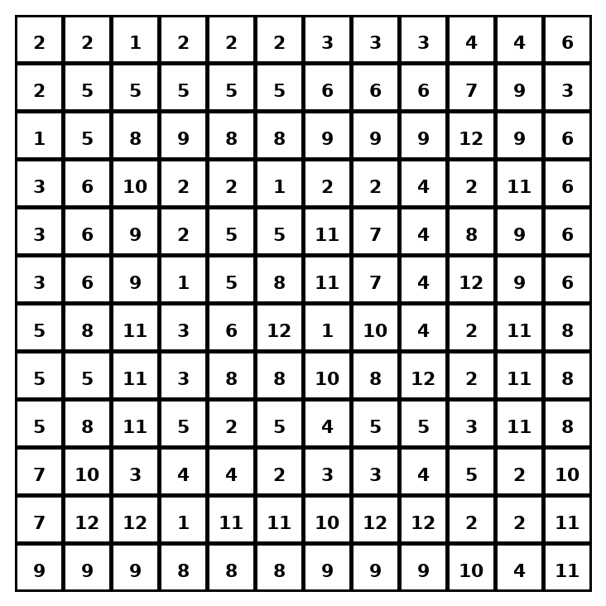

Early finisher writing: Choose one problem and explain your thinking in one complete sentence: Because ___, I ___.
____________________________________________________________________________________________

Teacher Answer Key
# | Answer | Color | Teacher Tip
1 | 32 | red | A = 1/2(b1 + b2)h.
2 | 50 | orange | A = 1/2(b1 + b2)h.
3 | 42 | yellow | A = 1/2(b1 + b2)h.
4 | 40 | green | A = 1/2(b1 + b2)h.
5 | 36 | blue | A = 1/2(b1 + b2)h.
6 | 72 | purple | A = 1/2(b1 + b2)h.
7 | 70 | pink | A = 1/2(b1 + b2)h.
8 | 42 | yellow | A = 1/2(b1 + b2)h.
9 | 56 | brown | A = 1/2(b1 + b2)h.
10 | 51 | gray | A = 1/2(b1 + b2)h.
11 | 60 | teal | A = 1/2(b1 + b2)h.
12 | 96 | black | A = 1/2(b1 + b2)h.

Use note: This file is original practice aligned to the lesson skill. It is designed for low-prep review, centers, sub plans, or early finishers.

