5-3-flagship Area of Triangles Flagship
Architecture Firm | Standard: 6.G.1 | Color-by-Number Practice

Learning Goal: I can find the area of a triangle using the formula A = 1/2 x base x height. | Directions: Solve each problem. Match each answer to the Color Code. On the next page, color every box with that problem number using the matching color.

Vocabulary: base, height, triangle, area | Explain one: I solved problem ___ by ___. Because ___, my answer is ___.

Solve First
1. Find the area of a triangle with base 7 and height 8.  Work: ________________________________________  Answer: ________________ | 2. Find the area of a triangle with base 9 and height 10.  Work: ________________________________________  Answer: ________________
3. Find the area of a triangle with base 11 and height 12.  Work: ________________________________________  Answer: ________________ | 4. Find the area of a triangle with base 13 and height 14.  Work: ________________________________________  Answer: ________________
5. Find the area of a triangle with base 15 and height 16.  Work: ________________________________________  Answer: ________________ | 6. Find the area of a triangle with base 17 and height 6.  Work: ________________________________________  Answer: ________________
7. Find the area of a triangle with base 19 and height 8.  Work: ________________________________________  Answer: ________________ | 8. Find the area of a triangle with base 21 and height 10.  Work: ________________________________________  Answer: ________________
9. Find the area of a triangle with base 23 and height 12.  Work: ________________________________________  Answer: ________________ | 10. Find the area of a triangle with base 25 and height 14.  Work: ________________________________________  Answer: ________________
11. Find the area of a triangle with base 18 and height 15.  Work: ________________________________________  Answer: ________________ | 12. Find the area of a triangle with base 22 and height 9.  Work: ________________________________________  Answer: ________________

Quick check: Before coloring, make sure every answer appears in the Color Code on the next page.

5-3-flagship Mystery Picture: Blueprint Mosaic
Solve a problem, match the answer to a color, then color every box with that problem number.
Color Code | Color Code | Color Code | Color Code
28 = red | 45 = orange | 66 = yellow | 91 = green
120 = blue | 51 = purple | 76 = pink | 105 = brown
138 = gray | 175 = teal | 135 = black | 99 = light blue

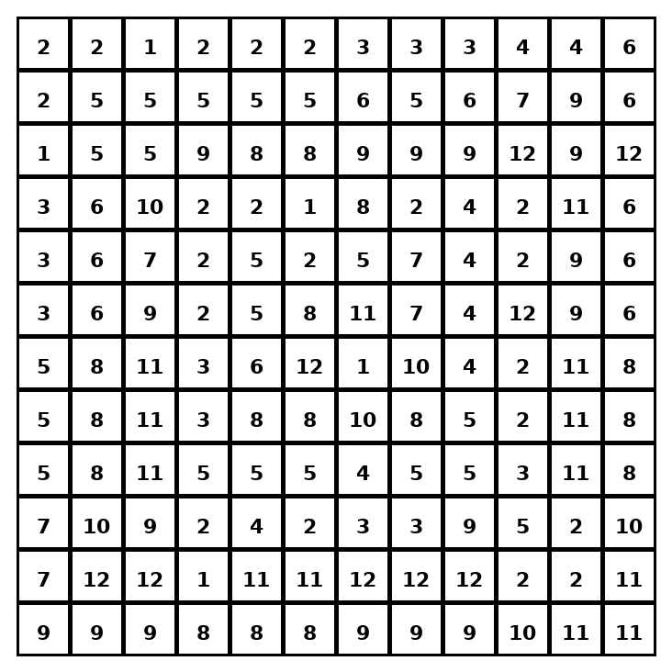

Early finisher writing: Choose one problem and explain your thinking in one complete sentence: Because ___, I ___.
____________________________________________________________________________________________

Teacher Answer Key
# | Answer | Color | Teacher Tip
1 | 28 | red | A = 1/2 x base x height.
2 | 45 | orange | A = 1/2 x base x height.
3 | 66 | yellow | A = 1/2 x base x height.
4 | 91 | green | A = 1/2 x base x height.
5 | 120 | blue | A = 1/2 x base x height.
6 | 51 | purple | A = 1/2 x base x height.
7 | 76 | pink | A = 1/2 x base x height.
8 | 105 | brown | A = 1/2 x base x height.
9 | 138 | gray | A = 1/2 x base x height.
10 | 175 | teal | A = 1/2 x base x height.
11 | 135 | black | A = 1/2 x base x height.
12 | 99 | light blue | A = 1/2 x base x height.

Use note: This file is original practice aligned to the lesson skill. It is designed for low-prep review, centers, sub plans, or early finishers.

