5-3 Area of Triangles
Architecture Firm | Standard: 6.G.1 | Color-by-Number Practice

Learning Goal: I can find the area of a triangle using the formula A = 1/2 x base x height. | Directions: Solve each problem. Match each answer to the Color Code. On the next page, color every box with that problem number using the matching color.

Vocabulary: base, height, triangle, area | Explain one: I solved problem ___ by ___. Because ___, my answer is ___.

Solve First
1. Find the area of a triangle with base 6 and height 4.  Work: ________________________________________  Answer: ________________ | 2. Find the area of a triangle with base 8 and height 5.  Work: ________________________________________  Answer: ________________
3. Find the area of a triangle with base 10 and height 6.  Work: ________________________________________  Answer: ________________ | 4. Find the area of a triangle with base 12 and height 7.  Work: ________________________________________  Answer: ________________
5. Find the area of a triangle with base 14 and height 8.  Work: ________________________________________  Answer: ________________ | 6. Find the area of a triangle with base 9 and height 6.  Work: ________________________________________  Answer: ________________
7. Find the area of a triangle with base 11 and height 10.  Work: ________________________________________  Answer: ________________ | 8. Find the area of a triangle with base 15 and height 4.  Work: ________________________________________  Answer: ________________
9. Find the area of a triangle with base 16 and height 9.  Work: ________________________________________  Answer: ________________ | 10. Find the area of a triangle with base 18 and height 5.  Work: ________________________________________  Answer: ________________
11. Find the area of a triangle with base 20 and height 7.  Work: ________________________________________  Answer: ________________ | 12. Find the area of a triangle with base 13 and height 12.  Work: ________________________________________  Answer: ________________

Quick check: Before coloring, make sure every answer appears in the Color Code on the next page.

5-3 Mystery Picture: Blueprint Mosaic
Solve a problem, match the answer to a color, then color every box with that problem number.
Color Code | Color Code | Color Code | Color Code
12 = red | 20 = orange | 30 = yellow | 42 = green
56 = blue | 27 = purple | 55 = pink | 72 = brown
45 = gray | 70 = teal | 78 = black

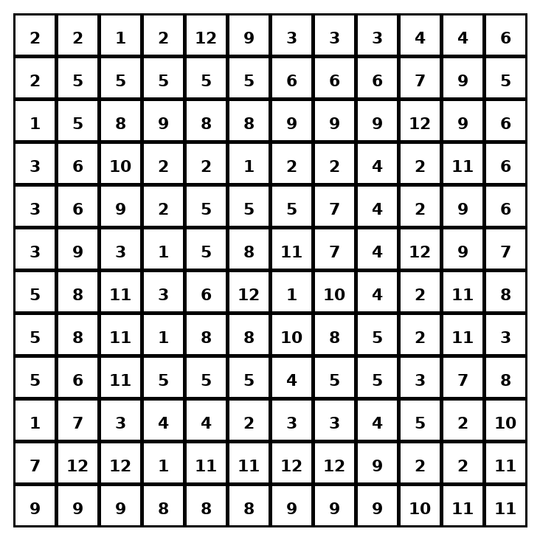

Early finisher writing: Choose one problem and explain your thinking in one complete sentence: Because ___, I ___.
____________________________________________________________________________________________

Teacher Answer Key
# | Answer | Color | Teacher Tip
1 | 12 | red | A = 1/2 x base x height.
2 | 20 | orange | A = 1/2 x base x height.
3 | 30 | yellow | A = 1/2 x base x height.
4 | 42 | green | A = 1/2 x base x height.
5 | 56 | blue | A = 1/2 x base x height.
6 | 27 | purple | A = 1/2 x base x height.
7 | 55 | pink | A = 1/2 x base x height.
8 | 30 | yellow | A = 1/2 x base x height.
9 | 72 | brown | A = 1/2 x base x height.
10 | 45 | gray | A = 1/2 x base x height.
11 | 70 | teal | A = 1/2 x base x height.
12 | 78 | black | A = 1/2 x base x height.

Use note: This file is original practice aligned to the lesson skill. It is designed for low-prep review, centers, sub plans, or early finishers.

