5-4 Area of Regular Polygons
Architecture Firm | Standard: 6.G.1 | Color-by-Number Practice

Learning Goal: I can find the area of a regular polygon by decomposing it into triangles. | Directions: Solve each problem. Match each answer to the Color Code. On the next page, color every box with that problem number using the matching color.

Vocabulary: perimeter, apothem, regular polygon | Explain one: I solved problem ___ by ___. Because ___, my answer is ___.

Solve First
1. A regular polygon has perimeter 6 and apothem 4. Find its area.  Work: ________________________________________  Answer: ________________ | 2. A regular polygon has perimeter 8 and apothem 5. Find its area.  Work: ________________________________________  Answer: ________________
3. A regular polygon has perimeter 10 and apothem 6. Find its area.  Work: ________________________________________  Answer: ________________ | 4. A regular polygon has perimeter 12 and apothem 7. Find its area.  Work: ________________________________________  Answer: ________________
5. A regular polygon has perimeter 5 and apothem 8. Find its area.  Work: ________________________________________  Answer: ________________ | 6. A regular polygon has perimeter 7 and apothem 10. Find its area.  Work: ________________________________________  Answer: ________________
7. A regular polygon has perimeter 9 and apothem 12. Find its area.  Work: ________________________________________  Answer: ________________ | 8. A regular polygon has perimeter 11 and apothem 6. Find its area.  Work: ________________________________________  Answer: ________________
9. A regular polygon has perimeter 13 and apothem 4. Find its area.  Work: ________________________________________  Answer: ________________ | 10. A regular polygon has perimeter 14 and apothem 5. Find its area.  Work: ________________________________________  Answer: ________________
11. A regular polygon has perimeter 15 and apothem 8. Find its area.  Work: ________________________________________  Answer: ________________ | 12. A regular polygon has perimeter 16 and apothem 3. Find its area.  Work: ________________________________________  Answer: ________________

Quick check: Before coloring, make sure every answer appears in the Color Code on the next page.

5-4 Mystery Picture: Blueprint Mosaic
Solve a problem, match the answer to a color, then color every box with that problem number.
Color Code | Color Code | Color Code | Color Code
12 = red | 20 = orange | 30 = yellow | 42 = green
35 = blue | 54 = purple | 33 = pink | 26 = brown
60 = gray | 24 = teal

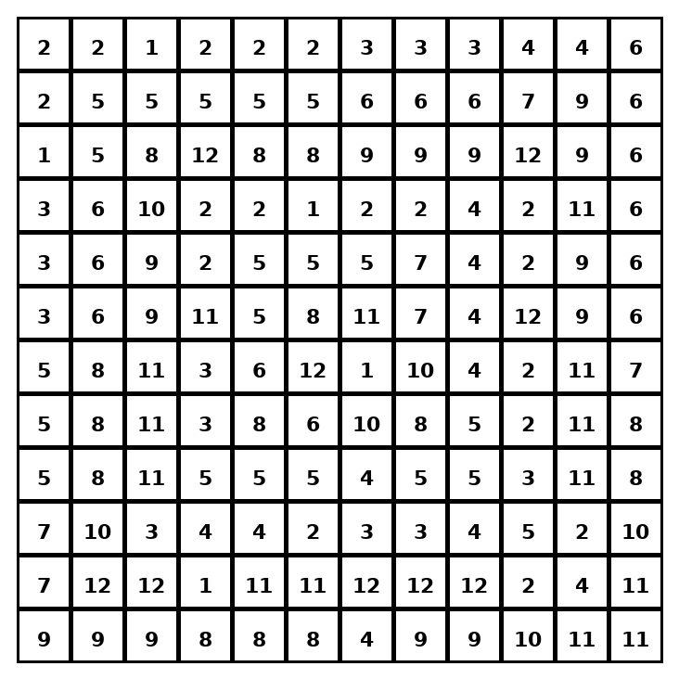

Early finisher writing: Choose one problem and explain your thinking in one complete sentence: Because ___, I ___.
____________________________________________________________________________________________

Teacher Answer Key
# | Answer | Color | Teacher Tip
1 | 12 | red | A = 1/2 x perimeter x apothem.
2 | 20 | orange | A = 1/2 x perimeter x apothem.
3 | 30 | yellow | A = 1/2 x perimeter x apothem.
4 | 42 | green | A = 1/2 x perimeter x apothem.
5 | 20 | orange | A = 1/2 x perimeter x apothem.
6 | 35 | blue | A = 1/2 x perimeter x apothem.
7 | 54 | purple | A = 1/2 x perimeter x apothem.
8 | 33 | pink | A = 1/2 x perimeter x apothem.
9 | 26 | brown | A = 1/2 x perimeter x apothem.
10 | 35 | blue | A = 1/2 x perimeter x apothem.
11 | 60 | gray | A = 1/2 x perimeter x apothem.
12 | 24 | teal | A = 1/2 x perimeter x apothem.

Use note: This file is original practice aligned to the lesson skill. It is designed for low-prep review, centers, sub plans, or early finishers.

