5-5 Area of Composite Figures
Architecture Firm | Standard: 6.G.1 | Color-by-Number Practice

Learning Goal: I can find the area of a composite figure by adding or subtracting the areas of basic shapes. | Directions: Solve each problem. Match each answer to the Color Code. On the next page, color every box with that problem number using the matching color.

Vocabulary: composite figure, add, subtract, area | Explain one: I solved problem ___ by ___. Because ___, my answer is ___.

Solve First
1. A composite figure is a 6 x 4 rectangle with a 3 x 2 rectangle added. Find the total area.  Work: ________________________________________  Answer: ________________ | 2. A composite figure is a 8 x 5 rectangle with a 4 x 3 rectangle added. Find the total area.  Work: ________________________________________  Answer: ________________
3. A composite figure is a 10 x 6 rectangle with a 5 x 2 rectangle added. Find the total area.  Work: ________________________________________  Answer: ________________ | 4. A composite figure is a 12 x 7 rectangle with a 6 x 3 rectangle added. Find the total area.  Work: ________________________________________  Answer: ________________
5. A composite figure is a 9 x 8 rectangle with a 3 x 4 rectangle added. Find the total area.  Work: ________________________________________  Answer: ________________ | 6. A composite figure is a 14 x 5 rectangle with a 4 x 2 rectangle added. Find the total area.  Work: ________________________________________  Answer: ________________
7. A composite figure is a 15 x 6 rectangle with a 5 x 3 rectangle added. Find the total area.  Work: ________________________________________  Answer: ________________ | 8. A composite figure is a 16 x 7 rectangle with a 6 x 2 rectangle added. Find the total area.  Work: ________________________________________  Answer: ________________
9. A composite figure is a 18 x 8 rectangle with a 3 x 5 rectangle added. Find the total area.  Work: ________________________________________  Answer: ________________ | 10. A composite figure is a 20 x 9 rectangle with a 4 x 4 rectangle added. Find the total area.  Work: ________________________________________  Answer: ________________
11. A composite figure is a 11 x 10 rectangle with a 5 x 2 rectangle added. Find the total area.  Work: ________________________________________  Answer: ________________ | 12. A composite figure is a 13 x 12 rectangle with a 6 x 3 rectangle added. Find the total area.  Work: ________________________________________  Answer: ________________

Quick check: Before coloring, make sure every answer appears in the Color Code on the next page.

5-5 Mystery Picture: Blueprint Mosaic
Solve a problem, match the answer to a color, then color every box with that problem number.
Color Code | Color Code | Color Code | Color Code
30 = red | 52 = orange | 70 = yellow | 102 = green
84 = blue | 78 = purple | 105 = pink | 124 = brown
159 = gray | 196 = teal | 120 = black | 174 = light blue

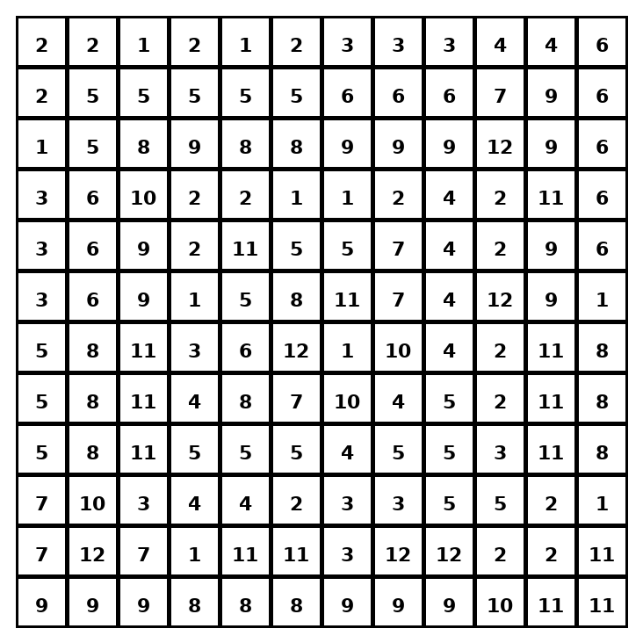

Early finisher writing: Choose one problem and explain your thinking in one complete sentence: Because ___, I ___.
____________________________________________________________________________________________

Teacher Answer Key
# | Answer | Color | Teacher Tip
1 | 30 | red | Find each area, then add.
2 | 52 | orange | Find each area, then add.
3 | 70 | yellow | Find each area, then add.
4 | 102 | green | Find each area, then add.
5 | 84 | blue | Find each area, then add.
6 | 78 | purple | Find each area, then add.
7 | 105 | pink | Find each area, then add.
8 | 124 | brown | Find each area, then add.
9 | 159 | gray | Find each area, then add.
10 | 196 | teal | Find each area, then add.
11 | 120 | black | Find each area, then add.
12 | 174 | light blue | Find each area, then add.

Use note: This file is original practice aligned to the lesson skill. It is designed for low-prep review, centers, sub plans, or early finishers.

