6-1 Powers and Exponents
Music Studio | Standard: 6.EE.1 | Color-by-Number Practice

Learning Goal: I can write and evaluate numbers in exponent form using a base and a power. | Directions: Solve each problem. Match each answer to the Color Code. On the next page, color every box with that problem number using the matching color.

Vocabulary: base, exponent, power, evaluate | Explain one: I solved problem ___ by ___. Because ___, my answer is ___.

Solve First
1. Evaluate 2^3.  Work: ________________________________________  Answer: ________________ | 2. Evaluate 3^2.  Work: ________________________________________  Answer: ________________
3. Evaluate 4^2.  Work: ________________________________________  Answer: ________________ | 4. Evaluate 5^2.  Work: ________________________________________  Answer: ________________
5. Evaluate 2^4.  Work: ________________________________________  Answer: ________________ | 6. Evaluate 10^2.  Work: ________________________________________  Answer: ________________
7. Evaluate 6^2.  Work: ________________________________________  Answer: ________________ | 8. Evaluate 3^3.  Work: ________________________________________  Answer: ________________
9. Evaluate 2^5.  Work: ________________________________________  Answer: ________________ | 10. Evaluate 7^2.  Work: ________________________________________  Answer: ________________
11. Evaluate 4^3.  Work: ________________________________________  Answer: ________________ | 12. Evaluate 5^3.  Work: ________________________________________  Answer: ________________

Quick check: Before coloring, make sure every answer appears in the Color Code on the next page.

6-1 Mystery Picture: Beat Board Mosaic
Solve a problem, match the answer to a color, then color every box with that problem number.
Color Code | Color Code | Color Code | Color Code
8 = red | 9 = orange | 16 = yellow | 25 = green
100 = blue | 36 = purple | 27 = pink | 32 = brown
49 = gray | 64 = teal | 125 = black

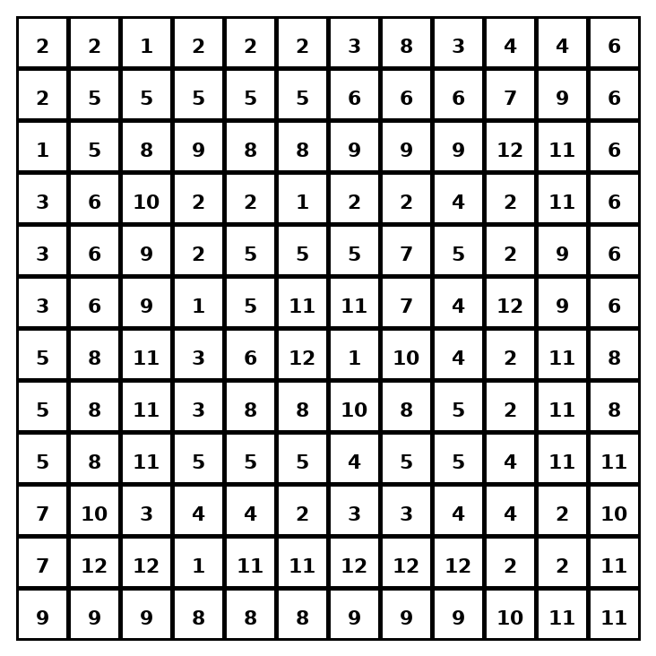

Early finisher writing: Choose one problem and explain your thinking in one complete sentence: Because ___, I ___.
____________________________________________________________________________________________

Teacher Answer Key
# | Answer | Color | Teacher Tip
1 | 8 | red | Multiply the base by itself the exponent number of times.
2 | 9 | orange | Multiply the base by itself the exponent number of times.
3 | 16 | yellow | Multiply the base by itself the exponent number of times.
4 | 25 | green | Multiply the base by itself the exponent number of times.
5 | 16 | yellow | Multiply the base by itself the exponent number of times.
6 | 100 | blue | Multiply the base by itself the exponent number of times.
7 | 36 | purple | Multiply the base by itself the exponent number of times.
8 | 27 | pink | Multiply the base by itself the exponent number of times.
9 | 32 | brown | Multiply the base by itself the exponent number of times.
10 | 49 | gray | Multiply the base by itself the exponent number of times.
11 | 64 | teal | Multiply the base by itself the exponent number of times.
12 | 125 | black | Multiply the base by itself the exponent number of times.

Use note: This file is original practice aligned to the lesson skill. It is designed for low-prep review, centers, sub plans, or early finishers.

