6-2 Evaluate Expressions
Music Studio | Standard: 6.EE.2c | Color-by-Number Practice

Learning Goal: I can evaluate algebraic expressions by substituting values for the variables. | Directions: Solve each problem. Match each answer to the Color Code. On the next page, color every box with that problem number using the matching color.

Vocabulary: variable, substitute, expression, value | Explain one: I solved problem ___ by ___. Because ___, my answer is ___.

Solve First
1. Evaluate 3x + 2 when x=4.  Work: ________________________________________  Answer: ________________ | 2. Evaluate 5x - 1 when x=6.  Work: ________________________________________  Answer: ________________
3. Evaluate 2a + 7 when a=8.  Work: ________________________________________  Answer: ________________ | 4. Evaluate 4n + 3 when n=5.  Work: ________________________________________  Answer: ________________
5. Evaluate 6m - 2 when m=7.  Work: ________________________________________  Answer: ________________ | 6. Evaluate 10 - y when y=3.  Work: ________________________________________  Answer: ________________
7. Evaluate p/3 + 5 when p=12.  Work: ________________________________________  Answer: ________________ | 8. Evaluate 2q + 9 when q=9.  Work: ________________________________________  Answer: ________________
9. Evaluate 7r - 4 when r=3.  Work: ________________________________________  Answer: ________________ | 10. Evaluate s/4 + 6 when s=20.  Work: ________________________________________  Answer: ________________
11. Evaluate 8 + 3t when t=6.  Work: ________________________________________  Answer: ________________ | 12. Evaluate 18 - 2z when z=5.  Work: ________________________________________  Answer: ________________

Quick check: Before coloring, make sure every answer appears in the Color Code on the next page.

6-2 Mystery Picture: Beat Board Mosaic
Solve a problem, match the answer to a color, then color every box with that problem number.
Color Code | Color Code | Color Code | Color Code
14 = red | 29 = orange | 23 = yellow | 40 = green
7 = blue | 9 = purple | 27 = pink | 17 = brown
11 = gray | 26 = teal | 8 = black

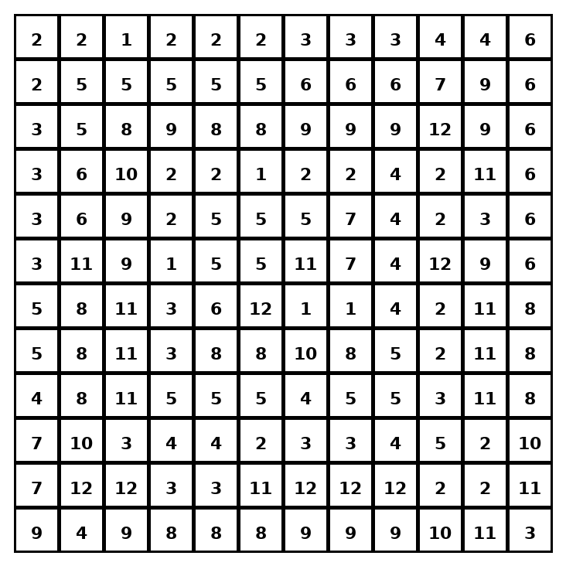

Early finisher writing: Choose one problem and explain your thinking in one complete sentence: Because ___, I ___.
____________________________________________________________________________________________

Teacher Answer Key
# | Answer | Color | Teacher Tip
1 | 14 | red | Substitute the value for the variable first.
2 | 29 | orange | Substitute the value for the variable first.
3 | 23 | yellow | Substitute the value for the variable first.
4 | 23 | yellow | Substitute the value for the variable first.
5 | 40 | green | Substitute the value for the variable first.
6 | 7 | blue | Substitute the value for the variable first.
7 | 9 | purple | Substitute the value for the variable first.
8 | 27 | pink | Substitute the value for the variable first.
9 | 17 | brown | Substitute the value for the variable first.
10 | 11 | gray | Substitute the value for the variable first.
11 | 26 | teal | Substitute the value for the variable first.
12 | 8 | black | Substitute the value for the variable first.

Use note: This file is original practice aligned to the lesson skill. It is designed for low-prep review, centers, sub plans, or early finishers.

