6-3 Write Algebraic Expressions
Music Studio | Standard: 6.EE.2a | Color-by-Number Practice

Learning Goal: I can write algebraic expressions from words and real-world situations. | Directions: Solve each problem. Match each answer to the Color Code. On the next page, color every box with that problem number using the matching color.

Vocabulary: variable, expression, operation, phrase | Explain one: I solved problem ___ by ___. Because ___, my answer is ___.

Solve First
1. Write an expression for: 7 more than x.  Work: ________________________________________  Answer: ________________ | 2. Write an expression for: 5 less than n.  Work: ________________________________________  Answer: ________________
3. Write an expression for: 3 times a number.  Work: ________________________________________  Answer: ________________ | 4. Write an expression for: half of y.  Work: ________________________________________  Answer: ________________
5. Write an expression for: the sum of m and 9.  Work: ________________________________________  Answer: ________________ | 6. Write an expression for: the product of 6 and p.  Work: ________________________________________  Answer: ________________
7. Write an expression for: q divided by 4.  Work: ________________________________________  Answer: ________________ | 8. Write an expression for: 12 minus r.  Work: ________________________________________  Answer: ________________
9. Write an expression for: twice a number plus 5.  Work: ________________________________________  Answer: ________________ | 10. Write an expression for: 8 more than 3 times k.  Work: ________________________________________  Answer: ________________
11. Write an expression for: the difference of t and 11.  Work: ________________________________________  Answer: ________________ | 12. Write an expression for: 4 groups of b.  Work: ________________________________________  Answer: ________________

Quick check: Before coloring, make sure every answer appears in the Color Code on the next page.

6-3 Mystery Picture: Beat Board Mosaic
Solve a problem, match the answer to a color, then color every box with that problem number.
Color Code | Color Code | Color Code | Color Code
x + 7 = red | n - 5 = orange | 3x = yellow | y/2 = green
m + 9 = blue | 6p = purple | q/4 = pink | 12 - r = brown
2x + 5 = gray | 3k + 8 = teal | t - 11 = black | 4b = light blue

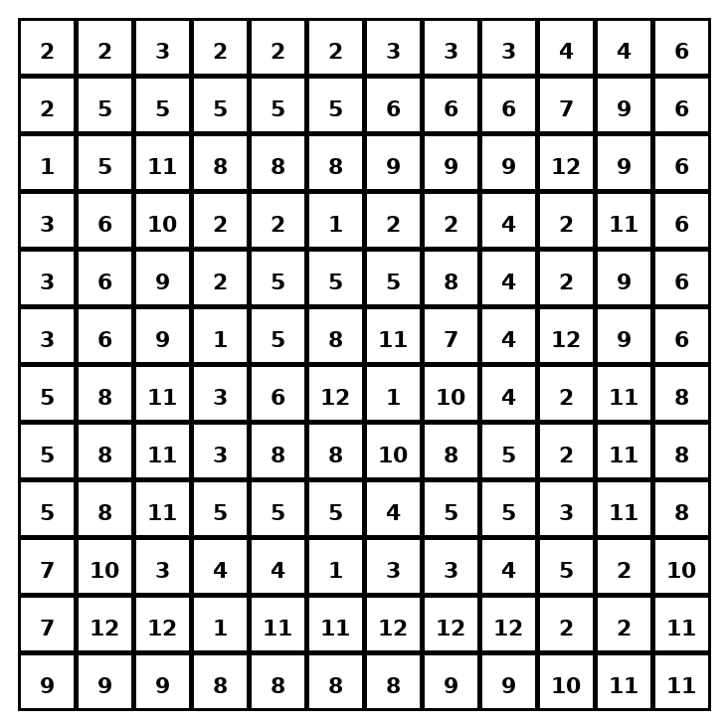

Early finisher writing: Choose one problem and explain your thinking in one complete sentence: Because ___, I ___.
____________________________________________________________________________________________

Teacher Answer Key
# | Answer | Color | Teacher Tip
1 | x + 7 | red | Translate words into operations.
2 | n - 5 | orange | Translate words into operations.
3 | 3x | yellow | Translate words into operations.
4 | y/2 | green | Translate words into operations.
5 | m + 9 | blue | Translate words into operations.
6 | 6p | purple | Translate words into operations.
7 | q/4 | pink | Translate words into operations.
8 | 12 - r | brown | Translate words into operations.
9 | 2x + 5 | gray | Translate words into operations.
10 | 3k + 8 | teal | Translate words into operations.
11 | t - 11 | black | Translate words into operations.
12 | 4b | light blue | Translate words into operations.

Use note: This file is original practice aligned to the lesson skill. It is designed for low-prep review, centers, sub plans, or early finishers.

