6-4 Properties of Operations
Music Studio | Standard: 6.EE.3 | Color-by-Number Practice

Learning Goal: I can use the commutative, associative, and identity properties to rewrite expressions. | Directions: Solve each problem. Match each answer to the Color Code. On the next page, color every box with that problem number using the matching color.

Vocabulary: commutative, associative, identity | Explain one: I solved problem ___ by ___. Because ___, my answer is ___.

Solve First
1. Complete the property statement: 7 + 5 = 5 + __  Work: ________________________________________  Answer: ________________ | 2. Complete the property statement: 3 x 9 = 9 x __  Work: ________________________________________  Answer: ________________
3. Complete the property statement: (2 + 4) + 6 = 2 + (__ + 6)  Work: ________________________________________  Answer: ________________ | 4. Complete the property statement: (5 x 3) x 2 = 5 x (__ x 2)  Work: ________________________________________  Answer: ________________
5. Complete the property statement: 8 + 0 = __  Work: ________________________________________  Answer: ________________ | 6. Complete the property statement: 12 x 1 = __  Work: ________________________________________  Answer: ________________
7. Complete the property statement: 9 + 6 = 6 + __  Work: ________________________________________  Answer: ________________ | 8. Complete the property statement: 4 x 11 = 11 x __  Work: ________________________________________  Answer: ________________
9. Complete the property statement: (7 + 1) + 5 = 7 + (__ + 5)  Work: ________________________________________  Answer: ________________ | 10. Complete the property statement: (6 x 2) x 3 = 6 x (__ x 3)  Work: ________________________________________  Answer: ________________
11. Complete the property statement: 15 + 0 = __  Work: ________________________________________  Answer: ________________ | 12. Complete the property statement: 18 x 1 = __  Work: ________________________________________  Answer: ________________

Quick check: Before coloring, make sure every answer appears in the Color Code on the next page.

6-4 Mystery Picture: Beat Board Mosaic
Solve a problem, match the answer to a color, then color every box with that problem number.
Color Code | Color Code | Color Code | Color Code
7 = red | 3 = orange | 4 = yellow | 8 = green
12 = blue | 9 = purple | 1 = pink | 2 = brown
15 = gray | 18 = teal

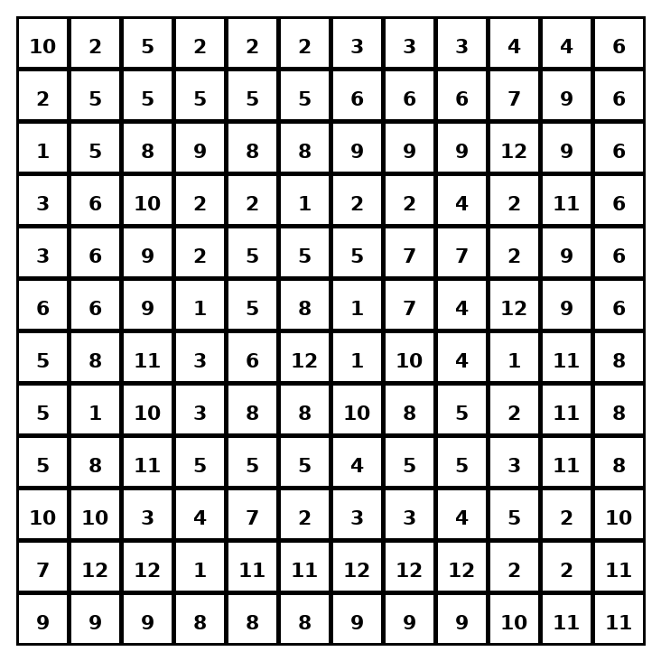

Early finisher writing: Choose one problem and explain your thinking in one complete sentence: Because ___, I ___.
____________________________________________________________________________________________

Teacher Answer Key
# | Answer | Color | Teacher Tip
1 | 7 | red | Use the property to keep the value the same.
2 | 3 | orange | Use the property to keep the value the same.
3 | 4 | yellow | Use the property to keep the value the same.
4 | 3 | orange | Use the property to keep the value the same.
5 | 8 | green | Use the property to keep the value the same.
6 | 12 | blue | Use the property to keep the value the same.
7 | 9 | purple | Use the property to keep the value the same.
8 | 4 | yellow | Use the property to keep the value the same.
9 | 1 | pink | Use the property to keep the value the same.
10 | 2 | brown | Use the property to keep the value the same.
11 | 15 | gray | Use the property to keep the value the same.
12 | 18 | teal | Use the property to keep the value the same.

Use note: This file is original practice aligned to the lesson skill. It is designed for low-prep review, centers, sub plans, or early finishers.

