6-5 The Distributive Property
Music Studio | Standard: 6.EE.3 | Color-by-Number Practice

Learning Goal: I can use the distributive property to expand and factor expressions. | Directions: Solve each problem. Match each answer to the Color Code. On the next page, color every box with that problem number using the matching color.

Vocabulary: factor, term, distribute, expand | Explain one: I solved problem ___ by ___. Because ___, my answer is ___.

Solve First
1. Expand: 3(4 + 5).  Work: ________________________________________  Answer: ________________ | 2. Expand: 2(6 + 7).  Work: ________________________________________  Answer: ________________
3. Expand: 5(3 + 8).  Work: ________________________________________  Answer: ________________ | 4. Expand: 4(9 + 2).  Work: ________________________________________  Answer: ________________
5. Expand: 6(5 + 4).  Work: ________________________________________  Answer: ________________ | 6. Expand: 7(2 + 3).  Work: ________________________________________  Answer: ________________
7. Expand: 8(1 + 6).  Work: ________________________________________  Answer: ________________ | 8. Expand: 9(4 + 1).  Work: ________________________________________  Answer: ________________
9. Expand: 10(2 + 5).  Work: ________________________________________  Answer: ________________ | 10. Expand: 11(3 + 2).  Work: ________________________________________  Answer: ________________
11. Expand: 12(1 + 4).  Work: ________________________________________  Answer: ________________ | 12. Expand: 5(7 + 9).  Work: ________________________________________  Answer: ________________

Quick check: Before coloring, make sure every answer appears in the Color Code on the next page.

6-5 Mystery Picture: Beat Board Mosaic
Solve a problem, match the answer to a color, then color every box with that problem number.
Color Code | Color Code | Color Code | Color Code
12 + 15 = red | 12 + 14 = orange | 15 + 40 = yellow | 36 + 8 = green
30 + 24 = blue | 14 + 21 = purple | 8 + 48 = pink | 36 + 9 = brown
20 + 50 = gray | 33 + 22 = teal | 12 + 48 = black | 35 + 45 = light blue

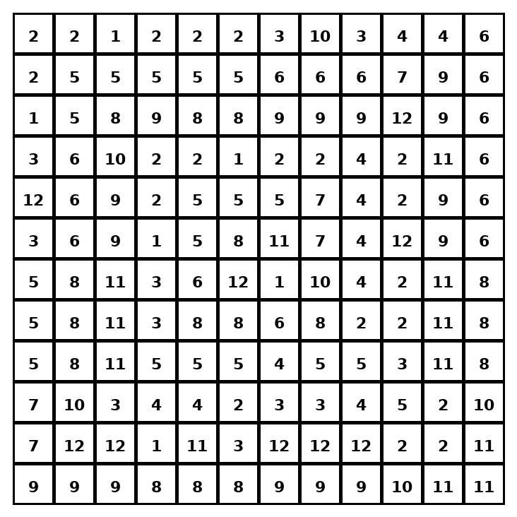

Early finisher writing: Choose one problem and explain your thinking in one complete sentence: Because ___, I ___.
____________________________________________________________________________________________

Teacher Answer Key
# | Answer | Color | Teacher Tip
1 | 12 + 15 | red | Multiply the outside number by each term inside.
2 | 12 + 14 | orange | Multiply the outside number by each term inside.
3 | 15 + 40 | yellow | Multiply the outside number by each term inside.
4 | 36 + 8 | green | Multiply the outside number by each term inside.
5 | 30 + 24 | blue | Multiply the outside number by each term inside.
6 | 14 + 21 | purple | Multiply the outside number by each term inside.
7 | 8 + 48 | pink | Multiply the outside number by each term inside.
8 | 36 + 9 | brown | Multiply the outside number by each term inside.
9 | 20 + 50 | gray | Multiply the outside number by each term inside.
10 | 33 + 22 | teal | Multiply the outside number by each term inside.
11 | 12 + 48 | black | Multiply the outside number by each term inside.
12 | 35 + 45 | light blue | Multiply the outside number by each term inside.

Use note: This file is original practice aligned to the lesson skill. It is designed for low-prep review, centers, sub plans, or early finishers.

