6-6 Equivalent Expressions
Music Studio | Standard: 6.EE.4 | Color-by-Number Practice

Learning Goal: I can show that two expressions are equivalent by simplifying and combining like terms. | Directions: Solve each problem. Match each answer to the Color Code. On the next page, color every box with that problem number using the matching color.

Vocabulary: equivalent, like terms, simplify | Explain one: I solved problem ___ by ___. Because ___, my answer is ___.

Solve First
1. Simplify: 3x + 2x.  Work: ________________________________________  Answer: ________________ | 2. Simplify: 7a - 2a.  Work: ________________________________________  Answer: ________________
3. Simplify: 4n + n + 6.  Work: ________________________________________  Answer: ________________ | 4. Simplify: 2y + 5 + 3y.  Work: ________________________________________  Answer: ________________
5. Simplify: 6m - m + 1.  Work: ________________________________________  Answer: ________________ | 6. Simplify: 8p + 2 - 3p.  Work: ________________________________________  Answer: ________________
7. Simplify: 10q - 4q.  Work: ________________________________________  Answer: ________________ | 8. Simplify: 3r + 4 + 2r.  Work: ________________________________________  Answer: ________________
9. Simplify: 9s - 2s + 8.  Work: ________________________________________  Answer: ________________ | 10. Simplify: t + t + 9.  Work: ________________________________________  Answer: ________________
11. Simplify: 5k + 3k - 1.  Work: ________________________________________  Answer: ________________ | 12. Simplify: 12b - 7b + 4.  Work: ________________________________________  Answer: ________________

Quick check: Before coloring, make sure every answer appears in the Color Code on the next page.

6-6 Mystery Picture: Beat Board Mosaic
Solve a problem, match the answer to a color, then color every box with that problem number.
Color Code | Color Code | Color Code | Color Code
5x = red | 5a = orange | 5n + 6 = yellow | 5y + 5 = green
5m + 1 = blue | 5p + 2 = purple | 6q = pink | 5r + 4 = brown
7s + 8 = gray | 2t + 9 = teal | 8k - 1 = black | 5b + 4 = light blue

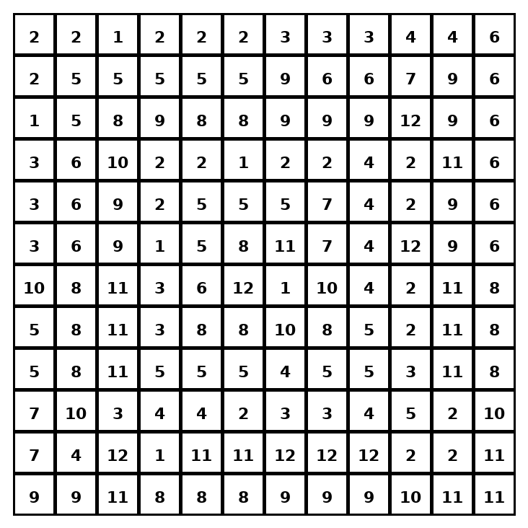

Early finisher writing: Choose one problem and explain your thinking in one complete sentence: Because ___, I ___.
____________________________________________________________________________________________

Teacher Answer Key
# | Answer | Color | Teacher Tip
1 | 5x | red | Combine like terms.
2 | 5a | orange | Combine like terms.
3 | 5n + 6 | yellow | Combine like terms.
4 | 5y + 5 | green | Combine like terms.
5 | 5m + 1 | blue | Combine like terms.
6 | 5p + 2 | purple | Combine like terms.
7 | 6q | pink | Combine like terms.
8 | 5r + 4 | brown | Combine like terms.
9 | 7s + 8 | gray | Combine like terms.
10 | 2t + 9 | teal | Combine like terms.
11 | 8k - 1 | black | Combine like terms.
12 | 5b + 4 | light blue | Combine like terms.

Use note: This file is original practice aligned to the lesson skill. It is designed for low-prep review, centers, sub plans, or early finishers.

