6-7 Simplify Algebraic Expressions
Music Studio | Standard: 6.EE.3 | Color-by-Number Practice

Learning Goal: I can simplify algebraic expressions by combining like terms. | Directions: Solve each problem. Match each answer to the Color Code. On the next page, color every box with that problem number using the matching color.

Vocabulary: coefficient, like terms, simplify | Explain one: I solved problem ___ by ___. Because ___, my answer is ___.

Solve First
1. Simplify: 2x + 3 + 4x.  Work: ________________________________________  Answer: ________________ | 2. Simplify: 5a + 7 - 2a.  Work: ________________________________________  Answer: ________________
3. Simplify: 8n - 3n + 2.  Work: ________________________________________  Answer: ________________ | 4. Simplify: 6y + 4 + y.  Work: ________________________________________  Answer: ________________
5. Simplify: 9m - m - 5.  Work: ________________________________________  Answer: ________________ | 6. Simplify: 3p + 2p + 10.  Work: ________________________________________  Answer: ________________
7. Simplify: 11q - 6q + 1.  Work: ________________________________________  Answer: ________________ | 8. Simplify: 4r + 8 + 3r.  Work: ________________________________________  Answer: ________________
9. Simplify: 12s - 5s - 2.  Work: ________________________________________  Answer: ________________ | 10. Simplify: t + 6 + 3t.  Work: ________________________________________  Answer: ________________
11. Simplify: 7k + 9 - k.  Work: ________________________________________  Answer: ________________ | 12. Simplify: 10b - 4b + 7.  Work: ________________________________________  Answer: ________________

Quick check: Before coloring, make sure every answer appears in the Color Code on the next page.

6-7 Mystery Picture: Beat Board Mosaic
Solve a problem, match the answer to a color, then color every box with that problem number.
Color Code | Color Code | Color Code | Color Code
6x + 3 = red | 3a + 7 = orange | 5n + 2 = yellow | 7y + 4 = green
8m - 5 = blue | 5p + 10 = purple | 5q + 1 = pink | 7r + 8 = brown
7s - 2 = gray | 4t + 6 = teal | 6k + 9 = black | 6b + 7 = light blue

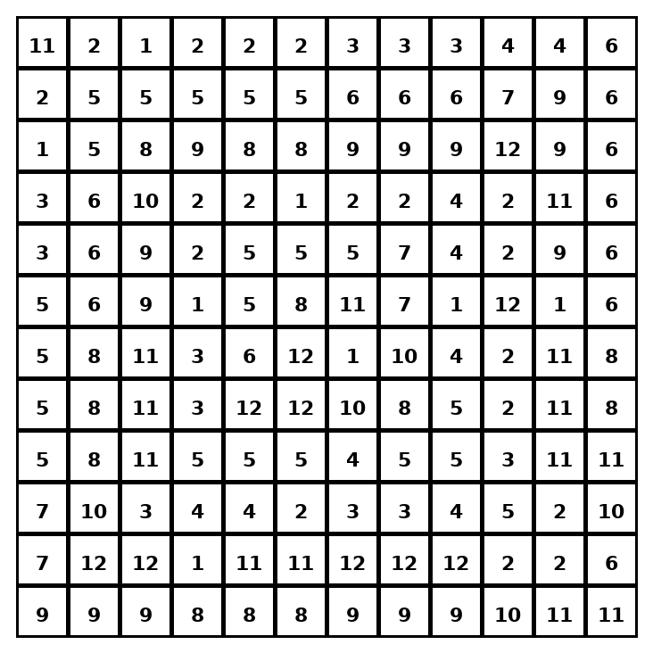

Early finisher writing: Choose one problem and explain your thinking in one complete sentence: Because ___, I ___.
____________________________________________________________________________________________

Teacher Answer Key
# | Answer | Color | Teacher Tip
1 | 6x + 3 | red | Circle like terms, then combine coefficients.
2 | 3a + 7 | orange | Circle like terms, then combine coefficients.
3 | 5n + 2 | yellow | Circle like terms, then combine coefficients.
4 | 7y + 4 | green | Circle like terms, then combine coefficients.
5 | 8m - 5 | blue | Circle like terms, then combine coefficients.
6 | 5p + 10 | purple | Circle like terms, then combine coefficients.
7 | 5q + 1 | pink | Circle like terms, then combine coefficients.
8 | 7r + 8 | brown | Circle like terms, then combine coefficients.
9 | 7s - 2 | gray | Circle like terms, then combine coefficients.
10 | 4t + 6 | teal | Circle like terms, then combine coefficients.
11 | 6k + 9 | black | Circle like terms, then combine coefficients.
12 | 6b + 7 | light blue | Circle like terms, then combine coefficients.

Use note: This file is original practice aligned to the lesson skill. It is designed for low-prep review, centers, sub plans, or early finishers.

